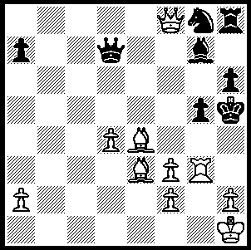

Morphy-Schulter 1857:
White wins quickly in
spectacular fashion:

247

In our chess alphabet series I have chosen USA for U, focusing mainly on the leading American players. Chess sets have been found in many colonial era homes in USA but there was little formal organisation before the start of the nineteenth century with the first chess club with permanent quarters opened in New York in 1801. The arrival of ‘The Turk’ (von Kempelen’s bogus automaton) in 1826 created the first US chess craze although there was no serious competition organised before the New York Tournament of 1857. This was a knock-out modelled on London 1851, with Paul Morphy (1837-84) defeating Louis Paulsen, a German émigré, +5 -1 =2. Morphy was subsequently sent by the New Orleans Chess Club to Europe where he was undefeated in matches against the leading Europeans. His successes ensured the further increased popularity of the game despite his inability to arrange a match with the Englishman Howard Staunton who claimed to be world champion. On his return to America he pursued a not very successful legal career and played little serious chess. Here is an exciting game from Morphy:

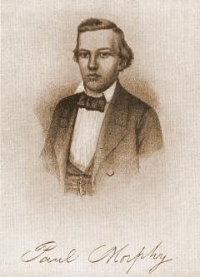
Paul Morphy – Theodore Lichrenheim
1st American Congress 1857
Petroffs Defence: Boden-Kieseritsky Gambit
1.e4 e5 2.Nf3 Nf6
3.Bc4 Nxe4 4.Nc3(a) d5
5.Bxd5 Nf6 6.Bb3 Bd6
7.d3 0-0 8.h3 h6(b)
9.Be3 Nc6(c) 10.Qd2 Na5
11.g4 Nxb3 12.axb3 Bd7(d)
13.Rg1 Nh7 14.Ne4 Kh8(e)
15.g5 h5 16.Nh4 g6
17.Qe2 Bc6 18.f4(f) exf4
19.Bd4+ Kg8 20.Nf5! Re8(g)
21.Nh6+ Kf8 22.0-0-0 Bxe4(h)
23.dxe4 Qe7(i) 24.e5! Bxe5
25.Bxe5 Qxe5 26.Rd7! Qg7(j)
27.Qc4 Re7 28.Rxe7 Kxe7
29.Re1+(k) resigns

a) 4.d4 is the alternative. The Boden-Kierseritsky Gambit was popular around this time with the main line being 4…Nxc3 5.dxc3 f6 (not 5…d6 6.Nxe5! dxe5? 7.Bxf7+ Ke7 8.Bg5+) 6.Nh4 (Boden) or 6.0-0 with play for the pawn. Boden-Morphy 1858 went 5…c6 6.Nxe5 d5 7.0-0 Bd6 8.Re1=. The gambit can also arise from the Bishops Opening (2.Bc4) or the Vienna (2.Nc3 Nf6 3.Bc4 Nxe4 4 Nf3).
b) Prevents the pinning Bg5 but, with White uncastled, provides a target for a pawn storm.
c) 9…c5! prepares a knight outpost on d4.
d) Aiming for c6, to attack and pin the unprotected knight.
e) 14…a5 now or on subsequent moves to deter White from castling.
f) The threat of f4-5 forces capture, opening the a1-h8 diagonal.
g) If 20…gxf5 21.Nf6+! wins quickly.
h) Black misses his best chance – 22…Nxg5! 23.Nxf7! Kxf7 (23…Nxf7 24.Rxg6 maintains the attack) 24.Nxg5+ Qxg5! 25.Qxe8+ Rxe8 26.Rxg5 f3 with a winning endgame.
i) 23…Re6 is better.
j) This loses as do 26…Qxe2 27 Rxf7# and 26…Qe3+ 27.Qxe3 Rxe3 28.Rxf7+ Ke8 29.Rxh7. However Black is saved by 26…Nxg5! (déjà vu) 27.Rxg5 Qf6 28.Qd2 (28.Qxh5!? Rad8!) 28…Re7 29.Rxe7 Qxe7 30.Rd5 Re8! 31.Qxf4 Kg7 32.Kb1 Qe3 33.Qxc7 (33.Nf5+ gxf5 34.Qxf5 is inferior) 33…Kxh6 34.Rd3.
k) 29.Qxc7+ is quicker but after 29…Kd6 30.Rd1+ Ke7 31.Qxc7+ Ke8 32.Re1+ Kf8 33.Qd6#.

SOLUTION: 1.Qf7+! (or 1.Qe8+) Qxf7 2.Rh3#. I did say ‘spectacular’ so NOT 1.Rh3+.

