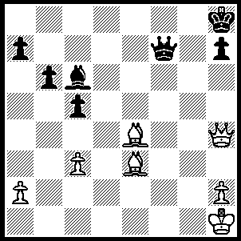
CHESS IN THE USA (II)

A brilliant win by Pillsbury
(Black) in a blindfold
exhibition (3 moves):

248

Paul Morphy’s successes in Europe in the late 1850s made him a national hero and the ensuing ‘Morphy Excitement’ was responsible for doubling the number of players in the USA. The Manhattan Chess Club opened in 1877 and was instrumental in bringing the first official world championship match, between Steinitz and Zukertort, to America in 1886. About this time a young American Harry Nelson Pillsbury (1872-1906) began to take an interest in the game and was to become one of the world’s leading players with invitations to compete in the tournaments all over the world. He only came clear first in one major event, Hastings 1895, but this tournament, considered the strongest ever in England, included world champion Emanuel Lasker, ex-world champion Steinitz as well as Tchigorin, Tarrasch, Schlecter and Blackburne. His lifestyle which included wine, women, strong cigars, frequent travelling and the giving of blindfold simultaneous exhibitions (over a thousand games in 70 displays) may have contributed to his health problems which began to appear in his mid twenties and he died at the tragically early age of 33. ‘A genius has gone,’ lamented world champion Lasker whose score with Pillsbury was +5 =4 -5.

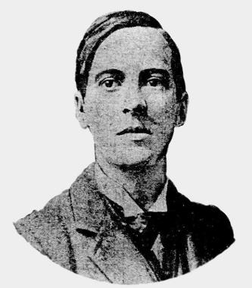
Harry Pillsbury - Emanuel Lasker
Cambridge Springs 1904
Queens Gambit, Semi-Tarrasch Defence
1.d4 d5 2.c4 e6
3.Nc3 Nf6 4.Nf3 c5
5.Bg5 cxd 6.Qxd4 Nc6
7.Bxf6! gxf6(a) 8.Qh4 dxc
9.Rd1 Bd7 10.e3 Ne5(b)
11.Nxe5 fxe5 12.Qxc4 Qb6
13.Be2! Qxb2 14.0-0! Rc8
15.Qd3 Rc7(c) 16.Ne4 Be7
17.Nd6+ Kf8 18.Nc4 Qb5
19.f4! exf?(d) 20.Qd4! f6
21.Qxf4 Qc5 22.Ne5 Be8
23.Ng4 f5 24.Qh6+ Kf7
25.Bc4! Rc6(e) 26.Rxf5+! Qxf5
27.Rf1 Qxf1+ 28.Kxf1 Bd7
29.Qh5+ Kf8 30.Ne5 resigns

a) If 7…Nxd4 8.Bxd8 Nc2+ 9.Kd2 Nxa1 10.Bc7 dxc 11.e4 Nb3+ 12.axb3 cxb3 13Bc4 is in White’s favour.
b) Better are 10…f5 and 10…Be7.
c) If 15…Bc6 16.Bf3.
d) More solid was 19…Bc6 20.fxe Qd5.
e) 25…Qxc4?? 26.Ne5+.

MAMMOTH MATCH
The River Elbe flows through the city of Hamburg and each year for the past 51 years a chess match has been played between school students from the east of the river and those to the west. This year the match was played over 1352 boards with the west just winning 680.5 – 671.5.

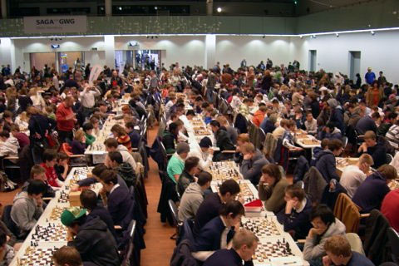

SOLUTION: 1…Qf1+ (depriving the king of an escape square) 2.Bg1 Qf3+!! 3.Bxf3 Bxf3#.

