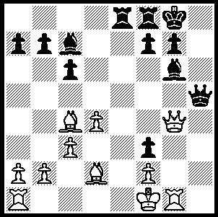
CHESS IN THE USA (Part III)

A sensational move by the American
attacking genius Frank Marshall
forces mate in 3
(Black v M. Didieu 1900)

240

Harry Pillsbury was succeeded as the USA leading player by the brilliant Frank Marshall (1877-1944) whose surprise win at Cambridge Springs in 1907 (ahead of Lasker, Schlechter, Tchigorin) helped him secure a world championship match against Lasker which he lost 3.5-11.5. Marshall later won the Havana tournament in 1913 ahead of Capablanca and was 4th in the great New York tournament in 1924 where he also gained the 2nd Brilliancy Prize for his victory over Bogolubov (published in this column May 8, 2004). Chess flourished in the USA during the Depression partly due to the inspiration of Marshall who founded the famous Marshall Chess Club in New York and an influx of players from Eastern Europe.
Here is a game from Marshal at New York which epitomises his chess philosophy: ‘I have always liked a wide open game and tried to knock out my opponents with a checkmate as quickly as possible. I subscribe to the old belief that offence is the best form of defence.’

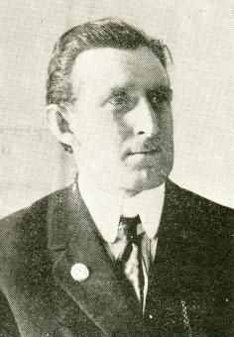
Richard Reti - Frank Marshall
New York 1924, Rd 15
Queens Gambit, Marshall Defence
1.Nf3 Nf6 2.c4 d5
3.cxd Nxd5 4.d4 Bf5
5.Nc3 e6 6.Qb3 Nc6!
7.e4(a) Nxc3 8.exf4 Nd5
9.Bb5(b) Bb4+ 10.Bd2 Bxd2+
11. Nxd2 exf 12.Bxc6+ bxc6
13.0-0 0-0 14.Qa4 Rb8(c)
15.Nb3(d) Rb6 16.Qxa7 Qg4
17.Qa5 c5! 18.Qxc5 Nf4
19.g3 Rh6 20.Qxc7 Ne2+
21.Kg2 Qg4 22.Rh1 f4
23.f3(e) Qh3+ 24.Kf2 Rc8 !
25.Qa5 Nxg3! 26.Rhg1(f) Qxh2+
27.Rg2 Qh4 28.Rc1 Re8
29.Qb5 Ne4+ 30.Kf1 Qh1+
White resigns

a) White cannot contemplate 7.Qxb7 in view of 7…N(either)b4.
b) If 9.fxe Bb4+ 10.Bd2 Bxd2+ 11.Nxd2 0-0 12.exf+ Rxf7 with an excellent attacking position. However rather than give up a pawn White could continue 9.Qxb7 N6b4 10.Qb5+ c6 11.Qa4 exf 12.a3 Nb6 13.Qb3 Nd5 14.Be2 =.
c) Rather than consolidating with 14…Nf5 15.0-0 Qd5 Marshall plans a kingside attack.
d) This leaves White’s king bereft of defence.
e) If 23.h3 f3+ 24.Kh1 Rxh3 25.Rxh3 Qxh3+ 26 Ke1 Nxd4! 27.Rc1 Nxb3 28.axb3 Qg2 winning.
f) If 26.hxg3 Qxg3+ 27.Ke2 Qg2+ 28.Kd3 Rxh1 29.Rxh1 Qxf3+ & wins.

SOLUTION: 1…Qd5!! & if 2.Bxd5 Bd3# or 2.b3 Qxc4+ 3.bxc4 Bd3#.

