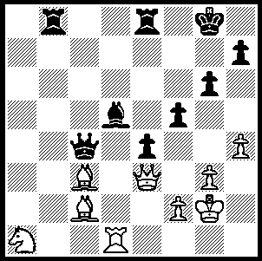
CHESS IN THE USA (Part IV)

Reshevsky-Najdorf 1952:
Reshevsky wins material against
his great Argentinian rival (4 moves):

241

After the era of Frank Marshall, two players, Reuben Fine (1914-1993) and Samuel Reshevsky (1911-1992) became the dominant players in the USA giving hope that an America might become world champion.

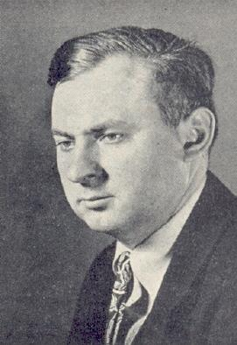
Reuben Fine, best remembered for
his ‘Basic Chess Endings’, developed
his prowess at the Marshall Club
and achieved his greatest success
at the AVRO (Holland) tournament
in 1938 where he tied first with Keres
(2nd on tiebreak) ahead of Botvinnik,
Alekhine, Reshevsky, Euwe, Capablanca
& Flohr. This event was to provide a
challenger to Alekhine for the world
title. World War II and concentration
on his study and work as a psychiatrist
virtually ended Fine’s chess career and
he declined an invitation to compete in
the World Championship Tournament in
1948 to find a successor to Alekhine.

Sanuel Reshevsky, born in Poland, learnt chess at the age of four and by the age of 8 was giving simultaneous displays throughout Europe and the USA where he was to settle. A serious contender for the world title, Reshevsky played in the World Championship tournament in 1948 to decide the successor to the deceased Alekhine, finishing =3rd with Keres (10.5/20) behind Botvinnik and Smyslov. In the 1953 Candidates Tournament he led at various points before finishing =2nd (16/28) to Smyslov who won the right to challenge Botvinnik. With Fine and Reshevsky on top boards the USA won four Olympiads in succession between 1931 and 1937.
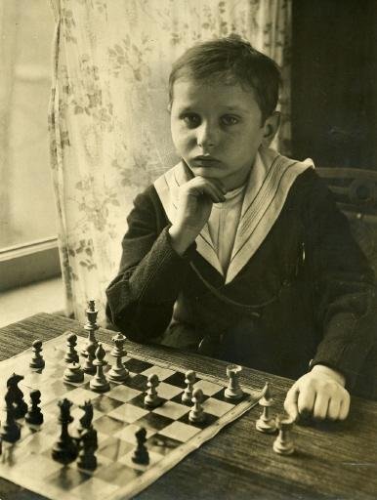

Samuel Reshevsky - Yuri Averbakh
1953 Candidates, Rd 18
Nimzo-Indian, Rubinstein Variation
1.d4 Nf6 2.c4 e6
3.Nc3 Bb4 4.e3 0-0
5.Ne2 d5 6.a3 Be7
7.cxd exd 8.Ng3 Be6
9.Bd3 Nbd7 10.0-0 c6
11.Bd2 Re8 12.Qc2 a5
13.Nce2 Nb6 14.Nf4 Bd7
15.Rfe1(a) Bf8 16.f3 Bc8(b)
17.Rac1 g6 18.Nfe2 Bg7
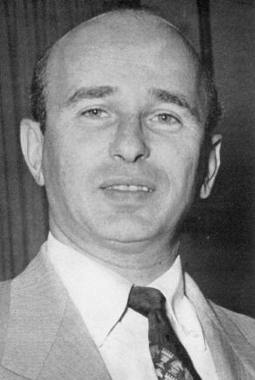
19.h3(c) a4 20.e4 dxe
21.fxe Be6 22.Be3 Bb3
23.Qd2 Nfd7 24.Bg5(d) f6
25.Be3 Nf8 26.h4! Bf7
27.h5! Ne6(e) 28.Rf1 Bf8
29.Rf2 Nd7 30.Rcf1 c5
31.d5 Nc7 32.hxg hxg
33.Rf4 b5 34.Rh4 Ne5
35.Kh1 Qd7(f) 36.Rxf6! Ng4
37.Bg5!(g) Bg7(h) 38.Rf4 Ne5
39.Bf6 Bxf6 40.Rxf6 Kg7
41.Qg5(i) Rh8 42.Nf5+ Qxf5
43.Rxf5 Rxh4+ 44.Kg1! resigns

a) Play revolves around White’s attempts to play e4.
b) Preventing 17.e4 by discovering a queen attack the d pawn after …dxe.
c) Not 19.e4 dxe 20.fxe Ng4 21.Bc3 Bh6 with good play.
d) Inducing a kingside weakening.
e) 27…gxh provides White with knight outpost on f5.
f) Setting a faulty trap.
g) Refuting Black’s efforts to develop a counter attack.
h) Not 37…Nxf6 38.Bxf6 Bg7 39.Bxg7 Kxg7 40.Qc6+ Kf8 41.Qf6 mating. 37…Be7 also loses - 38.Qc3! b4 39.Rxg6+! Bxg6 40.Qh8+ Kf7 41.Rh7+! Bxf7 42.Qxh7+ Kf8 43.Nf4 Ne5 44.Bh6#.
i) Threat 42.Nf5+ Kg8 43. Rh8+! Kxh8 44.Qh6+ & mates.

SOLUTION: 1.Bb3! winning after 1…Rxb3 Nxb3 3.Qxb3 Qd4 with dual threats 4.Qg7# & 4.Qxd5+.

THE PERTH OPEN (Australian & WA Grand Prix event) will be played next week, Sat 20 / Sun 21 June. Please check for details.

