Chess in the USA (Part VII)

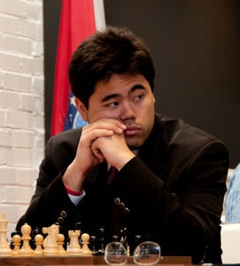
Sagalchik – Nakamura 2003:
Black to play and mate in 2:

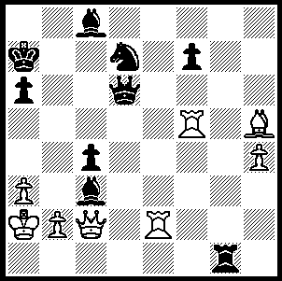

Hikaru Nakamura 251

The top two places in this year’s US Championship which finished on May 20 were taken by young players auguring well for US chess. Winner was 21 year old Hikaru Nakarmura who was unbeaten in scoring 7/9. Nakamura’s previous US title was gained when he was 16. Second was 17 year old Robert Hess with 6.5 while fourteen year old Ray Robson also impressed with 4.5.

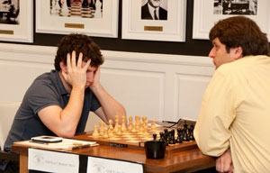 Robert Hess (left)

However there are very worrying concerns behind the scenes. For the past three years the US Chess Federation has been running at a loss and its finances are in a parlous position, a state which is exacerbated by four impending court cases with issues ranging from computer hacking, libel, fraud, negligence, infliction of emotional distress, with the most serious being action being taken against the Federation by Susan Polgar and her husband.

Here is a brilliant Nakamura game with an amazing queen sacrifice followed by a 12 move king hunt against a Polish GM

Krasenkow-Nakamura
2007 Casino de Barcelona
Reti / Catalan Opening
1.Nf3 Nf6 2.c4 e6
3.g3 d5 4.Bg2 Be7
5.0-0 0-0 6.b3 a5
7.Nc3(a) c6 8.d4 Nbd7
9.Qc2 b6 10.e4 Ba6
11.Nd2(b) c5! 12.exd5(c) cxd4
13.Nb5 exd5(d) 14.Nxd4 Rc8
15.Re1 b5 16.Bb2 Re8
17.Qd1 bxc4 18.bxc4 Qb6!(e)
19.Rb1 dxc4! 20.Nc6?(f) Rxc6
21.Bxf6?(g) Qxf2+!! 22.Kxf2(h) Bc5+
23.Kf3(i) Rxf6+ 24.Kg4 Ne5+
25.Kg5(j) Rg6+ 26.Kh5(k) f6(l)
27.Rxe5(m) Rxe5+ 28.Kh4 Bc8!
White resigns (n)

a) If.now 7 d4 a4! (8.bxa dxc4).
b) Better is 11.e5 Ne8 12.Ne2.
c) After 12.dxc5 d4! 13.Na4 bxc5 14.e5?! Nxe5 15.Bxa8 Qxa8 Black has excellent compensation for the exchange.
d) 13...Bxb5 is met by 14.dxe6!
e) Not 18…dxc 19.Nc6 while 18...Bxc4 19.Nxc4 Rxc4 gives White the chance to fight back with 20.Nf5 Bc5 21.Qd2!
f) Falling into a deep trap. White should have tried 20.Bc3 Qc5 21.Qa4.)
g) Better 21.Rxe7 Rxe7 22.Bxf6 Nxf6 23.Rxb6 Rxb6, but Black has a clear advantage.
h) After 22.Kh1 Rxf6 23.Ne4 Qa7 Black wins.
i) Alternatives also lose: eg 23.Kf1 c3+ 24.Re2 c2!
j) 25.Rxe5 is met by 25...Bc8+ and after 25.Kh4 Rh6+ 26.Kg5 Rg6+ 27.Kh5 Bc8! wins.
k) Black also wins after both 26.Kf4 Nd3+ and 26.Kf5 Bc8+ 27.Ke4 Rd6!
l) 26...Bc8! 27.Ne4 Be7 closes the mating net even quicker.
m) If 27.Bd5+ Kh8 28.Kh4 Rh6+ 29.Qh5 g5+ 30.Kh3 Rxh5+ wins.
n) Black mates either after 29.Bf3 Rh6+ 30.Bh5 g5 mate; or after 29.Bd5+ Rxd5 30.g4 Rd3
31.Qf3 Bf2+! 32.Kh3 Rxg4! 33.Rb8 Rg3+ 34.Kh4 Rh3 mate.

SOLUTION: 1…Qxa3+!! 2.Kxa3 or bxa3 Ra1#.

