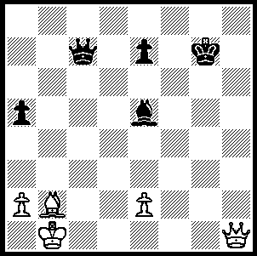
DOUBLE PIN is a term used in
problems where a piece is pinned
onto both king and queen at the
same time. White wins by employing
a double pin (6 moves with the second
being a quiet move hard to find and
skewers deciding the issue):

Diagram 255

Last week featured the Donostia (San Sebastion, Spain) event won by the young American Hikaru Nakamura who defeated former FIDE champion Ukranian Ruslan Ponamariov 2-0 in a blitz play-off.
Nakamura spends a lot of time on the Internet Chess Club and his skills at fast time limits are legendary. Here is one of his play-off wins. Look out for White's 33rd move, it's a real bolt from the blue.

Hikaru Nakamura - Ruslan Ponomariov
2009 Donostia, Play-off, Game 1
Sicilian Scheveningen, Keres Attack
1.e4 c5 2.Nf3 d6
3.d4 cxd4 4.Nxd4 Nf6
5.Nc3 e6 6.g4 h6
7.Bg2 Nc6 8.h3 a6
9.Be3 Ne5 10.Qe2 g5(a)
11.f4 gxf4 12.Bxf4 Nfd7
13.0-0-0 b5 14.Qf2 Bb7
15.Kb1 Qb6 16.Rhf1 Be7
17.Be3 Qc7 18.Nf3 Rh7(b)
9.Bd4 b4 20.Na4 Nc4
21.Nd2! Rc8 22.Nxc4 Qxc4
23.b3 Qb5 24.Nb2(c) Ne5(d)
25.Bxe5 dxe5 26.Nc4 Rxc4!
27.bxc4 Qxc4 28.Qb6 Qc6
29.Qa5(e) f6 30.h4 Rg7
31.Bf3 Rg8(f) 32.g5! hxg5
33.Qxe5!!(g) Kf7 34.Qg3 g4(h)
35.Bxg4 Qc5 36.Bxe6+! resigns

a) Preventing White from driving away the knight on e5 by 11.f4.
b) Not 18...0-0-0 19.Nxe5 Nxe5 20.Bb6 or 19…dxe5 20.Qxf7.
c) Heading for c4 to attack d6.
d) 24...e5 25.Be3 Nf6 is a reasonable continuation.
e) After 29.Qxc6+ Bxc6 Black can establish a bishop on d4 with a solid position.
f) Not 31...Qc5 32.Rd8+! Kf7 32.Qxc5 Bxc5 33.Rfd1.
g) Brilliant! 33...fxe5 34.Bh5+ Rg6 35.Bxg6#. Black position is now in ruins.
h) If 34…Qxe4 35.Bh5+ Kf8 36.Qb8+.

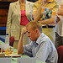
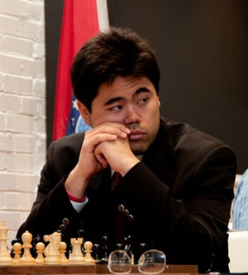

The Perth Club meets on Wednesdays from 7pm at N. Woodvale Primary School. Chichester Dr. (a junior club also meets on Tuesdays 6.30-8.30). The club has a thriving membership with all standards of players catered for. The 2009 club championship had an entry of 32 players. Many times WA champion Wolfgang Leonhardt led into the final round closely followed by Peter Dix. However Robert Maris overcame Wolfgang in the final round while Peter lost to Ross List resulting in a three way tie with Robert, Wolfgang and Ross all on 5.5/7 with Peter sharing 4th place with Ned Tomic (5/7). New members are always welcome – contact Norbert Muller 94099579.

SOLUTION: 1.Qh2! Kf6 2.e4! (depriving the Black king of f5 & d5) 2…Ke6 3.Qh3+ Kf7 (3…Kf6 4.Qf5+ Kg7 5.Bxe5+ or 3…Kd6 4.Bxe5+ Kxe5 5.Qh2+) 4.Qf5+ (4.Qh5+ also wins) 4…Bf6 5.Bxf6 exf6 6.Qh7+.

