One does not usually consider chess players an especially altruistic lot but one particular act of generosity will enable young Englishman David Howell to compete in this year’s World Junior Championship with former world championship challenger Nigel Short as coach. Last year Howell, without a coach, led the tournament only to lose his final game to winner Abhijeet Gupta (India). A former leading English IM Michael Basman donated £2000 to the Howell family, an amount equalled by the charitable John Robinson Fund. Howell is at present in joint lead in the British Championship being held in the resort town of Torquay.

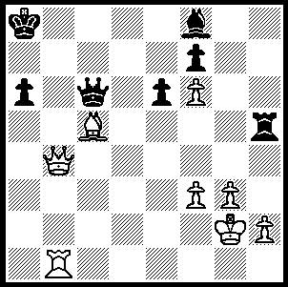

Here is a position from one of his
games (Hebden-Howell, Br. Ch.
Rd2): Black, faced with mate and
the loss of a piece, turns the tables
cleverly with a skewer concluding
the combination (5 moves):

Diagram 257

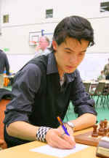
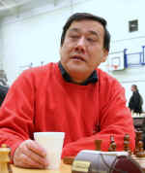

David Howell Mark Hebden

Here is a win from joint leader English International Gawain Jones with a text book Kings Indian kingside attack:

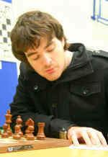
A Summerscale - G Jones
2009 British Championship, Rd 5
Kings Indian Defence, Classical

1.Nf3 Nf6 2.c4 g6
3.Nc3 Bg7 4.d4 0-0
5.e4 d6 6.Be2 e5
7.0-0 Nc6 8.d5 Ne7
9.Ne1 Nd7 10.Be3 f5
11.f3 f4 12.Bf2 g5
13.a4 Rf6 14.a5 Rh6
15.Kh1(a) Nf6 16.c5 Qe8 Gawain Jones

17.Ra3(b) Qh5 18.Bg1 Qh4(c)
19.Bb5 Nh5 20.Ne2 Ng3+
21.Nxg3 fxg3 22.Nd3 Ng6
23.c6 Nf4 24.Nxf4(d) Qxf4
25.Qe1 bxc(e) 26.Bc4(f) c5
27.Rb3 Bd7 28.Qe3 Rxh2+!!
29.Bxh2 Qh4 30.Qg1 Rf8
31.Rb7 Rf4 32.Rxc7 Qh6!
White resigns(g)

Aaron Sommerscale

a) If 15.Nd3 Qe8 16.Nb5 Qh5 17.h3 Nf6 with a crushing attack.
b) If 17.Nb5 Qh5 18.Bg1 Qh4 19.Nxc7 Nh5 20.h3 Ng3+ 21.Kh2 Bxh3 wins.
c) Intending …Nh5 / …Ng3#
d) 24.Qd2 loses in brilliant fashion – 24…Qxh2+!! 25.Bxh2 Rxh2+ 26.Kg1 Nh3+!27.gxh3 Rxd2.
e) Not 25...Rxh2+ 26.Bxh2 Qh4 27.Qxg3.
f) 26.Bxc6 allows the queenside pieces into play with 26…Rb8/ 27…Ba6.
g) There is no defence against …Rh5 /…Rxh2+ mating.

Our own Junior Championships were played late May at Mt. Lawley Senior High. Chris Boni became WA Junior champion after scoring 5/6. Multi title winner was runner-up Amy Brown (4/6) who became Under 16 champion, Girls champion & Girls Under 16 champion. Other top prize winners: Under 14 – 1st William Williams (6/6), 2nd George Carolin-Uncovich (4.5): Under 12 – 1st Tayla Wood (6.5/7, also Girls Under 14 champ): Under 10 – 1st= Patrick Olofsson, David Stebbings, Tristan Tan (all 6/8 & 2/4 in Play-Off): Under 14 Girls – 1st Sarah Moritz.

SOLUTION: 1…Bd6!! (preventing mate and deflecting the White bishop) 2.Bxd6 Qc2+ 3.Kg1 Rb5 (skewer winning the rook). The game continued 4.Qe4+ Qxe4 5.fxe4 Rxb1+ 6.Kg2 Rb2+ 7.Kh3 Kb7 8.g4 Kc6 9.e5 Kd7 10.Kg3 (White draws with 10.g5 Rf2 – 10…a5 11.g6! wins – 11.Kg3 Rf1 12.h4=) 10…a5 11.h4 (again 11.g5 Ke8 12.h4 a4 13.h5 a3! 14.g6=) 11…a4 12.Kf4 Rb3 13.g5 a3 14.g6 a2 15.gxf a1=Q & wins.

