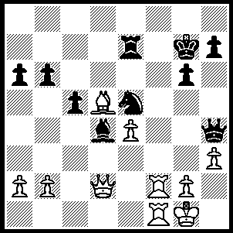
Hawkins-Palliser
(Br. Ch. 2009)
Black to play and win
(despite White’s attempts
to secure a perpetual
– 10 moves)

258

David Howell, whom British IM Michael Basman is supporting financially to compete in this year’s World Junior Championship with Nigel Short as trainer, won this year’s British Championship after leading throughout. After defeating defending champion Stuart Conquest in Round 10 Howell was one point ahead going into the final round and agreed a speedy draw with Australian International Gary Lane to secure the title. Leading scores: David Howell 9/11, Mark Hebden 8.5, Simon Williams 8.5, Richard Palliser 8.

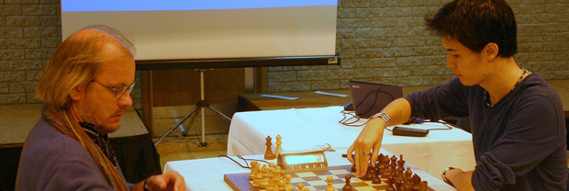

The start of the Rd 10 Conquest-Howell game, a Two Knights Defence

In his win against the dangerous Palliser a surprising early exchange sacrifice provided Howell with excellent attacking chances:

David Howell - Richard Palliser

2009 British Championship, Rd. 9

Trompovsky Opening

1.d4 Nf6 2.Bg5 d5

3.Bxf6 gxf6 4.e3 c5

5.dxc5 e6 6.Nd2 Bxc5

7.g3(a) Nc6 8.Ne2 d4(b)

9.exd4 Qd5(c) 10.dxc5! Qxh1

11.Nc3 Qxh2 12.Nde4 0-0(d)

13.Qd2 Rd8(e) 14.Nxf6+ Kh8

15.Qg5(f) h6 16.Qg4 Qh1!(g)

17.Rd1 Rxd1+ 18.Nxd1 Bd7!

19.Ne3(h) Ne5 20.Qf4 Nf3+

21.Ke2 Rd8(i) 22.Bg2(j) Ng1+?(k)
23.Kf1 Qh2 24.Nfg4 resigns
a) An original position after only seven moves.
b) Leading to complications. An alternative was 8...f5 9.Bg2 Qf6 10.c3 Bd7.
c) Looks strong but is met by a brilliant positional sacrifice: better therefore was 9...Nxd4 10.Bg2 Qb6.
d) If 12...Qh6 13.Qd6 trapping Black’s king in the centre.
e) Black might have tried 13...Kg7 when he could defend against 14.Qf4 with13…Qh6. Howevever after 14.0-0-0 Black’s lack of development and offside queen give cause for concern.
f) White now threatens 16.Nh5 as well as 16.Rd1 to challenge Black’s back row defender.
g) A mysterious move, the intention of which becomes clear on next note.

h) 19.Nxd7 Rd8 20.Nf6 Ne5 21.Qe4 Nf3+ 22.Ke2 Ng1+ is the clever point of Black’s 16th move.

i) After 21...Bc6! White seems to have nothing better than 22.Nfg4 (not 22.Bg2? Qe1+ 23.Kd3 Rd8+ winning) 22…Rf8 23.Qf6+ Kh7 24.Qe7 Kg7 25.Qf6+ Kh7 draw.

j) Not 22.Qxf3? Bb5+ 23.c4 Rd2+! 24.Kxe2 Qxf3.

k) Black’s only chance was 22...e5! although after 23.Bxh1 (23.Qxf3? Bb5+ 24.c4 Bxc4+! 25.Nxc4 Qd1+ 26.Ke3 Qd3#) 23…exf4 24.Bxf3 fxe3 25.Bxb7 exf2 26.Kxf2 White is better.

Continuing a roundup of WA results – the 2009 Metro Open (32 entries) was won by Gordon Dunlop with 6/7 (losing only his final round game), followed by John Fedec (5.5) & Marc Vliestra (5).

Top Rating scores – Under 1570: 1st Andre Vaz Pinto (5), 2nd Wallace Sheridan (4.5): Under 1400: =1st Ben Motu, Phil Savory (3).

SOLUTION: 1…Nf3+! (exposing White’s king and enabling the rook to enter the attack) White resigns - 2.gxf3 Qg3+ 3.Kh1 Qxh3+ 4.Kg1 Re5 5.Qf4 Rh5 6.Qf7+ Kh6 7.Qf8+ Kg5 8.Qd8+ Kf4 9.Qf8+ Kg3 (the attacked king becomes an attacker) 10.Qd6+ Be5.

