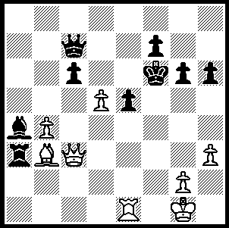
In Timman-Kasparov the pin
on White’s bishop seems to
ensure a Black advantage.
However it was White who
won quickly. Can you see how?

259

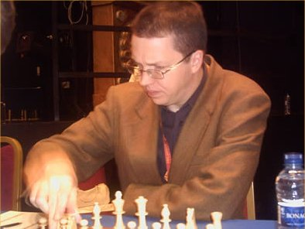
From 7-17 August the annual UK-Netherlands
match was played at Simpsons, The Strand,
London, as part of the Staunton Memorial.
Each team’s five players play twice against
each of the opposing five players. The UK
won this year by 26.5-23.5 with Nigel Short,
a former challenger to Gary Kasparov for the
world title, in superb form scoring 8/10. His
performance will ensure his rating again
reaches 2700+ and he will overtake Michael
Adams as the top rated UK player.
The always dapper Nigel Short

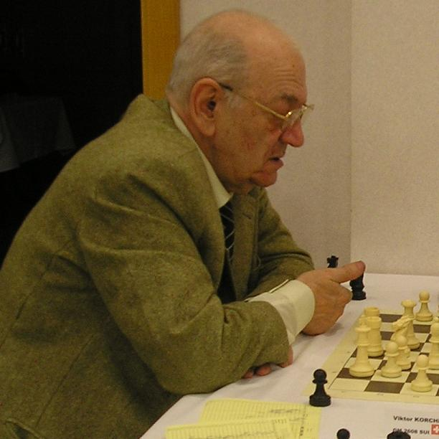

Alongside this event was a GM round robin
comprising five UK and five foreign players.
The event attracted considerable interest and
large audiences, due mainly to the participation
of the legendary Viktor Korchnoi, now 78,
who came so close to defeating Anatoly Karpov
for the world title in 1978. Korchnoi inflicted
the only defeat on the winner Jan Timman and
came 3rd with 6/9.

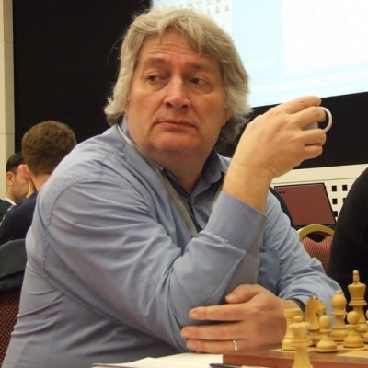
Jan Timman , himself a veteran at 57, was at one time
considered the best player outside the Soviet Union.
He was Netherlands champion 9 times and represented
his country in 13 Olympiads, winning the top board
gold medal in 1976. After FIDE refused to recognise
the 1993 Kasparov-Short world championship match,
Timman played Karpov for the title, losing 8.5-12.5.

In his encounter with Korchnoi at the Staunton Memorial, Timman gains the theoretical advantage of R +2 ps v 2B. However Korchnoi’s bishops aided by his sole rook turn the tide:
Jan Timman – Viktor Korchnoi
2009 Staunton Memorial, Rd 7
French Tarrasch
1. e4 e6 16. Bd2 c5 31. Rd8 Bc6
2. d4 d5 17. Rad1 Rf7 32. a5 Be7
3. Nd2 c5 18. h3 Bf8 33. Rc8 Bh4
4. Ngf3 Nc6 19. Bf4 e5 34. g3 Bb7
5. Bb5 cxd4 20. Nxe5 fxe5 35. Rxc5 Bf6
6. Nxd4 Bd7 21. Bxe5 Qc8 36. Rd3 Re7
7. Nxc6 bxc6 22. Bxb8 Qxb8 37. f3 Bxf3!
8. Bd3 Qc7 23. Re2 Qb6 38.Rc8 Bb7
9. Qe2 Bd6 24. a4 Qa6 39. Rcd8 Re1+
10. Nf3 dxe4 25. c4 h6 40. Kf2 Ra1
11. Bxe4 Nf6 26. Re3 Bc6 41. R8d7 Be4
12. O-O Rb8 27. Qe6 Qb7 42. R3d6 Bc3
13. Re1 Nxe4 28. Rd8 Kh7 43. Rxa7 Bb4
14. Qxe4 f6 29. Qc8 Qxc8 44. Raa6 Bxd6
15. b3 O-O 30. Rxc8 Bb7 and Black wins (a)

a) cont.45. Rxd6 Rxa5 46. Ke3 Bg2 47. h4 Rf5 48. b4 Rf3+ 49. Kd4 Rxg3 50. b5 Rg4+ 51. Kc5 Rxh4 52. b6 Bb7 53. Kb5 Rh1 54. c5 Rb1+ 55. Ka5 Ra1+56. Kb4 Rc1 57. Kb5 Bg2 58. Rd2 Rb1+ 59. Kc4 Bh1 White resigns)

SOLUTION: 1.d6! (a clearance sacrifice to open the a2-g8 diagonal) 1…Qxd6 (other queen moves are no better, eg 1…Qb6+ 2.Kh1 R/Bxb3 3.Qxe5# or 3…Qd4 4.Qxd4 exd4 5.d7 queening) 2.Qf3+ resigns (2…Ke7 – 2.Kg5 3.h4+ mates – 3.Qxf7+ Kd8 4.Rd1 Ra1!? a counter pin that fails 5.Qf8+!)

