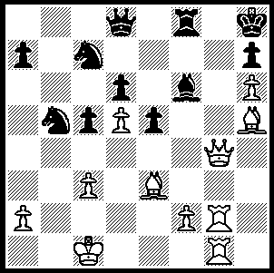
The Zurich Chess Club, Switzerland, recently
celebrated its 200th anniversary with a number
of spectacular events including a strong Open
and opportunities for amateurs to play living
legends Spassky, Kasparov, Karpov, Korchnoi,
Kramnik, Anand, Topalov and Ponamariov in
simuls. The final event was an eight player
Rapid-Play won by Kramnik (5/7) with Anand
runner-up. Here is a position from the event
(Ponamariov-Hug): White to play & mate in 6:
262

One of the most interesting games from the Rapid-Play was the clash between Kramnik and Topalov, not only for the game itself but also for the intense rivalry and ill-feeling between the two players which has persisted since their world championship ‘Toiletgate’ match when Topalov accused Kramnik of cheating during his trips to the toilet. The world’s top rated player, Topalov, and ex-world champion Kramnik grudgingly shake hands before a game but only because it is mandatory.

Veselin Topalov - Vladimir Kramnik
Champions Rapid Zurich 2009, Rd 4
Catalan
1.d4 Nf6 2.c4 e6
3.Nf3 d5 4.g3 dxc4
5.Bg2 c6 6.Ne5 Bb4+
7.Bd2 Qxd4 8.Bxb4 Qxe5
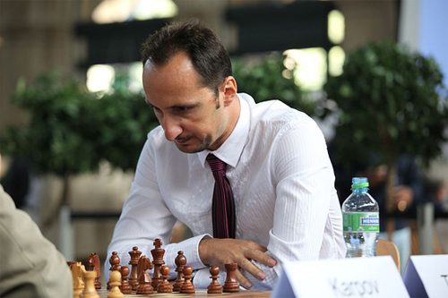
9.Nd2 b5(a) 10.Bc3 Qc7
11.a4 Bb7 12.Bxf6 gxf6
13.Ne4 Ke7 14.Qd2 Nd7
15.axb5 cxb5 16.Qb4+ Nc5!!
17.Ra5(b) Bxe4 18.Bxe4 Rab8
19.0-0 Kf8 20.Rfa1 Kg7
21.Rxa7 Qe5 22.Bf3 Rhf8
23.Re7 Nb3 24.Raa7 Nd4
25.Kg2 Nxe2 26.Rac7 Nd4
27.Rc5 Nc2! 28.Rxe5 Nxb4
29.R5xe6 Nd3 30.Bh5 Nxb2(c)
31.Rc6 Rbc8 32.Rb6 Rb8
33.Rc6 Nd3 34.f4(d) Nb4
35.Rcc7 Nd5 36.Rxf7+ Rxf7
37.Rxf7+ Kg8 38.Rd7 Nb6 Veselin Topalov
39.Rc7 b4! 40.Bf7+ Kh8
41.Bxc4 Nxc4 42.Rxc4 b3
43.Rc1 b2 44.Rb1 Kg7
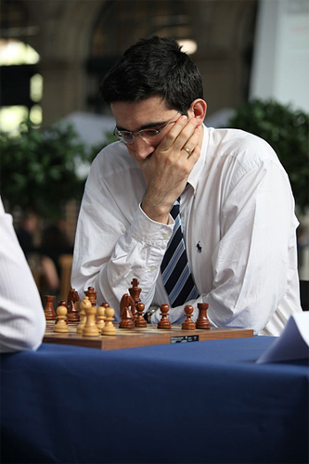
45.g4 Rb3! 46.Kf2 Kg6
47.Ke1 h5! 48.gxh5+(e) Kxh5
49.Kd2 Rh3 50.Rh1 Kg4
51.Kc2 Kxf4 52.Kxb2 f5
53.Kc2 Ke3 54.Kd1 Kf2
55.Re1 Rd3+ 56.Kc2 Rd5!
57.Re8 f4 58.Rh8 f3
59.h4(f) Kg3 60.h5 f2
61.Rg8+ Kf4 White resigns

a) Black would not consider 9…Qxb2 falling
fatally behind in development.
b) If 17.Qxc5+ Qxc5 18.Nxc5 Bxg2 or 17.Nxc5
a5 18.Rxa5 Qxa5 19.Qxa5 Rxa5 20.Bxb7 b4
21.Na6 Ra2 22.0-0 Rxb2 winning.
c) Black is confident he can withstand White’s
pressure and win the ending.
d) If 34.Rcc7 Ne5 35.f4 Ng6.
e) If 48.h3 Rxh3 49.gxh5+ Kxh5 50.Rxb2 Rh1+
51.Kd2 Rh2+ 52.Kc3 Rxb2 53.Kxb2 Kg4. Vladimir Kramnik
f) White is a tempo too late.

SOLUTION: 1 Qg7+!! bxg7 2.hxg7+ Kg8 3.gxf8=Q+ Kxf8 4.Bh6+ (4.Rg8+ also mates)
4…Ke7 5.Rg7+ Kf6 6.Rf7#.

