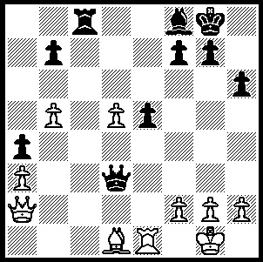
It is believed that serious drinking problems affected
Alekhine’s play in his world championship match in
1935 against Max Euwe which he lost 12.5-13.5.
After reforming his drinking habits he was able to
regain the title from Euwe 15.5-9.5 in 1937. Here is
a position from a game from one of his two successful
world championship matches against Efim Bogoljobov
in which Alekhine blunders away the game. White
played 1.Bxa4? Can you find the move which causes
an immediate White resignation?

265

A contemporary player, like Alekhine a naturalised Frenchman, appears to have even more serious drinking problems. A report on last month’s Kolkata Open in India stated that Vladeslav Tkachiev fell asleep at the board in a drunken stupor. He had arrived very drunk, played a few moves and fell asleep several times during the game. Other players and even the Chief Arbiter tried to wake him but Tkachiev kept nodding off, resting his head on the table. Having only managed eleven moves he lost the game on time and was carried off. Despite his alcohol problems Tkachiev has maintained a high standard of play and won the French championship in August. However he failed to turn up for the final round of last year’s Olympiad and ruined the medal chances of the French team. Here is a short game from the Kolkata event in which the combinative theme of the problem is again seen (the two players are Indian Grandmasters, not the famous Indian batsmen):

S Ganguly - R Laxman
2009 Kolkata Open
Petroff Defence
1.e4 e5 2.Nf3 Nf6
3.Nxe5 d6 4.Nf3 Nxe4
5.d4 d5 6.Bd3 Bd6
7.0-0 0-0 8.c4 c6
9.Re1 Re8 10.Nc3 Nxc3
11.bxc3 Rxe1+ 12.Qxe1 Qe7?(a)
13.Bf4! Be6(b) 14.Bxd6 Qxd6
15.Bxh7+! Kh8(c) 16.Ng5 Black resigns

a) 12...h6 would avoid back row mate problems
b) Not 13...Qxe1+ 14.Rxe1 Bxf4 15.Re8#.
c) 15…Kf8 is better: not 15...Kxh7 16.Qb1+ Kg8 17.Qxb7 & wins.
d) Black loses more material – 16…Nd7 17.Bf5! (17…Bxf5? 18.Nxf7+) 17…Rf8 18.Bxe6 fxe6 19.Qb1 Nf6 20.Qxb7 or 16…Qe7 17.f4 Qf6 18.Qh4 Qh6 19.Qg3 Qf6 (19…Nd7/Na6 20.f5) 20.Re1 Nd7 21.Rxe6! fxe6 22.Qh4 g6 (22…Qh6 23.Nf7+) 23.Qh6 Qg7/Qxf4 24.Nf7+! Qxf7 25.Bxg6+ wins the queen.

Giant Chess Set in Trafalgar Square.
Chess was at the centre of this year's London Design Festival (19 – 23 Sept) with a tournament played in Trafalgar Square on a gigantic chess set with two meter high ceramic chess pieces.The pieces, handcrafted with many references to iconic buildings in London with its domes, towers and spires, rested on a specially created mosaic glass chess board between the two fountains in Trafalgar Square.

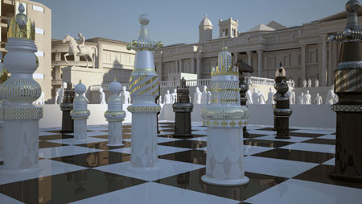

WILLETTON OPEN (event in Yulgibar-Big Think Australian Chess Grand Prix & WA Grand Prix) Sat 10 (12.30 – 7.30) & Sun 11 Oct (11 – 6) at Legacy House, Mill Pt. Rd. / Frasers Lane, S. Perth. Confirm your entry with Haydn Barber (9398 4242 / hadix@vianet.net.au) by Friday 9 October to receive entry discount.

SOLUTION: 1.Bxa4? Qe4!! forking rook & bishop. If 2.Rxe4 Rc1+ 3.Re1 Rxe1#.

