Kasparov – Karpov (World Champ. II 85) Black has just player 1…Rcd8 but resigns 3
moves later when faced with material loss. Can you find Kasparov’s winning moves ?

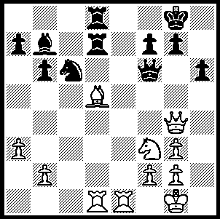
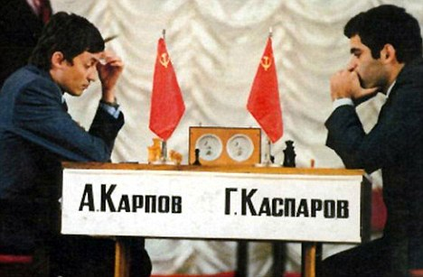
Diagram 270
Karpov – Kasparov 1984

Although Gary Kasparov has retired from competitive chess, he continues to pursue his interest in the game through writing. (He has also recently been coaching teenage star Magnus Carlsen.) His most recent book, Kasparov vs Karpov 1975-85, published by Everyman, has won the 2009 English Chess Federation Book Prize. The book delves into the first two of the five world title matches between Kasparov and Anatoly Karpov, the first the 48 game marathon aborted match, the second Kasparov’s narrow win 13-11. In the words of the three judges, "The book can be read on several levels - as a dramatic story, or as providing insights into opening theory, or as great games enhanced by deep analytical annotations. Kasparov succeeds triumphantly in illuminating every aspect of this historic struggle. He is establishing as formidable a reputation as an author, as he did as a player."

Kasparov recently emerged momentarily from retirement to take on his old foe in an exhibition match in Valencia. Although Karpov is still active he was well beaten with Kasparov victorious in the Rapid-Play 3-1 and 6-1 in Blitz games. Here is one of Karpov’s two wins in the match:

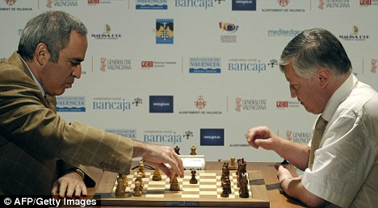
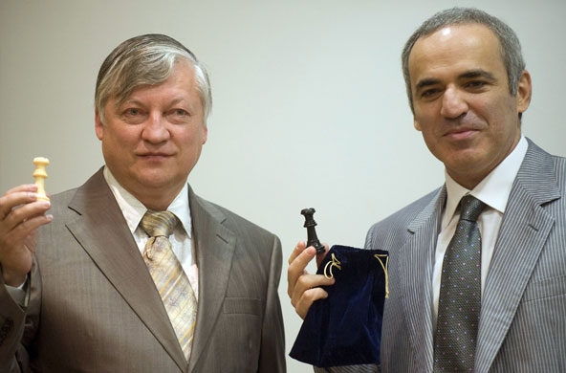

Karpov – Kasparov 2009

A Karpov - G Kasparov
Valencia Exhibition 2009, Rapid-Play
Queens Pawn, Semi-Grunfeld Defence
1.d4 Nf6 2.c4 g6
3.g3 Bg7 4.Bg2 d5
5.cxd5 Nxd5 6.e4 Nb6
7.Ne2 c5 8.d5 e6
9.0-0 0-0 10.Nec3 Na6
11.a4 exd5 12.exd5 Nb4
13.Be3 Bd4 14.a5(a) Bxe3
15.axb6 Bd4 16.bxa7(b) Bf5
17.Na3 Rxa7(c) 18.Ncb5 Rxa3!?
19.Rxa3 Bxb2 20.Re3 Qb6
21.Qe2 Bg7 22.Rd1 Bd7
23.Na3 Bd4 24.Re7 Ba4
25.Rc1 Qf6 26.Rxb7 Bb2(d)
27.Rxc5!! Bxa3 28.h4(e) Nd3
29.Ra5 Nc5 30.Rba7 Qd4(f)
31.Qe3 Qxe3 32.fxe3 Bc1(g)
33.Kf2 Nd3+ 34.Ke2 Bc2
35.d6! Re8(h) 36.Ra8! Black resigns

(a) Not14.Bxd4 cxd4 15.Qxd4? Nc2.
(b) If 16.Rxa7 Rb8 17.Nd2 Qxb6.
(c) If 17...Bd3 White might play 18.Nab5.
(d) If 26...Qxf2+ 27.Qxf2 Bxf2+ 28.Kf1! – not 28.Kxf2? Nd3+.
(e) Providing an escape square for the king but 28.Ra5! Re8 29.Qc4 Re1+ 30.Bf1! leaves White in a winning position.
(f) Not 30...Re8? 31.Ra8!)
(g) 32...Bb4 33.Rxa4 Nxa4 34.Rxa4 Bc5 should draw but Kasparov hopes for more.
(h) Hoping for 36.d7?? Rxe3+ 37.Kf1 Re1#.

Dennis Holland consolidated his lead in the 2009 WA Grand Prix by winning the Willetton Open (10-11 Oct). Prize winners: 1st Dennis Holland (5/6), =2nd Stephanus Kurniawan & Akef Abdat (4.5): Under 1750 Dave Dempster (3.5): Under 1600 Grant Bultman, Bruce Wright & Alex de Heer (3): Under 1200 Bernard Laugery (2.5).

SOLUTION: 1.Qxd7! Rxd7 2.Re8+ Kh7 3.Be4+ resigns (after 3…g6 4.Rxd7 and Black will lose further material).

