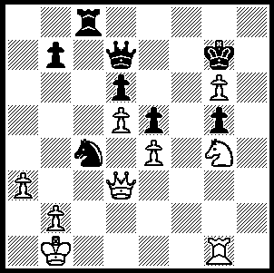
Carlsen –Topalov (Nanjing 2009):
White played 1.Ne3 and, 4 moves
after the exchange of knights, Black
resigned. However 1.Qh3 would
have led to a quicker and more
spectacular finish. Can you see
how (4 moves)?

271

In the 2nd Pearl Spring Tournament, Nanjing, a five player double round robin, Norwegian 19 year old Magnus Carlsen scored an amazing 8/10, 2.5 points clear of Veselin Topalov who is ranked number 1 in world ratings. Carlsen, who received coaching from Gary Kasparov, now joins the exclusive 2800+ group and has his sights firmly set on gaining a crack at the world title against either Viswanathan Anand, the title holder, or against Topalov who is scheduled to challenge for the title in Sofia, Bulgaria, in April next year. Here is a Carlsen win from Pearl Spring:

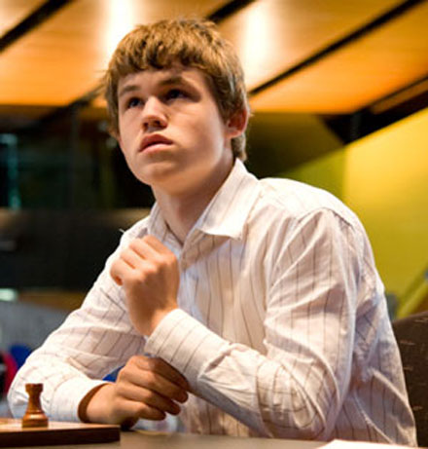
Magnus Carlsen - Teimour Radjabov
2009 Pearl Spring, Nanjing, Rd 5
Sicilian 3.Bb5
1.e4 c5 2.Nf3 Nc6
3.Bb5 e6 4.0-0 Nge7
5.c3 a6 6.Ba4 b5
7.Bc2 Bb7 8.Qe2 d5
9.e5 d4 10.Be4 Qb6(a)
11.d3 Rd8(b) 12.a4! Nd5(c)
13.axb5 axb5 14.cxd4 cxd4
15.Nbd2 Nf4 16.Qd1 Nb4(d)
17.Nb3! Bxe4(e) 18.dxe4 Nfd3
19.Bg5 Rc8(f) 20.Nfxd4 Nxb2(g)
21.Qe2 Nc4 22.Rfc1! Bc5
23.Nxb5! 0-0(h) 24.Nxc5(i) Nxe5
25.Be7 resigns

(a) 10...Nd5 is a good alternative.
(b) Not 11...Ng6 12.h4! driving back the knight as 12…Ngxe5 loses a piece and 12...h5 would be too weakening.
(c) 12...b4 allows White to establish his b1 knight on c4.
(d) Black appears to have seized space and the initiative but his backward development will tell against him.
(e) After 17...Ng6 18.Bg5 Rd7 19.Qe2 the d4 pawn is weak.
(f) 19...Rd7? loses to 20.Ra8+.
(g) If 20...Nxe5 21.Ra5!
(h) If 23...Bxf2+ 24.Qxf2 Qxb5 25.Qe2 0-0 26.Nd4 Qxe5 27.Rxc4 Rxc4 28.Qxc4 Qxg5 29.Qxb4 winning.
(i) An unusual concentration of the four knights: Black loses material in all lines - 24...Rxc5 25.Be7! Rxb5 26.Bxf8 Nxe5 27.Bc5! Qb8 28.Qxb5! or 24...Qxb5 25.Qxc4 Qxc4 26.Rxc4 Nd3 27.Be7.


I recently came belatedly across news that
Australian WIM Arriane Caoili went
undefeated (8/9) in winning the Women’s
World Chess Championship Oceania Zonal
2009 played in the Gold Coast in June. It
was Caoili’s first major success since shunning
competitive chess to concentrate on her studies.
Arriane represented the Philippines in the
Olympiad in Bled, Slovenia, 2002 and Australia
in the Olympiad in Turin, 2006 where she
caught the attention of the world media after it
was reported that British GM Danny Gormally
punched Armenian GM Levon Aronian in a
nightclub at the Olympiad wind-up for dancing
with Arriane. This fame led to her being invited
to compete in ‘Dancing with the Stars’ where
she was runner-up.

SOLUTION: 1.Qh3 Rh8 (hopeless is 1…Kxg6 2.Qh6+ Kf7 3.Rf1+) 2.Qxh8+! Kxh8 3.Rh1+ and Black succumbs either to a skewer (3…Kg7 4.Rh7+) or a fork (3…Kf8 4.Nf6+) and White is a rook up.

