SIMON WINAWER

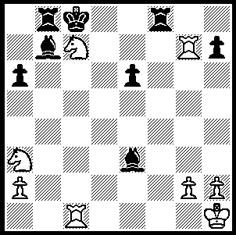
In our Alphabet Series W is for WINAWER.
Simon Winawer was born in Warsaw, Poland,
in 1838. He was an unknown visitor to the
Paris Exhibition in 1867 when, on a whim,
he entered an international tournament held
during the festivities. To everyone’s surprise,
including his own, he came 2nd= with Steinitz,
thus beginning a series of excellent results: 1st=
with Zukertort, Paris 1868, 1st= with Steinitz,
Vienna 1882 (Steinitz & Zukertort were
recognised as the world’s top two players and
contested the first official world championship White wins quickly in
match in 1886). He performed badly at London Winawer – Chigorin 1875
1883 and decided to retire but on his way back
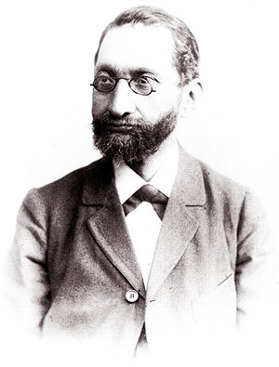
to Vienna he stopped at Nuremberg for urgent
dental treatment and was persuaded to compete
in a tournament there, coming 1st ahead of
Blackburne. He was clearly one of the best 15
players in the world but was soon overtaken by
a group of younger players. He died in 1920
leaving a legacy of important opening lines
named after him, the Winawer Attack against
the Berlin Defence to the Ruy Lopez, the
Winawer Counter Gambit in the Slav Queens
Gambit (1.d4 d5 2.c4 c6 3.Nc3 e5) and, of most
importance, the Winawer Variation in the French
Defence (1.e4 e6 2.d4 d5 3.Nc3 Bb4), the
mainstay of world champion Mikhail Botvinnik
for much of his career. It seems appropriate to
show a Winawer victory using his defence: Simon Winawer

Mikhail Chigorin(a) - Simon Winawer
London 1883
French Winawer Exchange

1.e4 e6 2.d4 d5
3. Nc3 Bb4 4.exd(b) exd
5.Nf3 Bg4 6.Be2 Nf6
7.0-0 Bxf3 8.Bxf3 0-0
9.Bg5 c6 10.Qd3 Bd6
11.Ne2 Nbd7 12.Ng3 Qc7
13.Kh1 Bxg3(c) 14.fxg3 Rfe8
15.b3(d) Re6 16.Bf4 Qa5
17.g4 h6 18.g5 hxg
19.Bxg5 Rae8 20.a4 Ne4
21.Bf4 Ndf6 22.g4 g5!
23.Be5 Qd2 24.Bg2? Nf2+!
25.Rxf2 Qxf2 26.Rf1 Nxg4!(f)
27.Bh3 Rxe5! 28.Bxg4(g) Re1
29.Bh3 Rxf1+ 30.Bxf1 Re1
White resigns

a) Tchigorin twice challenged Steinitz for the world title and led in the second match 10 wins to 8 before a rally by Steinitz enabled him to retain his title.
b) This exchange, rather than the almost universal 4.e5, presents Black with little difficulty, although Larsen attempted with some success to infuse some bite into the variation with 5.Qf3.
c) Black intends to show his knights are superior to White’s bishops. He will gain a knight outpost on e4 backed up by doubled rooks on the e file, while White will attempt to open up the kingside and attack the king.
d) The b pawn is no longer unprotected and c4 is now a possibility but c3 becomes weak.
e) White sets a trap expecting to win the knight on f6. 24.Bxe4 Nxe4 25.Qxd2 Nxd2 would leave Black with a positional advantage.
f) The trapper is trapped - 27.Rxf2 Nxf2+ forks king & queen.
g) 28.dxe5?? Qxh2#

SOLUTION: 1.Nxe6+ Bxc1 Rc7#.

