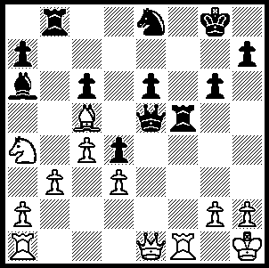
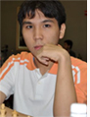

277

Wesley So (v Kanmazalp 2004)
then 11, wins a piece in 5 moves. Wesley So , now 16,
sensational at the World Cup.

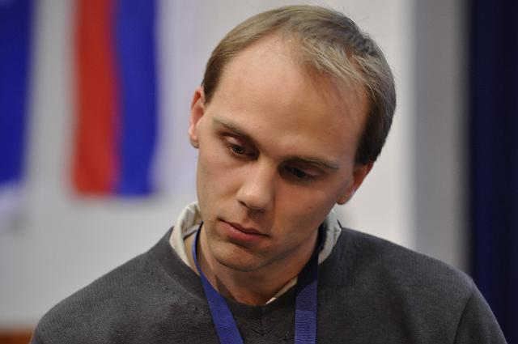
The main centre of interest for chess enthusiasts
at present is the FIDE World Cup being played
in Siberia (20 Nov – 15 Dec) with the winner
qualifying for the next World Championship
Candidates Tournament. This seven round Knock
Out event with 128 players is a real test of ability
and nerve with each round comprising two games
with a classic time limit, followed by four games
of Rapid Play (25 min + 10 sec) if the scores are
level, followed by pairs of Blitz (5 min + 3 sec) if
necessary. In the first round one match finished 9-7
with all games from 5 to 16 being decisive. Australia’s Australia’s David Smerdon
entrant GM David Smerdon was eliminated in Round 1
when he lost the fourth Rapid Play after five draws.

The sensation of the event was 16 year old Philippines youngster Wesley So who reached Round 4, the last 16. He defeated two of the world’s top players along the way, beating Vassily Ivanchuk (Ukraine) in Round 2 & Gata Kamsky (USA) in Round 3. Here is one of his Rapid Play wins from Round 1:

White Gadir Guseinov (Azerbaijan)
Black Wesley So (Philippines)
2009 World Cup, Rd 1
Sicilian, Scheveningen Variation

1.e4 c5 2.Nf3 e6
3.d4 cxd4 4.Nxd4 Nc6
5.Nc3 Qc7 6.g3 Nf6
7.Bg2 a6 8.0–0 Be7
9.Be3 0–0 10.f4 d6
11.Kh1 Bd7 12.Nb3 b5
13.a3 b4 14.axb4 Nxb4
15.g4 h6 16.Nd4 Rab8
17.h4(a) h5! 18.gxh5(b) Rfc8
19.Bf3(c) e5! 20.fxe5(d) dxe5
21.Nf5(e) Bxf5 22.exf5 e4!
23.Bg2(f) Qg3 24.Bf2 Qe5(g)
25.Bg1 Bd6 26.Rc1 Rc4(h)
27.Qe2 Rbc8 28.Qe3(i) Nxh5
29.Ne2 Rxc2 30.Rxc2 Rxc2
31.Qg5(j) Rxe2 32.Qxh5 Rxg2!
White resigns (k)

a) White pawns look very threatening but the attack soon passes to Black who counters brilliantly.
b) 18.g5 allows 18…Ng4.
c) 19.h6! would open lines against Black’s king (19...g6? 20.f5).
d) 20.Nb3 is strongly met by the 20...d5! (21.exd e4!).
e) On 21.Nde2 Black has 21...Ng4. Better was 21.Nb3 Be6 22.Rg1!
f) Not 23.Nxe4? Nxc2.
g) Black plans a queen/bishop battery targeting h2. White now rejects a possible repetition 25.Bd4 Qg3 26.Bf2 as a draw would lose the match.
h) The rook eyes h4.
i) White has no good move.
j) Black threatened 31…Rxe2 32.Qxe2 Ng3+ winning the queen.
k) 33.Kxg2 Qg3+ 34.Kh1 Qh3+ 35.Bh2 Qxh2#.

SOLUTION: 1.Qxe5 Rxe5 2.Rf8+ Kg7 3.Rxe8! Rxe8 4.Bxd4 / 5.Bxe5.

