WORLD CUP (conclusion)
Top rated player Boris Gelfand (Israel) defeated Ruslan Ponamariov (Ukraine) in a long and intriguing final in the 2009 World Cup held in Siberia. All four classic games were drawn, the four Rapid Play games resulted in a win apiece and two draws and the Blitz games were won 3-1 by Gelfand giving him a 7-5 victory.

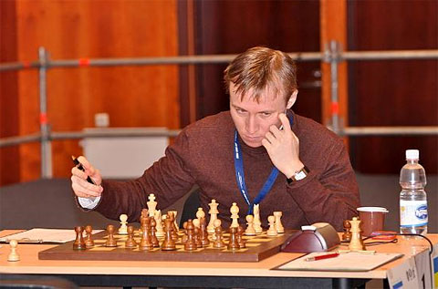
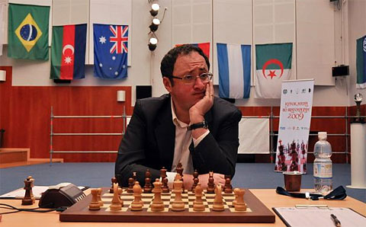

Boris Gelfand Ruslan Ponomariov

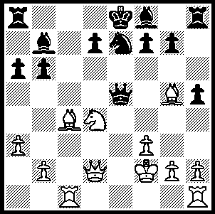
Here is a decisive position from the first Blitz
game, the only short game of the match.
Ponamariov’s position is most unpleasant and
after 17…f6 he resigns after another four moves.
Can you see why? (Game moves: 1.d4 e6 2.c4 c5
3.Nf3 cxd 4.Nxd4 a6 5.Nc3 Qc7 6.e4 - the game
has transposed into a Sicilian Maroczy Bind –
6…Nf6 7.a3 b6 8.Be3 Bb7 9.f3 Nc6 10.Rc1 h5 –
10…Rc8 is more logical- 11.Nd5! exd5 12.cxd5
Nxd5? - the open lines will put Black’s king in
danger - 13.exd5 Qe5 14.Kf2 Ne7 15.Qd2 Nxd5
16.Bg5 Ne7 17.Bc4 f6) 278

One of Gelfand’s victims was Judit Polgar who has failed to regain her former ranking since returning to competitive chess after an extended lay-off following the birth of her second child. However she did beat Gelfand in the second of their Round 3 games before going down 1.5 – 3.5.

Judit Polgar - Boris Gelfand
2009 World Cup Round 3, Game 2
Bishops Opening
1.e4 e5 2.Bc4 Nf6
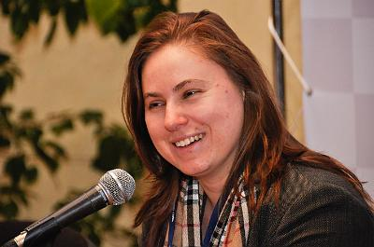
3.d3 c6 4.Qe2 Be7
5.Nf3 0-0 6.Bb3 d6
7.0-0 Nbd7 8.c3 a5
9.a4 b5 10.Bc2 Ba6
11.axb5 cxb5 12.Nbd2 Qc7
13.d4 a4 14.Bd3 Rfb8
15.Nh4 g6 16.f4 exf4
17.Ndf3 Nh5 18.Bd2 Nb6
19.g4!?(a) fxg3 20.Ng5 Nc4(b)
21.Nf5!?(c) Bxg5 22.Bxg5 f6
23.Bh4 gxh2+?(d) 24.Qxh2 Rf8 Judit Polgar being interviewed
25.Be2 gxf5 26.Bxh5 fxe4 at the World Cup
27.Qf4(e) f5 28.Kh1 Kh8
29.Rg1 Rf7(f) 30.Bxf7 Qxf7
31.Qh6 Rf8 32.Rg6! resigns(g)

a) Needing a win Polgar creates intense complications.
b) If 20...Bxg5 Black will be weak on the black squares around his king.
c) Not 21.Rxf7 gxh2+ 22.Kxh2 Nxd2 23.Qxd2 Bxg5!
d) 23...gxf5 24.Qxh5 Qf7 might enable Black to defend.
e) Not 27.Bxf6 - 27…Rxf6! 28.Rxf6 Qg7+ forcing 29.Qg2 when Black reaches an ending with knight & 2 pawns for a rook.
f) White was threatening 29.Qh6 / 30.Bf6+.
g) 32…Qxg6 33.Qxf8+ Qg8 34.Bf6+.

The 2010 Australian Championship will take place in Sydney Jan 2 – 13. Details and entry forms for the tournaments, Australian Championship, Major (Under 2150), Minor (Under 1600) and Norths Chess classic (2-9 Jan), are available on the CAWA website.

SOLUTION: 18.Bf4 Qa5 (18…Qc5 suffers the same fate after 19.Be6! – better than 19.Bf7+ - 19…Qa5 20.b4) 19.b4 Qa4 20.Bb3 Qxa3 21.Ra1 resigns

