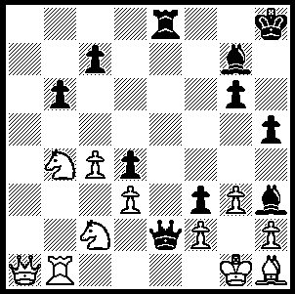

Berzinsh – Hennigan

(London Classic Open 2009):

Black mates in 4 moves:

279

The annual Hastings Chess Congress, held at the English south coast resort and traditionally played after Christmas, is the longest running Tournament in the world and over the years has attracted many of the world’s top players. However the British chess public was treated to an even greater attraction last month, the London Classic. In the main event the four strongest British players competed with four of the world’s strongest GMs. In a format that gave 3 points for a win and one point for a draw the winner was Norwegian teenager Magnus Carlsen, now the world’s top rated player, with 13 points (+3 =4 ), with ex-world champion Vladimir Kramnik second on 12 points (+3 =3 -1). Young British champion David Howell had an outstanding tournament winning one and drawing 6 to score 9 points. Other scores: Michael Adams 9 pts, Luke McShane 7 pts, three times Chinese champion Ni Hua 6 pts, US champion Hikura Nakamura 6 pts, Nigel Short 5 pts. Here is the game that gained the winner 10,000 € for the best played game of the event. An innovative exchange sacrifice leads to an ending where very accurate play is needed with bishop against rook to exploit his pawn superiority:


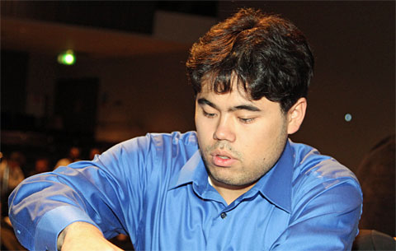

Hikura Nakamura and Luke McShane in play at the London Classic.

H Nakamura - L McShane
London Chess Classic, Rd 5
Kings Indian Classical
1.d4 Nf6 2.c4 g6
3.Nc3 Bg7 4.e4 d6
5.Be2 0-0 6.Nf3 e5
7.0-0 Na6 8.Be3 Ng4
9.Bg5 Qe8 10.c5(a) exd4
11.Nd5 Be6(b) 12.Be7 Bxd5
13.Bxf8 Qxf8 14.exd5 dxc5
15.Qb3 Rb8 16.Rfe1 Qd6
17.h3 Nf6 18.Bxa6 Qxa6
19.Rac1 Bf8 20.Ne5 Qb6
21.Qf3(c) Qd6 22.g4 Bh6
23.Rc2 Re8 24.Rce2 Rf8(d)
25.Nc4 Qxd5 26.Qxf6 Bg7!
27.Qh4 Qxc4 28.Re8 Qd5
29.Rxf8+ Bxf8 30.Re8 Kg7
31.g5 Qd6 32.Kf1(e) b5
33.Ke1 c4 34.Qe4 c5
35.h4 c3 36.bxc3 dxc3
37.Qe5+ Qxe5+ 38.Rxe5 a5
39.Kd1 a4 40.a3 b4
41.Kc2 h6! 42.Rd5?(f) hxg5
43.hxg5 Kh7! 44.Rd7 Bg7
45.Rxf7 b3+ 46.Kb1 Kg8
47.Ra7 Bd4 48.Rxa4 Kf7(g)
49.Ra6 Be5 50.Ra4(h) Ke6
51.Rh4 Kd5 52.a4 c4
53.Rh1 c2+ 54.Kc1 c3
55.Rh4 Bd6 White resigns

a) A sharp line attempting to exploit the blocked-in rook on f8 and the absence of a Black knight on f6.
b) Rather than safer moves such as 11…c6 or …f6, Black plays a speculative exchange sacrifice gaining a threatening central pawn mass in compensation.
c) 21.d6 Qxb3 22.dxc7 Rc8 23.axb3 would not worry Black.
d) White threatened 25.Nxf7!
e) The White king will attempt to block the Black pawns.
f) White should try to attack the a pawn with 42.Re8 hxg5 43.hxg5 Bd6 44.Ra8 which leaves Black’s unable to promote - eg 44…b3+ 45.Kxc3 Be5+ 46.Kd2 c4 47.Rxa4 c3+ 48.Kc1 Bd6 49.Kb1 c2+ 50.Kb2 Be5+ 51.Kc1 Bd6 52.Kb2= or 52.f4 f6=.
g) Not 48…Bxf2 49.Re4 and the a pawn becomes threatening.
h) 50.Rc6 c2+ 51.Kc1 Bf4+.

SOLUTION: 1…Qxf2+!! 2.Kxf2 Re2+ 3.Kxf3 (3.Kg1 f2#) 3…Bg4+ 4.Kf4 Bh6#.

