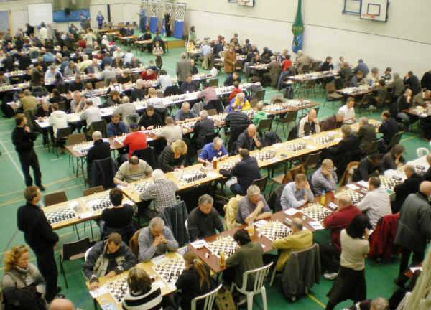
The Hastings Chess Congress,
played traditionally after Christmas
at the English south coast resort, has
been held on a regular basis since
1920 although strong tournaments
had taken place in 1895 (won by
Pillsbury ahead of Chigorin, Lasker,
Tarrasch et alia) and 1919 (won by
Capablanca). The main event in the
2009-10 Congress, the Hastings
Masters with 94 players, resulted
in a four way tie for first place.
In the final round leaders Mark
Hebdon (England) and Andrei
Istratescu (Romania) agreed a draw
in 11 moves leaving a number of Play at Hastings 2009-2100
players able to equal their score of
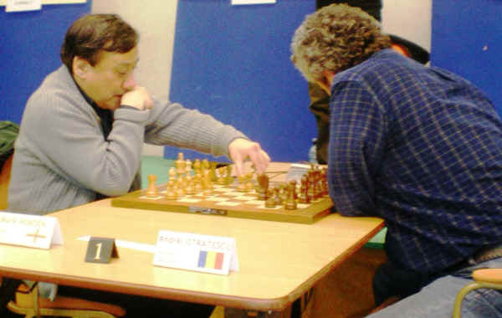
7/9. Two players were successful,
Romain Edouard (France) and young
British champion David Howell.

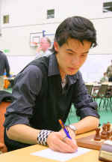

Hebden (left) v Istratescu

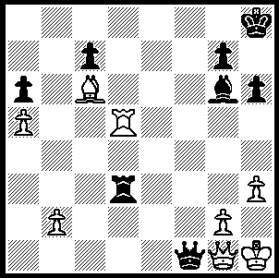

David Howell

Here is the position from Howell’s
final game (he is Black) where he
gains a winning advantage. Can you
see how (8 moves - Black’s 5th
move is the most difficult to find)? 281

The Brilliancy Prize went to Simon Williams for the following game. Judge Steve Giddins remarked, “ In all honesty I have had no time in which to establish whether it is fully sound, but my reasoning is that if it is, it certainly deserves the prize, and arguably it does so, even if not!”

Simon Williams - Andrew Green
2009-10 Hastings Masters
Kings Indian, Four Pawn Attack
1.f4 g6 2.Nf3 Bg7
3.c4 d6 4.d4 Nf6
5.Nc3 0-0 6.e4 c5
7.d5 e6 8.e5 dxe5
9.fxe5 Ng4 10.Bg5 Qa5
11.Be2 Nxe5 12.Nxe5 Bxe5
13.0-0 f6(a) 14.Bh6 Rf7
15.Ne4 Bd4+ 16.Qxd4`!!(b) cxd4
17.Nxf6+ Kh8(c) 18.Ne8 Rf5
19.g4 exd5(d) 20.gxf5 Bxf5
21.Bf3 dxc4(e) 22.Bxb7 Qb5
23.Nd6 Qb6 24.Rae1 d3+
25.Kh1 Nd7 26.Bxa8 Nf6
27.Nxf5 gxf5 28.Rxf5 resigns(f)

a) White’s pawn sacrifice has given him attacking chances based on superior development and threats to place his knight on f6 which this move seeks to nullify.
b) An amazing queen sacrifice. White will bring more pieces into the attack on Black’s king giving Black no time to unravel his undeveloped queenside.
c) The attempt to return material to stave off the attack by 17…Rxf6 18.Rxf6 Qd8 19.Raf1 Nd7 loses to 20.Rf7 exd (20…Qe8 21.dxe Qxe6 22.Rf8+) 21.Bg4 with an overwhelming attack.
d) 19…Rxf1+ 20.Rxf1 Nd7 21.dxe.
e) White threatened 22.Bxd5 / 23.Bg7#.
f) It’s mate after 28.Kg8 29.Bd5+! Kh8 30.Re8+! and if 28…Qd8 29.Bf3 d2 30.Rg1.

AUSTRALIAN CHAMPIONSHIP (Sydney): After 8 rounds joint leaders are Zong Yuan Zhao and George Xie (both NSW) with 7/8. In the Major Tim Hare is 6th= with 6.5/8 while Dick Lilly has 4.5.

SOLUTION: 1…Rxh3+!! 2.gxh3 Qxh3+ 3.Qh2 Qf1+ 4.Qg1 Be4+ 5.Kh2 Qe2+! 6.Kh3 Bxd5 7.Bxd5 Qh5+ 8.Kg3 Qxd5 & win

