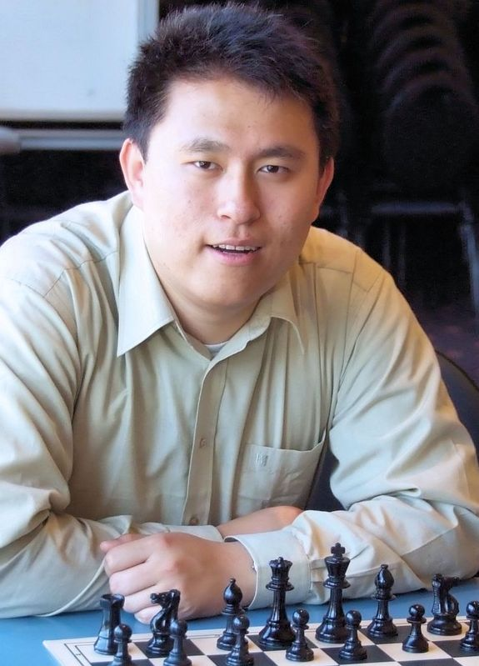
The 2100 AUSTRALIAN CHAMPIONSHIP
played recently in Sydney was won by Zhao,
Zong-Yuan. Zhao, who was 2009 Player of the
Year, conceded only 2 draws in his eleven games
and in scoring 10/11 equalled Darryl Johansen’s
record for the highest score since the champion-
ship has been run with eleven rounds. He was
pressed all the way by George Xie who lost his
final game to defending champion Stephen Solomon.
Scores: 1st Zhao 10/11, 2nd X ie 9, 3rd Gawain Jones
(UK) 7.5, 4th Darryl Johansen 7, =5th Stephen Solomon
6.5. Among the 28 competitors were a number of most
promising teenagers and the position and game
extract feature two of these youngsters.

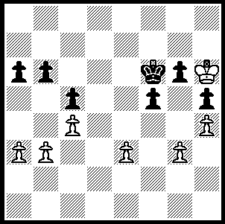

After declining three draw offers Malcolm
Pyke made one last effort to gain from
his aggressive king position with 1.b4.
Thirteen year old Laurence Matheson
took advantage of this error to gain a
surprise win (6 moves). Can you see how?

282

Defending champion Stephen Solomon had a long and exciting game against 14 year old Yi Yuan:

Stephen Solomon - Yi Yuan
2009-2100 Australian Championship, Rd 6
Scotch Game
1.e4 e5 2.Nf3 Nc6
3.d4 exd 4.Nxd4 Bb4+
5.c3 Bc5 6.Be3 Bb6
7.Nd2 Nge7 8.Be2 0-0
9.0-0 f5 10.Nxf5 Nxf5
11.Bxb6 axb6 12.exf5 Rxf5
13.Bd3 Rf6 14.Ne4 Rh6
15.Bc4+ Kh8 16.f4 Qh4
17.h3 d5? 18.Bxd5 Bxh3?(a)
19.Ng5 Be6 20.Nxe6 Ne7
21.Qd4 Nf5 22.Qe5 Qh2+
23.Kf2 Qg3+ 24.Ke2 Rf6
25.Rad1?(b) c6 26.Rd3 Qg4
27.Bf3 Qg6 28.Rfd1(c) Rfxe6
29.Rd8+ Re8 30.Rxa8 Rxa8

Position after 30…Rxa8 31.g4?!!(d) Re8 32.gxf5 Rxe5+
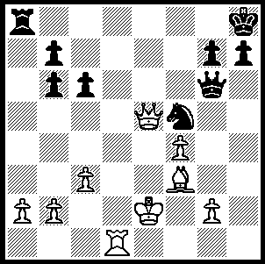
33.fxe5 Qe8 34.Kf2 g6
35.f6 h5 36.Re1 Qe6
37.Re3 b5 38.Bd1(e) c5
39.b3 c4 40.bxc bxc
41.a4 Kg8 42.Bf3 b6
43.Re4 Kf8 44.Be2 Qf5+
45.Ke3 Qg5+ 46.Kd4 h4
47.Bg4 Qd2+ 48.Kxc4 Qg2
49.Kd5 Qd2+ 50.Rd4 Qxc3
51.e6 Qc5+ 52.Ke4 Qc2+
53.Rd3 Qc4+ 54.Ke3 Qc1+
55.Kf3 Qf1+ 56.Ke4 Qh1+
57.Kf4 Qf1+ 58.Rf3 Qc1+
59.Re3?! g5+! 60.Ke4 Qc4+
61.Kf5!!(f) Qf4+ 62.Kg6 Qxe3
63.e7+ Ke8 64.Bh5 Kd7!(g)
65.Bg4+ Ke8 66.Kg7 Qxe7
67.fxe7 Kxe7 68.Kg6 Kd6
69.Kxg5 b5! 70.a4(h) Kc5
71.Kxh4 b4 72.Be2 b3
73.Kg3 b2 74.Bd3 b1=Q
75.Bxb1 Kb5 76.Kf4 Draw

a) This loses a piece but Black is subsequently able to gain some counterplay against White’s king.
b) 25.Nxc7 would leave Black with little compensation for the piece.
c) If 28.Rd8+ Rxd8 29.Nxd8 Rf8 wins back the piece (30.Qc7 Qe8+ or 30.Nxb7? Re8).
d) An audacious queen sacrifice to gain an advanced protected passed pawn.
e) White will attempt to drive the Black queen from the blockading square on e6.
f) White’s attempts to avoid the checks have led to the loss of a piece. He surrenders his rook so the bishop will be able to control the queening square e8 and the king will be able to assist in the promotion.
g) 64…Qxe7 loses to 65.Kxg5+ Qf7 66.Kxh4!
h) 70.axb Kc5 71.Bd7 h3=.

In the Major (95 entrants) WA’s Tim Hare came =7th with 7.5/11. Tim lost his last game when a win would have put him in second place.

SOLUTION: 1…cxb! 2.axb Ke3! (Black can abandon his kingside pawns to cover the advance on the queenside while being able to queen on the a file: not 2…a5 3.c5 bxc 4.bxa wins) 3.Kxg6 a5 4.c5 a4 (or 4…axb) 5.cxb Kd6 & wins.

