At the World Teams Championship played in Turkey
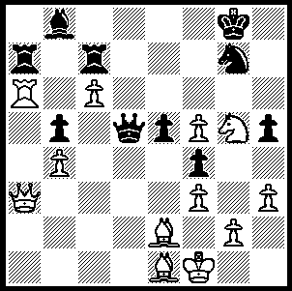
(Jan 5-13) Hikaru Nakamura (USA) was in sparkling
form. He finished with top score for Board 1 (6/8) and
after 6 games had scored 5.5/6. Included in his wins
was a fierce sacrificial kingside attack against world
number 6 Boris Gelfand (Israel) with the Kings Indian
Defence (at one moment he could have been two queens
down!). However his unbeaten run came to an end in
the penultimate round against world Olympiad champions
Armenia where in another main line Kings Indian Levon
Aronian produced what must have been the most
sensational move of the tournament. Nakamura had just
played …Ng7. Can you see how White took advantage
of this move (7-9 moves)? 284 Aronian - Nakamura

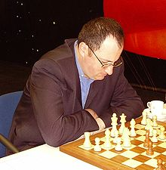
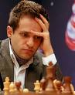
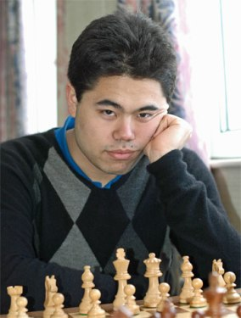

Levon Aronian Boris Gelfand

USA led after 7 rounds but the loss to Armenia allowed Russia, who had lost to Greece and drawn
with Armenia, to take over top spot. Top scores:
Russia 15/18 (24/36 game points), USA 13 (22.5).
India 13 (21), Azerbaijan 12(22), Armenia 12 (20.5).
Ten teams competed with 4 boards played each match.
Hikaru Nakamura

Boris Gelfand - Hikaru Nakamura
2100 World Teams Championship
Kings Indian: Classic Variation
1.d4 Nf6 2.c4 g6
3.Nc3 Bg7 4.e4 d6
5.Nf3 0-0 6.Be2 e5
7.0-0 Nc6 8.d5 Ne7
9.Nd2 Ne8 10.b4 f5
11.c5 Nf6 12.f3 f4
13.Nc4 g5 14.a4 Ng6
15.Ba3 Rf7 16.b5 dxc5
17.Bxc5 h5 18.a5 g4
19.b6 g3 20.Kh1 Bf8
21.d6(a) axb6 22.Bg1(b) Nh4
23.Re1(c) Nxg2!! 24.dxc7(d) Nxe1!!
25.Qxe1(e) g2+! 26.Kxg2 Rg7+
27.Kh1 Bh3! 28.Bf1 Qd3!
29.Nxe5 Bxf1 30.Qxf1 Qxc3
31.Rc1 Qxe5 32.c8=Q Rxc8
33.Rxc8 Qe6 White resigns

a) If 21. Bxf8 Nxe4 22.Nxe4 Qh4 wins.
b) 22.axb6 Rxa1 23.Qxa1 cxd6 24.Rd1 Rd7.
c) 23.dxc7 Bh3!! 24.gxh3 g2#.
d) If 24.Kxg2 Rg7 with a winning attack.
e) Of course if 25.cxd8=Q g2# while if 25.hxg3 Qxd1 26.Rxd1 Nxf3 27.Nxb6 Rxc7 28.Nxa8 Rxc3 wins material.

SOLUTION: 1.Rb6!!! If now 1…Rxa3 2.Rxb8+ Ne8 3.Rxe8+ Kg7 4.Ne6+ Kh7 (4…Kf7 5.Rf8+! Ke7 6.Bh4+ Kd6 7.Rd8+ Kxc6 8.Rxd5 Kxd5 9.Nxc7+) 5.Nxc7 Qxc6 6.Re7+ Kh8 7.Bxb5 and with 3 minor pieces and a threatening passed pawn White is in a winning position (although he will have to watch for Q/R threats on the back rank). Black actually played 1…Nxf5 giving up a piece to 2.Rxb8+ but soon resigned.

