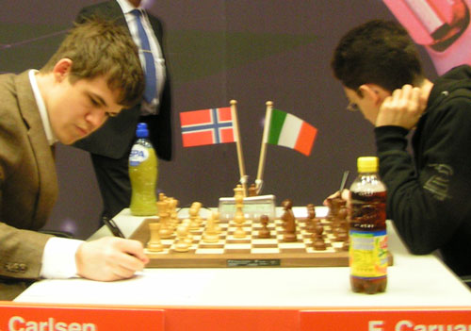
The 14 player 72nd Corus Wijk aan Zee, Netherlands, event (15 -30 Jan) came down to a final round with four players, world number 1 Magnus Carlsen (Norway), former world champion Vladimir Kramnik (Russia), Alexei Shirov (Spain) and world champion Viswanathan Anand (India), all in contention for first place. The brilliant attacking Shirov had set the early pace winning his first five games. After defeating Carlsen in Round 9 Kramnik joined Shirov in the lead and took over sole lead in Round 10 when Shirov lost to Anand. Carlsen took over the lead in Round 12 when Kramnik lost to Anand leaving scores before the final round: Carlsen 8, Kramnik & Shirov 7.5, Anand 7. The final round key games could hardly have been more
contrasting with Kramnik drawing quickly with
Sergey Karjakin (Ukraine), Shirov sacrifing brilliantly
for a winning attack only to agree to a draw with two
seconds left on his clock against Leiner Dominguez
Perez (Cuba), Anand with rook and 2 pawns for bishop
and knight unable to advance his pawns against Loek
van Wely (Neth.) and Carlsen struggling successfully
to hold an ending a pawn down against fellow teenager
Fabiano Caruana (Italy). Final leading scores: Carlsen
8.5/13, Kramnik & Shirov 8, Anand & Nakamura 7.5.

Rd 13: Carlsen - Caruana

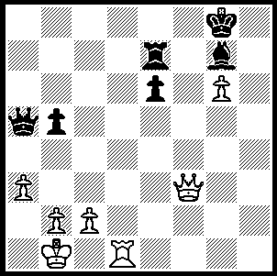
Here is the final agreed drawn position from
Shirov – Dominguez Perez,White to play.
Can you find the win (3 moves)?


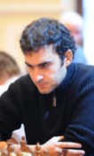

285

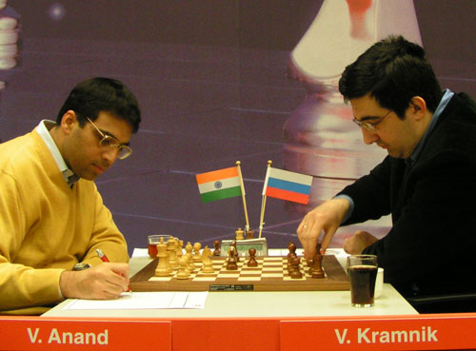

Alexei Shirov Leiner Dominguez Perez

ViswanathanAnand - Vladimir Kramnik
2100 Corus A Wijk aan Zee, Rd 12
Petroff Defence, Main Line
1.e4 e5 2.Nf3 Nf6
3.Nxe5 d6 4.Nf3 Nxe4
5.d4 d5 6.Bd3 Nc6
7.0-0 Be7 8.c4 Nb4
9.Be2 0-0 10.Nc3 Bf5
11.a3 Nxc3 12.bxc3 Nc6
13.Re1 Re8 14.cxd5 Qxd5
15.Bf4 Rac8 16.h3 Be4
17.Qc1(a) Na5 18.Qe3 Bf8
19.c4 Qd8(b) 20.Ne5 Bf5
21.Qc3 b6 22.Rad1 Qf6
23.Qg3 Nc6 24.Ng4 Qg6
25.d5 Na5 26.Bxc7 Bc2(c)
27.Rc1 Nb3 28.Rxc2! Qxc2
29.Nh6+ Kh8 30.Nxf7+ Kg8
31.Nh6+ Kh8 32.Nf7+ Kg8
33.Nh6+(d) Kh8 34.Be5 Qg6
35.Bg4(e) Rxc4(f) 36.Qxb3 Rxe5
37.Rxe5 Rc1+ 38.Kh2 Bd6
39.f4 Bxe5 40.fxe5 gxh6(g)
41.Qe3 Qb1 42.d6 Rh1+
43.Kg3 Re1 44.Qf4 Rf1
45.Bf3 resigns

a) Anand played this a move earlier and won against Kramnik at Sofia 2005.
b) Black cannot take the pawn 19...Nxc4 20.Bxc4 Qxc4 21.Nd2 Qa4 (21...Qc6 22.Nxe4 f5 23.Qb3+) 22.Nxe4 f5 23.Nc3!
c) 26...Bc5 was a lot stronger, eg 27.Bf4 h5 28.Ne3 Qxg3 29.Bxg3 Bxe3 30.fxe3 Rxe3.
d) The knight has checked three times on h6, but the first time there was a pawn on f7. It took awhile for Kramnik to realize that he could not claim a draw.
e) If 35.Qxg6 hxg6 36.d6 Rxe5 37.Nf7+ Kg8 38.d7 Ree8 39.dxc8=Q Rxc8 and Black can still fight.
f) Losing quickly: 35...Rcd8 36.Nf5 Nc5 with some hope.
g) If 40...Qxh6 41.Qf3.

SOLUTION: Black’s queen is defending against back rank attacks from rook and queen. 1.b4! attacking the overworked queen will win – 1…Qb6/c7 (1…Qa2 2.Rd8+) 2.Qa8+ Bf8 3.Rf1.

