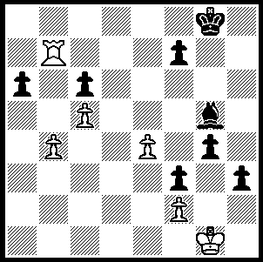

This week is about the power of pawns and
their lust to advance and promote. Firstly
Berger – Charousek 1892 where White’s rook
is eating up Black’s queenside pawns and his
king has just moved to g1 to prevent the
queening of Black’s one passed pawn.
How now can Black win?

288

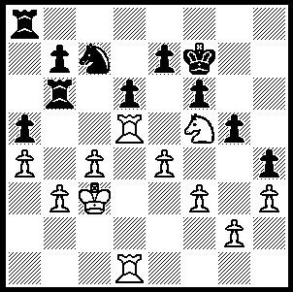

And now a wonderful ending from last
year’s Russian Championship, Timofeev –
Khismatullin, Russian Championships 2009,
Rd 5, Sicilian 3.Bb5+ Bd7. Queens were
exchanged on move 19 and there ensued
20 moves of boring manoeuvring to reach
this position:

287

Position after 39…Nc7
40.Rb5!!(a) Nxb5+ 41.axb5 Ke8
42.Ra1 e6 43.Ne3 d5(b)
44.exd5 Rd6 45.c5 Rdd8
46.Kd4 Rac8 47.Rxa5 e5+
48.Kc4 b6(c) 49.b4!! bxa5
50.bxa5 Ra8 51.a6 e4(d)
52.fxe4 Kd7 53.Nf5 Re8
54.c6+ Kd8 55.Nd6 Re7
56.Kc5 f5 57.exf5 Re2
58.Nb7+ Ke8 59.d6 Rxg2
60.d7+ Ke7 61.f6+ Kxf6
62.c7 resigns

a) This sacrifice leaves Black with an imprisoned rook on b6. If Black plays 40…Rxb5 41.cxb5 leaves White with a winning queenside majority (41…Rc8 42.Kb2 Ne6? – 42…Ne8 is better - 43 Rxd6!).
b) A necessary pawn sacrifice in view of the threat of K moves/Ra4/b4/bxa.
c) Seemingly obtaining counterplay.
d) Attempting to open the position up for his rooks.

This year the CAWA is introducing a Lightning (5 min) Grand Prix with the first of three events planned for tomorrow, February 13, 11.45 am at Legacy House, Mill Pt. Rd. / Frasers Lane, S. Perth, the 2100 Valentines Day Lightning Tournament.
The WA Junior Lightning Championship will also be played there tomorrow (1pm – 4.30pm). Entries for this should be submitted today (Haydn Barber 9398 4242).

The first regular Grand Prix event, the Kingsley Open, will take place at Legacy House on Sat.20 & Sun. 21 February. Enquiries Haydn Barber 9398 4242, hadix@vianet.au

SOLUTION: 1…Be3! 2.fxe3 (2.Rd7 g3 wins) 2…g3 3.Rd7 f2+ 4.Kf1 h2 White resigns.

