The recently concluded 27th annual Linares tournament was scaled back this year with two fewer players and all the games played in Spain. Neither of the top two players from 2009, Anand and Carlsen, was playing but the tournament produced an exciting finish. In the penultimate round Russian champion Alexander Grischuk defeated Veselin Topalov to draw level with the Romanian.

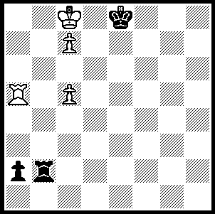
After drawing with Spaniard Francisco
Vallejo in the final round Grischuk could
only watch as Topalov tried to squeeze a
win with rook each and 4 queenside pawns
(including doubled c pawns) against Israeli
Boris Gelfand’s rook and 3 queenside pawns.
With Gelfand’s king cut off on the e file there
was always a chance and the following position
was reached. Can you see Topalov’s (White)
next move?
292

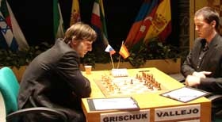
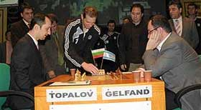

Today’s game is a bizarre encounter between Vallejo and Gelfand in which Black is forced into sacrificing his queen for a rook and a couple of pawns but succeeds in holding the game:

Boris Gelfand – Francisco Vallejo
Linares 2010, Rd 3
Queens Gambit, Slav Defence

1.d4 d5 2.c4 c6
3.Nc3 dxc4 4.e4 b5
5.a4 b4 6.Na2 Nf6
7.e5 Nd5 8.Bxc4 e6
9.Nf3 Ba6 10.b3 Bb7
11.Ng5 h6 12.Ne4 Qh4(a)
13.Qe2 Nd7 14.0-0 c5
15.dxc5 Bxc5 16.Bb5 Be7
17.Bd2 Rd8 18.f4 0-0
19.Rac1(b) f6 20.Nd6! Ba8
21.Be1 Qxf4! 22.Rxf4 Nxf4
23.Qc4 fxe5 24.Qc7 Bg5!
25.h4(c) Nd5! 26.hxg5(d) Nxc7
27.Rxc7 Nb6 28.Bxb4 Nd5
29.Rd7 Nxb4 30.Nxb4 Rxd7
31.Bxd7 Rd8 32.Bxe6+ Kf8
33.Nf5 a5 34.gxh6 gxh6
35.Nc2 Bxg2!(e) 36.Kxg2 Rd2+
37.Kf3 Rxc2 38.Ke4 Re2+
39.Kd3 Rg2 40.Bc4(f) h5
41.Ke4 h4 Draw(g)

a) Very risky as the queen is likely to be left without a retreat after the development of the f8 bishop on e7.
b) 19.Be1 fails to 19…Nxf4 20.Qf3 Nh3+ 21.gxh3 Qxe4.
c) Not 25.Bxd7 Ne2+ 26.Kh1 Rf1#. Another wild variation is 25.Bf2 Nb6 26.h4 Nfd5 27.Qxa7 Bxc1 28.Nxc1 Rxd6 29.Bc5 Bc6 30.Bxd6 Ra8 31.Qxa8+ Bxa8 32.Bxe5 with a dangerous passed a pawn.
d) If White keeps his queen Black develops a strong attack - 26.Qc2 Be3+ 27.Kh1 Bxc1 28.Qxc1 Nf4 29.Nxb4 Nf6!
e) Or 35...Bd5 36.Bxd5 Rxd5 37.Nfe3 Rd3 38.Nc4 Rxb3=.
f) Not 40.Nxh6 Rg6.
g) 42.Nxh4 Rg4+ 43.Kxe5 Rxh4=.

SOLUTION: 1.Rxa2! (getting rid of Black’s dangerous passed pawn and deflecting the Black rook which confines White’s king) Black resigns (1…Rxa2 2.Kb7 and White queens). How valuable the extra c pawn turned out to be! This left Topalov winner with 6.5/10, a half point ahead of Grischuk. Other scores Levon Aronian (Arm.) 5.5, Vuga Gashimov (Aze.), Gelfand & Vallejo 4. Topalov’s victory boosts his rating but leaves him one point behind Norwegian teenager Magnus Carlsen.

