Edimov – Le Quang Liem (Moscow Open 2010) Black to play and win (4 moves)

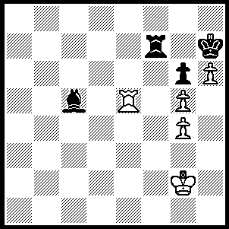
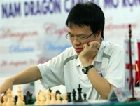

293

Few readers will have heard the name of Vietnam’s leading player, 18 year old Le Quang Liem. He was the Under 14 World Champion in 2005 and competed for Vietnam at the Chess Olympiads in 2006 and 2008. Last year he won the 4th Kolkata (Calcutta) Open Chess Tournament ahead of 13 higher-rated players and has followed this up with =1st at the 2100 Moscow Open. Then without even a day’s break he went on to win the 2100 Aeroflot Open (Moscow), arguably the toughest open tournament in the world, undefeated with 7/9. Liem is the fastest improver among the world top 50 and is now close to the 2700 rated grandmaster elite.

Le Quang Liem v Bu Xiangzhi
2100 Aeroflot Open, Rd 3
English Opening

1 d4 Nf6 2 c4 c5
3 Nf3 cxd4 4 Nxd4 Nc6
5 Nc3 e6 6 a3 Be7
7 e4 O-O 8 Nf3 b6
9 Be2 Bb7 10 O-O Rc8(a)
11 Bf4 Na5 12 Nd2 d5
13 cxd5 exd5 14 e5 Ne4
15 Ncxe4 dxe4 16 b4 Bg5(b)
17 Bxg5 Qxg5 18 h4!(c) Qxh4
19 bxa5 Rc6 20 Nxe4!(d) Rh6
21 f3 Bxe4 22 fxe4 Rd8(e)
23 Qb3 Qh2+ 24 Kf2 Qxe5
25 Rad1 Re8 26 axb6 Qxe4
27 Kg1!(g) Qe7 28 Rxf7! Qc5+
29 Rf2+ Kh8 30 Qb5 Qe3
31 Rd3 resigns

a) 10…Qc7, as played by world champion Vishy Anand, is a better choice.
b) If 16…Nc6 Black loses a pawn without compensation. 16…Bg4 has been played before and it was thought Black has sufficient attacking chances for the piece. Liem’s study disproves this idea.
c) An important deflection breaking up the Q/B battery against g2 and the attack on the knight on d2.
d) White will show the opening of the long diagonal is not to be feared.
e) This merely removes protection of f7.
g) The game is now clearly won.

DEFINITION: ‘A combination is a rearrangement of the connection of pieces of both sides, which force a coordinated connection of contacts, which is advantageous to one side.’ No, this is not Kevin Rudd speaking, but Russian GM and theorist Yuri Averbakh. Perhaps it’s easier to understand in the original Russian! The best definition I have found comes from the Russian publication Shakmaty, ‘A combination is a forced sequence of moves which uses tactical means and exploits specific peculiarities in the position to attain a certain goal.’

SOLUTION: 1…Rf2+ 2.Kh1/3 (2.Kg3 Bd6) 2…Rh2+! 3.Kxh2 Bd6 winning back the rook after which the win is easy.

