J. Penrose (White) wins brilliantly It is now many years since smoking was banned at
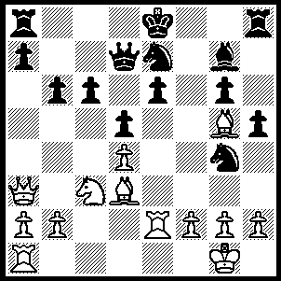
against Max Blau (Hastings 1957): chess venues. From my earliest forays into the world of senior chess at the age of twelve the typical picture of a chess room would evoke an atmosphere thick
with the noxious fumes of cigarettes, pipes and the
occasional cigar. For non-smokers it was an ordeal
to be endured to follow their passion as they
stoically suffered the inhalation of the poisonous
nicotine vapours.
Mikhail Botvinnik, world champion for most of the
period 1948-63 disliked tobacco and attempted to avoid the possibility of smokers distracting him
by asking his trainer Ragozin to smoke constantly
306 during their training games.

What brought these thoughts to mind was the reading of an account by chess writer GM Raymond Keene of the 1973 UK – Netherlands match in which smoking played a not insignificant part in the result of one game. Keene, who was paired against former world champion Max Euwe, was seated next to Jonathan Penrose who was playing Jan Donner, an inveterate chain smoker. Donner would smoke half a cigarette, stub it out and immediately light up again. This continuous process, which resulted in a mountain of simmering ash building up in the large ceramic ashtray on the table, was certainly not to the liking of Penrose, a non-smoker. Then suddenly the whole mass of half-smoked cigarettes burst into flames. The ashtray cracked in half and the flaming mass spread onto the table. Keene had the presence of mind to grab Donner’s coffee cup and hurl the contents onto the flames. Penrose and Donner hastily agreed a draw and fled the scene.

Here is Penrose’s most famous win, victory against the then world champion Mikhail Tal, like Donner a chain smoker at the board:

Jonathan Penrose – Mikhail Tal
Leipzig Olympiad 1960
Queens Pawn, Modern Benoni Defence
1.d4 Nf6 2.c4 e6
3.Nc3 c5 4.d5 exd
5.cxd d6 6.e4 g6(a)
7.Bd3 Bg7 8.Nge2 0-0
9.0-0 a6 10.a4 Qc7
11.h3 Nbd7 12.f4 Re8
13.Ng3 c4 14.Bc2 Nc5
15.Qf3 Nfd7 16.Be3 b5
17.axb Rb8 18.Qf2 axb
19.e5!(b) dxe(c) 20.f5! Bb7(d)
21.Rad1 Ba8 22.Nce4 Na4
23.Bxa4 bxa4 24.fxg fxg
25.Qf7+ Kh8 26.Nc5! Qa7(e)
27.Qxd7 Qxd7 28.Nxd7(f)

a) One of Tal’s favourite defences, combining counterattack on the queenside and pressure against White’s centre. In P.H. Clarke’s ‘Mikhail Tal’s Best Games of Chess’ there are three Benonis among the 50 games chosen.
b) Vacating e4 for knight occupation in the attack on Black’s king.
c) 19…b4 20.Nce4 Nxe4 21.Nxe4 dxe 22.f5 Nf8 23.f6 Bh8 24.Qh4! with a strong attack.
d) 20…Rf8 to guard the f file 21.Nce4 Nxe4 22.Nxe4 Bb7 23.f6 Bh8 24.Qh4 Rfd8 25.Ng5 is good for White.
e) There is no good move. Black could resign.
f) Conclusion - 28…Rxb2 29.Nb6 Rb3 30.Nxc4 Rd8 31.d6 Rc3 32.Rc1 Rxc1 33.Rxc1 Bd5 34.Nb6 Bb3 35.Ne4 h6 36.Ne4 h6 36.d7 Bf8 37.Rc8 Be7 38.Bc5 Bh4 39.g3 resigns.

SOLUTION: Black’s queen pawn is protected by four pieces but 1.Nxd5!! If (i) 1…Nxd5 2.Bxg6+ Qf7 3.Rxe6+ or (ii) 1…Qxd5 2.Qxe7# or (iii) 1…exd5 2.Rxd7+ or (iv) 1…cxd5 2.Bb5! Nc6 (2…Qxb5 3.Qxe7#) 3.Bxc6 Qxc6 4.Qe7# or (v) 1…Bf8 2.Rxe6! cxd5 (2…Qxd5 3.Rxe7+ Kd8 4.Rxa7+ Qxg5 5.Rxa8+ or 2…Qxe6 3.Nc7+) 3.Bb5! Qxb5 4.Rxe7+ Kd8 5.Qd6+.

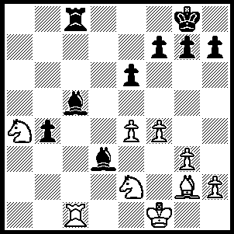
Do you remember this position from February Viswanath - Dunlop (Kingsley Open 2010)? The
game went 1…b6! 2.Nxc5 b7! 3.Nxd3 Rxc1+! 4.Nxc1 b8=Q+ with a draw. The suggestion was that White would be better playing playing 2.Nb2 when 2…Bc2
3.Ra1 g5 left Black with some chances of struggling to a draw. Michael Houstmann sent me a certain winning continuation for White, namely 2.Rc3 when 2…Bc2 is met by 3.Nd4 and 2…Bb5 by 3.Nxc5 b2 4.Rb3 remaining a piece up.

