A. Karpov – V. Salov (1993): White wins in three moves:
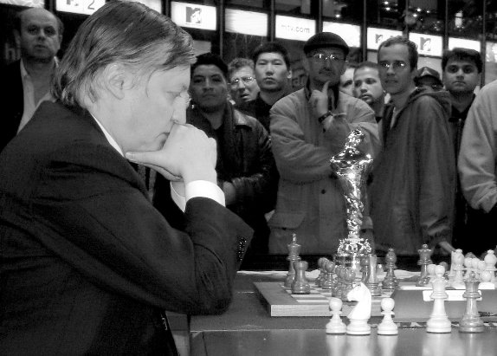
308 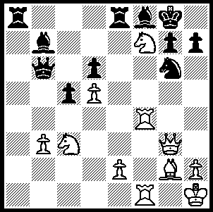

Former world champion Anatoly Karpov has
announced that he will stand for the FIDE Presidency. Elections will take place during the FIDE Congress at the 39th Chess Olympiad to be staged in Siberia (September - October 2010). Anatoly Karpov was born in 1975 in Zlataoust in the Urals. He was world junior champion in 1969 and in 1973, after first place in the Leningrad Interzonal, defeated Lev Polugayevsky, ex world champion Boris Spassky and then Viktor Korchnoi in a close match to win the right to challenge world champion Bobby Fischer. When Fischer failed to agree match terms with FIDE Karpov was awarded the title. He twice successfully defended his title against Russian defector Viktor Korchnoi before four historic but unsuccessful matches against Gary Kasparov (Karpov 19 wins, Kasparov 21 wins, 104 draws). Together with Kasparov Karpov was to dominate world chess to the end of the 20th century. After the FIDE - Kasparov split FIDE recognised Karpov as world champion again after victory over Jan Timman, and then match wins against present world Champion Vishy Anand and Gata Kamsky. However his play has deteriorated badly since the turn of the century and his ranking has slipped to roughly 150th. Here is a game from Karpov in his prime:

Jan Timman - Anatoly Karpov
Montreal 1979, Rd 11
English Opening
1.c4 Nf6 2.Nc3 e5
3.Nf3 Nc6 4.e3 Be7
5.d4 exd 6.Nxd4 0-0
7.Nxc6 bxc6 8.Be2 d5
9.0-0 Bd6 10.b3 Qe7
11.Bb2 dxc 12.bxc4(a) Rb8!
13.Qc1 Ng4 14.g3?(b) Re8!
15.Nd1(c) Nxh2! 16.c5 Nxf1!
17.cxd6 Nxg3!! 18.fxg3(d) Qxd6
19.Kf2 Qh6 20.Bd4 Qh2+
21.Ke1 Qxg3+ 22.Kd2 Qg2!
23.Nb2 Ba6 24.Nd3 Bxd3!
25.Kxd3 Rbd8 26.Bf1 Qe4+
27.Kc3 c5! 28.Bxc5 Qc6
29.Kb3 Rb8+ 30.Ka3 Re5
31.Bb4 Qb6 White resigns(e)

a) Better 12.Bxc4 keeping the b file closed.
b) 14.h3? loses quickly (14…Qe5 15.g3 Nxf2! 16.Rxf2 Rxb2! 17.Qxb2 Qxg3+ 18.Rg2 Qxe3+ etc) but surrendering the two bishops with 14.Bxg4 keeps White in the game.
c) 15.Qc2 allows 15…Nxh2! 16.Kxh2 Qh4+ 17.Kg1 Bxg3! 18.fxg3 Qxg3+ 19.Kh1 Re6! while 15.Bf3 is met by 15…Qf6 16.Bg2 Qh6 17.h4 g5! with a winning attack.
d) If 18.dxe7 Nxe2+ & 19…Nxc1.
e) ‘The ease with which Karpov defeated the best grandmasters in the world, in what appeared to be completely harmless positions still crates a great impression’ (Kasparov). ‘He has no equals in the art of harmoniously arranging his pieces’ (Botvinnik).

The GUFELD CUP (Grand Prix event) Sun 4 & Mon 5 April. Enrol early for $10 entry discount. Entries & information Haydn Barber 9398 4242 / hadix@vianet.au or cawa.org.au

SOLUTION: 1.Qxg6!! resigns (1…hxg6 2.Rh4 & 3.Rh8#).

