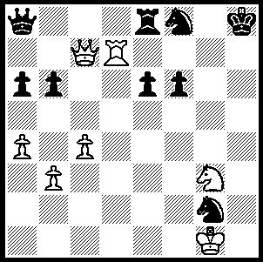

White seems lost but
produces a startling finish
(Karpov-Csom 1977):

290

FIDE PRESIDENT KIRSAN ILYUMZHINOV

Our last column reported on the intention of former
world champion Anatoly Karpov to stand for president
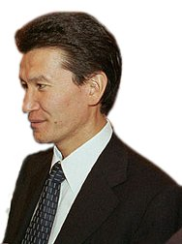
of FIDE, the world governing body of Chess (FIDE is
the acronym for Federation Internationale des Echecs).
It seems almost certain he will be opposed by the
incumbent president Kirsan Ilyumzhinov. Ilyumzhinov
was born in 1962 in Elista, the capital of Kalmykia, a
poor, dry Russian republic of 290,000 people bordering
the Caspian Sea. Ilyumzhinov, a successful businessman, was elected the first President of Kalmykia in 1993, a position he has held ever since after introducing presidential rule, concentrating all power in his own hands. He became President of FIDE in 1995 and is thought to have invested $40 million of his personal wealth on the game. A successful player in his early years (he won the Kalmykian national chess championship at the age of 14) Ilyumzhinov has made Chess a compulsory subject in the first three years of elementary school in Kalmykia. He has also supported religion, building churches, mosques, synagogues and Buddhist temples, and is also active in nature conservation and the promotion of Kalmyk culture and music.

I have been unable to discover any published games by Ilyumzhinov so here is another from Karpov:

ANATOLY KARPOV - GYULA SAX
Linares 1983
Sicilian Scheveningen, Keres Attack
1.e4 c5 2.Nf3 d6
3.d4 cxd 4.Nxd4 Nf6
5.Nc3 e6 6.g4 h6
7.Rg1 Be7 8.Be3 Nc6
9.Qe2 Bd7 10.h4 Nxd4
11.Bxd4 e5 12.Be3 Bc6
13.Qd3 Qa5(a) 14.0-0-0 Nxe4
15.Nxe4 d5 16.Qb3 dxe4
17.Bc4 Rf8 (b) Rd5!?(c) Bxd5.
19.Bxd5 Rd8 20.Bc4! Bb4!
21.c3 b5! 22.Be2! Bd6
23.Qd5!(d) Ke7(e) 24.Bc5! Bxc5
25.Qxe5+ Kd7 26.Qxc5 Qc7
27.Qf5+ Ke7 28.Qxe4+ Kd7
29.Qf5+ Ke7 30.Re1 Rd6
31.Bc4!+(f) Kd8 32.Bxb5 a6
33.Ba4 g6 34.Qf3 Kc8
35.Re7!! Rd1+(g) 36.Kxd1 Qxe7(h)
37.Qa8+ Kc7 38.Qa7+ Kd6
39.Qb6+ resigns (i)

a) 13…Nh7! is better.
b) 17…0-0 is bad due to 18.g5
c) A spectacular positional exchange sacrifice
d) Bxd5+ Ke7 give Black’s rooks scope.
e) An error: 23…Qc7 seems best while the spectacular 23…Qxc3?! leads to a winning endgame for White after 24.Kb1! Qxb2+?! 25.Kxb2 Rxd5 26.Bxa7.
f) Prevents 31…Re6.
g) If 35…Qxe7 36.Qa8+ Kc7 37.Qa7+ Kd8 38.Qb8#.
h) If 36…Rd8+ 37.Rd7! Rxd7 38.Qa8+ wins.
i) 39…Ke5 40.Qd4+ Ke6 41.Bb3#.

SOLUTION: 1.Nf5!! (a fine example of a clearance sacrifice) 1…exf5 2.Qh2+ Kg8 3.Qg3+ Kh8 4.Qg7#: if 1…Nxd7 again 2.Qh2+ while if 1…Qb8 2.Rh7+! (another clearance sacrifice) 2…Nxh7 3.Qg7#.

