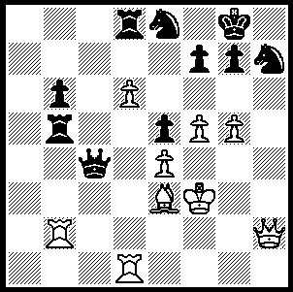

Another brilliant Karpov win:

against Ribli 1981 Karpov

(White), a piece down,

forces immediate resignation:

316

DOEBERL CUP 2010

The Doeberl Cup, Australia’s longest running and most prestigious weekend tournament finished with visiting Chinese GM Li Chao B topping the 72 player event with 7.5/9. Second was young Australian George Xie (7 pts), a result that gained him his third and final GM norm. WA champion Tristan Boyd, with three wins from his last three games, came an excellent =7th (6 pts). I am indebted to Tristan for emailing me the following two games, both brilliant White sacrificial king hunts against the Sicilian:

George Xie - Bobby Cheng (a)
Doeberl Cup 2010, Round 3
Sicilian, Kan Variation

1.e4 c5 2.Nc3 e6
3.Nf3 a6 4.g3 b5
5.d4 cxd4 6.Nxd4 Bb7
7.Bg2 Nf6 8.0-0 b4
9.Na4 Bxe4 10.Bxe4 Nxe4
11.Re1 d5 12.c4 bxc3
13.Nxc3 Nxc3 14.Qh5!! Ne4
15.Nxe6 Qb6 16.Nc7+! Qxc7
17.Qxd5 Qc6 18.Rxe4+ Be7
19.Rxe7+! Kxe7 20.Bg5+ f6
21.Re1+ Kf8 22.Qd8+ Kf7
23.Re7+ Kg6 24.Qxh8 & wins(b)

a) Bobby Cheng won the World U/12 last year and the Australian Junior U/18 at the start of this.
b) cont: 24…Ra7 25.Qxg7+ Kf5 26.g4+ Kxg4 27.Bxf6+ resigns.

Eugene Schon - Darryl Johansen (c)
Doeberl Cup 2010, Round 5
Sicilian, Scheveningen Variation

1.e4 c5 2.Nf3 e6
3.d4 cxd4 4.Nxd4 Nf6
5.Nc3 d6 6.Be3 a6
7.g4 e5 8.Nf5 g6
9.g5 gxf5 10.exf5! d5
11.Qf3 Ne4 12.Nxe4 dxe4
13.Qxe4 Nc6 14.Bc4 Qd7
15.g6 hxg6 16.fxg6 f5
17.Bf7+ Kd8 18.Qg2 Kc7
19.g7 Bxg7 20.Qxg7 f4
21.Rd1 Qg4 22.Bg6+ Bd7
23.Rxd7+! Qxd7 24.Bb6+ Kd6
25.Qf6+ Kd5(d) 26.Bf7+ Ke4
27.f3+ Kxf3 28.Rf1+ Kg2
29.Qg6+ Kxh2 30.Qg1+ Kh3
31.Rf3+ resigns

c) Eugene Schon is a Victorian junior who also drew with Indian GM Kunte. However, any chance he had of an IM norm disappeared after he lost to Tristan in Round 8. GM Darryl Johansen has been Australian champion five times.
d) If 25…Qe6 26.Bc7+ Kd5 27.c4+.

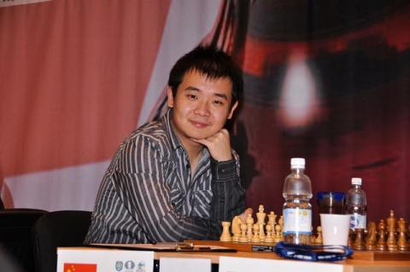
VASILY SMYSLOV
Former world champion Vasily
Smyslov (1921-2010) died on
March 30. Articles I have prepared
on the career of Smyslov have been
deferred to report on the Doeberl
Cup.

SOLUTION: 1.Qxh7+!! resigns
(1…Kxh7 2.Rh1+ Kg8 3.Rbh2 g6
4.Rh8+ Kg7 5.R1h7# or 3…f6 4.g6
& 5.Rh8#). Doeberl Cup winner Li Chao B

Doeberl Cup Winner Li Chao B

