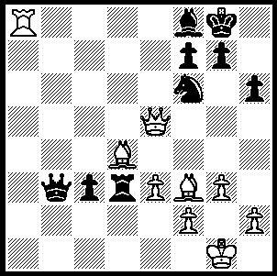
The death occurred on March 30 of
former world champion Vasily
Smyslov at the age of 89. Next
week we shall begin a short series
on the life of this outstanding player.
Below is a position from a game
towards the end of his career,
Smyslov – Sosonko 1984: White
to play and win (6 moves):
317

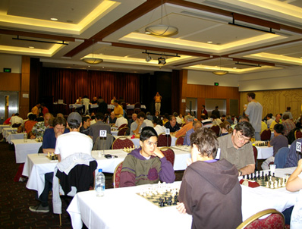

Last week contained a report on Australia’s
top weekender the Doeberl Cup in Canberra
won by Chinese GM Li Chao B, half a point
ahead of Australia’s George Xie who gained
his final Grand Master norm. WA champion
Tristan Boyd, sent me an annotated game
featuring a well calculated and thematic Ruy
Lopez victory, the first of three successive
wins which catapulted him into =7th place:

Tristan Boyd – Helen Milligan
2010 Doeberl Cup , Rd 7
Ruy Lopez, Flohr-Zaitsev Variation
1.e4 e5 2.Nf3 Nc6
3.Bb5 a6 4.Ba4 Nf6
5.0–0 Be7 6.Re1 b5
7.Bb3 d6 8.c3 0–0
9.h3 Bb7 10.d4 Re8
11.Nbd2 Bf8 12.d5 Nb8
13.Nf1 c6(a) 14.dxc6 Bxc6
15.Bg5(b) Nbd7 16.N3h2! Qc7(c)
17.Ng3 Qb7 18.Qf3 d5
19.Rad1! dxe4 20.Qf5 Nc5(d)
21.Bxf6 Nxb3 22.axb3 gxf6
23.Nh5 Re6 24.Re3(e) Be7
25.Qg4+ Kf8 26.Qg7+ Ke8
27.Qh8+ Bf8 28.Ng7+ Ke7
29.Nf5+ Ke8 30.Rg3 e3
31.fxe3 Be4 32.Rg8 Bxf5
33.Rxf8+ resigns

(a) Premature - Black should first play the recommended move 13…Nbd7 with the possibility of a later …Nc5. In the game White exploits the d-file and a2-g8 diagonal to full effect.
(b) White is willing to swap bishop for knight to maintain a grip on d5 eg 15...h6 16.Bxf6 Qxf6 17.Ne3 followed by B/N-d5 and a4, when White probes the queenside and Black has little counter-play.
(c) If 16...h6 17.Bxf6 Nxf6 18.Ng4! with similar ideas to the last note: if then 18...Nxe4? 19.Qf3 d5 20.Rxe4! with a winning attack.
(d) Under immense pressure Black panics, probably after realising that 20...g6 loses to 21.Rxd7! Qxd7 (21…gxf5 22.Bxf7+) 22.Qxf6 Bg7 23.Ng4! However it is difficult to find a decent continuation for Black, with White ready to play 21.Ng4 (and if necessary Nh5) against most moves eg 20…h6 21.Ng4! hxg5 22.Rxd7! Fritz 12 suggests 20...Nd5 21.Nxe4 Re6 22.Ng4 h5 or 21...h5, but White is clearly in the driving seat.
(e) The direct attack is stronger than the immediate win of an exchange. The rest is pure pleasure for White.

WEST AUSTRALIAN OPEN CHAMPIONSHIP: Sat May 1, Sun May 2, Sat May 8, Sun May 9, two rounds a day (1 on final day), 60min + 30 sec. Information and entry form on cawa.org.au (deadline for entry Thurs 29 April).

SOLUTION: 1.Rxf8+! Kxf8 2.Qc5+ resigns (2…Ke8 – 2…Kg8 3.Qc8+ Kh7 4.Qf5+ Kg8 5.Qxd3 – 3.Qc8+ Ke7 4.Bc5+ Rd6 5.Qc7+ winning the rook).

