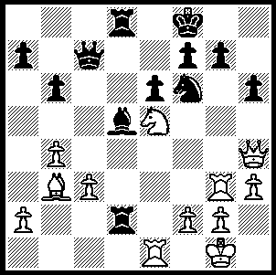

Smyslov – Pachman 1947:
What are Black’s two weaknesses
that White can exploit (2 moves)?

The death occurred on March 30th of former world champion Vassily Smyslov from heart failure at the age of 89. Smyslov learnt the moves at the age of six from his father, an engineering technologist and a strong chess player. He rapidly developed into a leading player in the USSR and at the age of 19 came 3rd in the Soviet championship ahead of Botvinnik and Keres. He played four times for the world title including three matches against Mikhail Botvinnik. He won the title in 1957 and was one of the finest players in world chess for over 40 years, remaining an immensely strong player even into his 60s. His play was characterised by originality, deep accurate analysis and he welcomed complications in his continuous quest for victory.
Here is a game played by Smyslov when he was only 14:

K. GERASIMOV - V. SMYSLOV
Moscow 1935: Colle System
1.d4 d5 2.Nf3 Nf6
3.e3 e6 4.Bd3 c5
5.b3 Nc6 6.Bb2 Bd6
7.0-0 Qc7 8.a3 b6
9.c4 Bb7 10.Nc3 a6
11.Re1(a) cxd 12.exd 0-0
13.Na4 Bf4 Ne5 dxc
15.bxc Nxe5 16.dxe5 Qc6!
17.Bf1(b) Rfd8 18.Qb3 Ng4
19.h3 Rd3!! 20.Qxb6(c) Rxh3!!(d)
21.Bd4 Bh2+ 22.Kh1 Bxe5+
White resigns(e)

a) More energetic was 11.dxc bxc 12.cxd exd 13.Rc1 to play against Black’s dominating but hanging pawns.
b) If 17.f3 Ng4! 18.Be4 (18.g3 Be3+ 19.Kg7 Nf2 20.Qe2 Nxd3) 18…Bxh2+ 19.Kh1 Nf2+ 20.Kxh2 Nxd1 21.Bxc6 Bxc6: 17.Qf3 leaves White struggling in the endgame after 17…Qxf3 18.gxd3 Nd7 19.Be4 Rab8 20.Rad1 Nc5 21.Nxc5 bxc5.
c) The rook cannot be captured – 20.Qxd4 Bh2+ 21.Kh1 Nxf2+ 22.Kxh2 Nxd3.
d) If now 21.Qxc6 Bh2+ 22.Kh1 Nxf2#.
e) Black wins by the pendulum manoeuvre 23.Kg1 Bh2+ 24.Kh1 Bc7+.

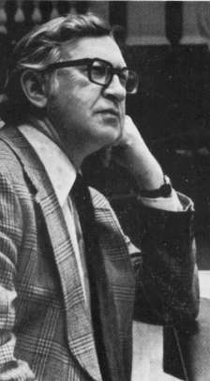
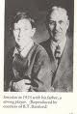
Vasily Smyslov & his father 1935, Vasily Smyslov, world champion 1957-8
the year he won the game above.

The GUFELD CUP, held over the Easter weekend was won convincingly by Stephanus Kurniawan with 5.5/6. Second was David Ellis 5/6 (+4 =2). Third was talented junior Ryan Sam (4.5) who was the only player to take a half point from the winner. Derek Elkington (4) led for 4 rounds before losses to the top two players relegated him to a share of the Under 1850 prize with Eddy Seah and Gordon Dunlop. Leonard Mechlowski and Chris Cuellar were 1st= in the Under 1750 section and Steven Hintz, Girma Orssengo and Gary Donaldson split the Under 1600 prize. Bernard Laugery won the Under 1200 section and George Carolin-Uncovich won the junior prize.

WA OPEN CHAMPIONSHIP: If you haven’t yet entered (starts Saturday) contact Haydn Barber ASAP hadix@vianet.au or 9398 4242.

SOLUTION: Black’s rook on d2 and his queen on c7 are both unprotected so 1.Qf4 attacking the unprotected rook and if 1…Bxb3 uniting the rooks 2.Ng6+! discovering an attack on the unprotected queen.

