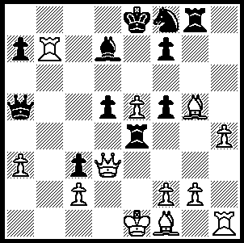

Smyslov – Botvinnik
(World Championship 1954):
White to play &
win (4 moves)

312

VASSILY SMYSLOV 1921 – 2010 (Part II)
Smyslov will be remembered by many for his titanic rivalry with Mikhail Botvinnik with the two protagonists playing 98 times with Botvinnik slightly on top with +26, =50, -22. He competed against Botvinnik four times for the world title. After Alekhine’s death in 1946 Smyslov was second to Botvinnik in the 5 player World Championship tournament (The Hague & Moscow 1948) - Botvinnik 14, Smyslov 11, Keres & Reshevsky 10.5, Euwe 4.5. Smyslov won the right to challenge Botvinnik after winning the gruelling 15 player 1953 Zurich Candidates Tournament with 18/28, two points ahead of Bronstein, Keres & Reshevsky. The 1954 match with Botvinnik was drawn 12-12. Undaunted Smyslov again qualified to challenge Botvinnik by winning the 1956 Candidates in Amsterdam with 11.5/18, a point and a half ahead of Keres. Then in the 1957 match he defeated Botvinnik 12.5-9.5 to become world champion. However Botvinnik exercised his right
to a return match and was able regain the title with a 12.5-10.5 victory.

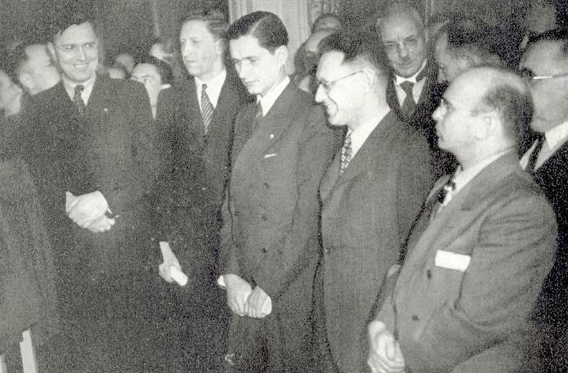

World Championship 1948: Euwe, Smyslov, Keres, Botvinnik, Reshevsky.

Here is one of Smyslov’s finest wins against his mighty rival:

M. BOTVINNIK - V. SMYSLOV
World Championship 1954
Kings Indian Defence
1.d4 Nf6 2.c4 g6
3.g3 Bg7 4.Bg2 0-0
5.Nc3 d6 6.Nf3 Nbd7
7.0-0 e5 8.e4 c6
9.Be3 Ng4 10.Bg5 Qb6
11.h3 exd! 12.Na4 Qa6
13.hxg4 b5 14.Nxd4(a) bxa4
15.Nxc6!? Qxc6 16.e5 Qxc4
17.Bxa8 Nxe5 18.Rc1(b) Qb4
19.a3 Qxb2 20.Qxa4 Bb7!
21.Rb1?(c) Nf3+ 22.Kh1 Bxa8!
23.Rxb2 Nxg5+ 24.Kh2 Nf3+
25.Kh3 Bxb2 26.Qxa7 Be4!(d)
27.a4 Kg7 28.Rd1 Be5
29.Qe7 Rc8! 30.a5(e) Rc2
31.Kg2 Nd4+ 32.Kf1 Bf3
33.Rb1 Nc6 White resigns(f)

a) Both 14.c5 dxc 15 Nxc5 Nxc5 16.Be7 Ne6 and 14.Be7 Re8 15.Bxd6 bxa4 16.Nxd4 Ne5! leave Black with excellent prospects.
b) 18.Qxd6 Be6 19.Bg2 Qxg4 or 18.Be7 Bxg4 19.Qd5 Qc8 20.Bxf8 Bf3 or 18.Bg2 Be6 19.Qxd6 Qxg4 20.Bf4 Nf3+ 21.Bxf3 Qxf3 22.Qd1 Qb7 23.f3 all leave Black with the better position.
c) An error: 21.Bxb7 Qxb7 22.Rc3 Nf3+ 23.Rxf3 Qxf3 24.Be7 Rc8 25.Bxd6 leaves White only slightly worse.
d) Preventing 27.Rb1 / 28.Rb8 exchanging rooks and lessening Black’s attack.
e) White cannot play the exchange sacrifice 30.Rxd6 because of 30…Rc1!! with a mating attack.
f) Black cannot be prevented from massing his pieces against f2.

The World Championship match in Sofia, Bulgaria, between Vishwanathan Anand (India), the defending champion, and challenger Veselin Topalov (Bulgaria) is proving an exciting and close contest. At time of writing Anand leads 4-3 (+2, =4, -1) in the 12 game match.

SOLUTION: 1.Qxe4! dxe4 2.Rb8+ Bc8 3.Bb5+ Qxb5 (3…Nd7 4.Rxc8#) 4.Rxb5 with an easily won ending.

