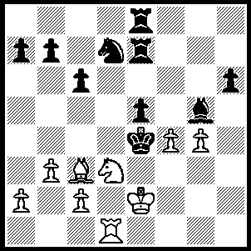

VASSILY SMYSLOV (1921-2100) :
The Latter Years.
Smyslov - Oll 1993:
White brings his sacrificial king
hunt to a conclusion in 3 moves
(move 2 is the tricky one):

313

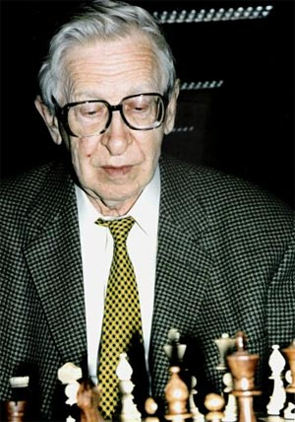

After losing the world championship title
to Botvinnik Smyslov remained an
immensely strong player and his glittering
tournament career continued well into his
60s culminating in a remarkable run in the
World Championship cycle of 1982-84
when he came close to becoming the first
challenger to Anatoly Karpov. Smyslov
finished second at the Las Palmas Interzonal
at the age of 61 scoring 8.5/13. In the quarter
final match he famously overcame Robert
Huebner on the spin of a roulette wheel after
a win each and twelve draws and in the semi-
final he was too strong for Zoltan Ribli winning
6.5-4.5. However he was to be defeated in the
final by a young Gary Kasparov 4.5-8.5.
Here is one of his Semi-Final wins:

Vassily Smyslov - Zoltan Ribli
Candidates Semi-Final 1983
Queens Gambit, Semi-Tarrasch Defence
1.d4 Nf6 2.Nf3 e6
3.c4 d5 4.Nc3 c5
5.cxd5 Nxd5 6.e3 Nc6
7.Bd3 Be7 8.0-0 0-0
9.a3 cxd4 10.exd4 Bf6
11.Qc2 h6 12.Rd1 Qb6
13.Bc4 Rd8 14.Ne2 Bd7
15.Qe4 Nce7 16.Bd3 Ba4!?(a)
17.Qh7+ Kf8 18.Re1 Bb5
19.Bxb5 Qxb5 20.Ng3 Ng6
21.Ne5 Nde7 22.Bxh6(b) Nxe5(c)
23.Nh5! Nf3+(d) 24.gxf3 Nf5
25.Nxf6 Nxh6 26.d5 Qxb2(e)
27.Qh8+ Ke7 28.Rxe6+!! fxe6
29.Qxg7+ Nf7 30.d6+! Rxd6
31.Nd5+ Rxd5 32.Qxb2 and wins (f)

a) The match was level and Ribli complicates - 16...Ng6 was playable.
b) A simpler & surer route to victory was 22.Nh5! Nxe5 23.Nxf6.
c) 22...Rxd4 loses to 23.Nh5! Bxe5 24.Rxe5! Nxe5 25.Qxg7+ Ke8 26.Nf6+ Kd8 27.Qf8+ Kc7 28.Qxe7+ Kc6 29.Be3 Rd3 30.Rc1+.
d) If 23...Nf5 24.Nxf6 Nxh6 25.dxe5 wins.
e) If 26...gxf6 27.Qxh6+ Ke7 28.dxe6 Qg5+ 29.Qxg5 fxg5 30.exf7+ with a winning endgame.
f) Conclusion 32… b6 33.Qb4+ Kf6 34.Re1 Rh8 35.h4 Rae8 36.Re4 Nd6 37.Qc3+ e5 38.Rxe5! Rxe5 39.f4 Nf7 40.fxe5+ Ke6 41.Qc4+ resigns.

WA ALLEGRO (15 min flagfall) Sunday 23 May (11am – 5pm), Legacy House, cnr Mill Pt Rd, S Perth. Entries accepted up to 10.45am on day. Details cawa.org.au and enquiries Haydn Barber hadix@vianet.net.au or 9398 4242.

WORLD CHAMPIONSHIP between defending champion Viswanathan Anand (India) and Vaselin Topalov (Bulgaria) remains locked at 5.5 – 5.5 with one game to play.

SOLUTION: A rook down, Smyslov concludes his king hunt with 1.Nf2+! Kxf4 2.Rg1!! trapping the king and threatening 3.Bd2# and if 2…e4 3.Nh3#.

