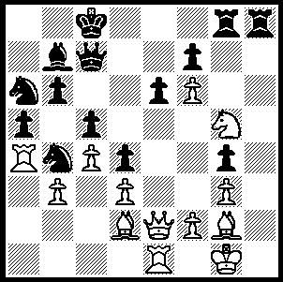
‘Aren’t you meant to have lapses in concentration and
be making silly blunders now that you’re seventy’ was
part of an email message from my son in Sydney after
I had informed him I had won the recent WA Open
Championship (well not quite 70, 10 days short). The
year began with the failure to win even one game in the
Metro Championship, my worst tournament result ever.
Was it perhaps time to hang up my boots (or should that be my thinking cap)? The WA Open result has naturally made such a thought disappear. Here is a position from my final game (Black v Kurniawan). White plays 1.Nxe6. Can you find how Black now wins?
319

WORLD CHAMPIONSHIP
Viswanathan Anand retained his world title with a 6.5-5.5 win against his Bulgarian challenger Veselin Topalov in Sofia. Here is the dramatic final game:

Veselin Topalov - Viswanathan Anand
World Championship 2010 Game 12
Queens Gambit Declined, Laskers Defence
1.d4 d5 2.c4 e6
3.Nf3 Nf6 4.Nc3 Be7
5.Bg5 h6 6.Bh4 O-O
7.e3 Ne4 8.Bxe7 Qxe7
9.Rc1 c6 10.Be2 Nxc3
11.Rxc3 dxc4 12.Bxc4 Nd7
13.O-O b6 14.Bd3 c5
15.Be4 Rb8 16.Qc2 Nf6(a)
17.dxc5 Nxe4 18.Qxe4 bxc5
19.Qc2 Bb7 20.Nd2 Rfd8
21.f3 Ba6 22.Rf2 Rd7
23.g3 Rbd8 24.Kg2 Bd3
25.Qc1 Ba6(b) 26.Ra3 Bb7
27.Nb3 Rc7 28.Na5(c) Ba8
29.Nc4 e5 30.e4(d) f5
31.exf5 e4 32.fxe4 Qxe4+
33.Kh3 Rd4 34.Ne3 Qe8!(e)
35.g4 h5 36.Kh4 g5+
37.fxg6 Qxg6 38.Qf1 Rxg4+
39.Kh3 Re7 40.Rf8+ Kg7
41.Nf5+(f) Kh7(g) 42.Rg3 Rxg3+
43.hxg3 Qg4+ 44.Kh2 Re2+
45.Kg1 Rg2+ 46.Qxg2 Bxg2 and wins(h)

a) A double edged move, allowing a weakening of his queenside pawns in return for a well placed bishop on b7 which Black hopes will assist in building up a kingside attack.
b) Perhaps an invitation to draw by repetition of position (26.Qc2 Bd3 etc) which Topalov rejects.
c) 28.Rc2 c4 29.Rxc4 Bxf3+! 30.Kxf3 Qf6+ 31.Kg2 Rxc4 32.Qxc4 Qxb2+.
d) 30.Rd2 e4 31.f4 Rd3! 32.Ne5 f6!
e) The winning move.
f) 41.Rxa8 Rxe3+! 42.Rxe3 Rh4+! 43.Kxh4 Qg4#.
g) 41…Kxf8? 42.Nh4+ wins. Now if 42.Nxe7 Rh4+! mates.
h) Conclusion - 47.Kxg2 Qe2+ 48.Kh3 c4 49.a4 a5 50.Rf6 Kg8 51.Nh6+ Kg7 52.Rb6 Qe4 53.Kh2 Kh7 54.Rd6 Qe5 55.Nf7 (55.Rb6 h4)55...Qxb2+ 56.Kh3 Qg7 White resigns.

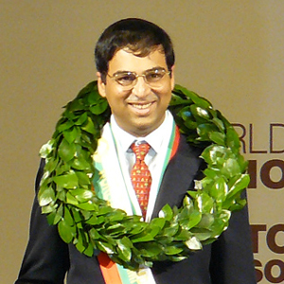
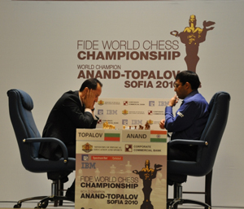

Game 12 –Topalov (L) v Anand The happy winner

WA OPEN: 1st David Ellis (6/7), =2nd Derek Elkington, Dave Dempster, Eddy Seah (5): Under 1850 – 1st Gordon Dunlop (4.5), =2nd Dennis Holland, Walter Stassen (4): Under 1800 – 1st Alex Janceski (4), 2nd Robin Shaw (3.5): Under 1650 – Behrouz Ghorbanian (4), =2nd Girma Orssengo, Denis McMahon, Gary Donaldson (3.5): Under 1300 – George Carolin-Uncovich (3), 2nd Bernard Laugery (2). Three players, including the top rated player Stephanus Kurniawan (4/7), lost games through their mobile phones going off while many times WA champion Haydn Barber (4.5) lost a game on time in a winning position after forgetting his clock.

SOLUTION: 1.Nxe6 (1.Bf4 seems best when I was considering the speculative queen sacrifice 1…Rxg5 with very interesting play) 1…Bxg2! (1…fxe6? 2.Qxe6+ wins easily for White) 2.Nxc7 Bf3 (2…Bc6 is also good) 3.Qxf3 (there is nothing better – 3.Qe8+ Kb7! wins) 3…gxf6 4.Nxa6 Nxa6 5.Re4 Re8 6.Rxe8+ Rxe8 7.g4 Re2 8.Bf4 Nb4 9.g5 Nxd3 10.Bg3 Ne5 with a clear win for Black

