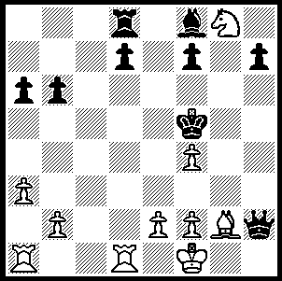

Andor Lilienthal – Meir Romm:
how does White bring his king
hunt to a conclusion (4 moves)?

Diagram 321

I recently reported on the death of ex-world champion Vassily Smyslov at the age of 89. This month has also seen the death of an even older Grand Master, Andor Lilienthal, soon after his 99th birthday. He was the last survivor of the very first FIDE titled GMs (1950). Born to Hungarian-Jewish parents in 1911 in Moscow, Lilienthal moved with his family to Budapest at the age of two. He learnt to play chess at the age of 16 and developed into one of the best players of his time, reaching number 6 ranking in 1934 and remaining in the top twenty until about 1950 according to Chess Metrics. He had a nomadic existence living in Vienna, Berlin and Paris. He moved back to Russia and became a citizen of the USSR in 1939 before finally returning to Budapest in 1975. He represented Hungary in 3 Olympiads in the 1930s, obtaining a remarkable average score of over 75%. His greatest tournament success was his 1st= at the 1940 USSR Championship but he is more famous for having defeated five players who were world champion, Emanuel Lasker, Capablanca, Euwe, Botvinnik and Smyslov. Here is his most famous game:

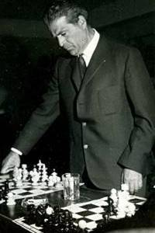
Andor Lilienthal - Jose Raul Capablanca
1935 Hastings, Rd 5
Nimzo-Indian Defence, Saemisch Variation
1.d4 Nf6 2.c4 e6
3.Nc3 Bb4 4.a3 Bxc3+
5.bxc3 b6 6.f3 d5
7.Bg5 h6 8.Bh4 Ba6
9.e4 Bxc4(a) 10.Bxc4 dxc4
11.Qa4+ Qd7 12.Qxc4 Qc6(b)
13.Qd3 Nbd7 14.Ne2 Rd8
15.0-0 a5 16.Qc2 Qc4
17.f4(c) Rc8 18.f5 e5
19.dxe5 Qxe4(d) 20.exf6 !! Qxc2(e)
21.fxg7 Rg8 22.Nd4 Qe4(f)
23.Rae1 Nc5 24.Rxe4+ Nxe4
25.Re1 Rxg7 26.Rxe4+ resigns(g)

Lilienthal giving a Simul.
a) Accepting the pawn sacrifice by 9... g5 10. Bg3 fxe4 11. dxe4 Nxe4 12.Be5 gives White an attack.
b) In Alekhine-Eliskases (Hastings 33-34) Black obtained a satisfactory game after 12...Nc6.
c) This now threatens 18.e5.
d) If 19...Qc5+ 20.Bf2! Qxe5 21.Bd4 Qxe4 22.Qxe4 Nxe4 23.Bxg7 Rh7 24.f6 "and Black's position is hopeless"(Lilienthal). On 19...Nxe5, White retains the initiative with 20.Nf4, eg 20...Nfd7 21.Rad1 0-0 22.Nd5 threatening 23.Ne7+ or 23.f6. If 19...Nxe4 20.Rf4 Qc5+ 21.Kh1 Ng5 22.Bf2 is strong for White.
e) No better is 20...Qxh4 21.fxg7 Rg8 22.f6! followed by Rf4 (if 22...Nxf6 23.Qf5 Ke7 and now 24.Rae1 or 24.Qe5+ wins.
f) If 22...Qa4, 23.Rae1+ Ne5 24.Rxe5+ Kd7 25.Rd5+ Ke8 26.Re1# or 22...Qd2, 23.Rael+ Ne5 24.Rxe5+ Kd7 25.Rd5+ Ke8 26.Re1+ wins or 22...Qxc3 23.Rae1+ Ne5 24.Rxe5+ Kd7 25.Re7+ Kd6 26.Nb5+ or 22...Qd3 23.Rae1+ Ne5 24.Rxe5+ Kd7 25.Rd5+.
g) 27.Re7+ Kd6 (27…Kf8 28.Be7+ Kg8 29.Bf6) 28.f6 and 29.Bg3+ wins. Lilienthal was one of the few players with an even record against Capablanca and this win made him famous. Lilienthal relates, "Wherever I went on an exhibition tour, both in the Soviet Union and elsewhere, chess players and fans always asked me to show them how I sacrificed the queen against the great Cuban.” When Bobby Fischer noticed Lilienthal at his 1992 return match against Boris Spassky, Fischer greeted him with the remark, "Pawn e5 takes Knight f6."

SOLUTION: 1.Rd5+ Kxf4 (1…Ke6 2.f5# or 1…Kg6 2.Rg5# or 1…Kg4 2.Nf6+ Kxf4 – 2…Kh4 3.Rh5# - 3.e3# ) 2.e3# Kg4 3.Nf6+ Kh4 4.Rh4#

