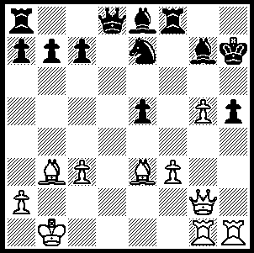

Rogers –Arapovic 1985:
White to play and mate in 5:

323

Last week WA was privileged to receive a visit from Australia’s most famous player, GM Ian Rogers. Ian came to take a coaching session with the state’s top juniors as part of the Junior Elite Training Squad scheme. He also gave a 20 board simultaneous exhibition at the Metro club, conceding only one draw to club stalwart Douglas McLean. Born in Hobart in 1960 Ian became a leading Australian player in his teens. After gaining his Grand Master title in 1985 Ian reached a rating of 2564, placing him in the world’s top 50 players. Among his victims were such illustrious players as Smyslov, Korchnoi, Shirov, Gelfand, Portisch, Huebner and Short. He was four times Australian champion, was Australian Grand Prix winner seven times and Doerberl Cup winner 12 times. In all he won over 100 tournaments including 15 round-robin GM events. He also competed with distinction for Australia in 14 Olympiads, 12 on top board. Ian retired from serious competitive chess in 2007 and now works as a chess reporter, columnist and analyst. He has recently returned to Australia after covering the Anand-Topalov World Championship match.

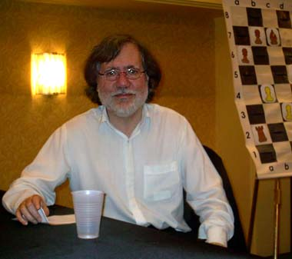

Here is a game from his final year showing his amazing innovative style. He sacrifices the double exchange, winning a number of pawns and temporarily imprisoning the opposing queen. His attack prevails despite having his king chased up the board by a rook and liberated queen.

Ian Rogers - Roland Berzinsh
Nimzo-Indian, Classical Variation
1.d4 Nf6 2.c4 e6
3.Nc3 Bb4 4.Qc2 c5
5.dxc Bxc5 6.Nf3 Qb6
7.e3 Qc7 8.a3 b6
9.b4 Be7 10.Bb2 a6
11.Be2 Bb7 12.0-0 d6
13.Rac1 Nbd7 14.Rfd1 Rc8
15.Qb1 Qb8 16.Qa1 0-0
17.Rd4 Qa8 18.Rcd1 Rfe8
19.Ne1 Ne5 20.Na4 Ned7
21.Rxd6 ! Bxd6 22.Rxd6 Qb8
23.Rxb6 ! Nxb6 24.Nxb6 Rcd8
25.Be5 Qa7 26.c5 Rd2
27.Kf1 Bc6 28.Bxf6 gxf6
29.Qxf6 Bb5 30.Bxb5 axb5
31.Nf3 Rc2 32.Nd4 Qxa3
33.Qg5+ Kh8 34.Qe5+ Kg8
35.g4! Qa1+ 36.Kg2 Rc1
37.Nd7 Rg1+ 38.Kh3 Qf1+
39.Kh4 Qxf2+ 40.Kh5 f6
41.Nxf6+ Kf7 42.Nxe8 resigns (a)

a) After 42…Kxe8 43.Qxe6+ Kf8 44.Qd6+ followed by 45.Nf5 sets up a mating attack.

The WA Allegro Championship was won by Michael Horstmann (8.5/9), his third win in four years. Michael Wilkins and Tom Donaldson were 2nd = with 7.5. Rating winners: Under 2000 Eugene Konavalov (5.5), Under 1700 Guy Booth (5), Under 1400 Bernard Laugery (4) and Best Junior George Carolin-Uncovich (4).

The Foundation Day Open (WA & Australian GP) was won by Edik Gilmetdinov (5.5/6). Second was David Ellis (4.5) with Walter Stassen third on 4. Rating winners: Under 1750 Ned Tomic (3.5), Under 1600 Denis McMahon, Wallace Sheridan, Girma Orssengo (all 3), Under 1500 Gary Donaldson (3) and Junior winner Aston Taminsjah (2).

The next Grand Prix event is the Perth Open to be played at N Woodvale Primary June 19, 20. Information N Muller 9409 9579 / norbert@nscom.net.au or CAWA website.

SOLUTION: 1.g6+!! Bxg6+ 2.Qxg6+! resigns (2…Nxg6 3.Rxh5+ Bh6 4.Rxh6+ Kg7 5.Rgxg6#).

