Earlier this month the beautiful and historic Castilian city of Leon in northwest Spain held its 23rd annual chess congress attended by hundreds of enthusiasts. The congress was well supported by the community, including the local paper which gave the event front page coverage and on one day devoted 12 pages to chess. The main event was a four player four game Rapid Play Knock Out with Blitz games to decide in the event of a 2-2 draw. Previous winners have included Anand, Topalov, Carlsen, Shirov, Kramnik and Kasparov. In the semi-final Levon Aronian (Armenia) defeated Leinier Dominguez (Cuba) 2.5-1.5 with a win the 4th game which went to 161 moves while Boris Gelfand (Israel) needed to go to the Blitz play-off to defeat Francisco Vallejo Pons 3.5-2.5. The final saw Aronian take the lead in Game 3 before Gelfand evened the score and then won the two blitz games to secure victory 4-2.

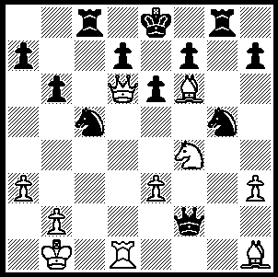

Here is a position from Gelfand –Vallejo Pons.
White looks to have an unstoppable mate but
can you find a saving try by Black and White’s
subsequent mate (6 moves)

324

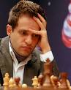
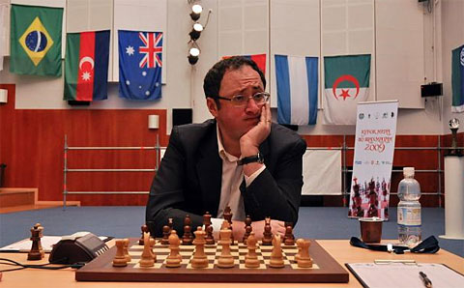

Boris Gelfand Levon Aronian

Here is Aronian’s only win in the final:

Levon Aronian - Boris Gelfand
23rd Leon Rapid Play, June 2010
Nimzovitsch Attack
1.Nf3 d5 2.c4 c6
3.e3 Nf6 4.Nc3 e6
5.b3 Bd6 6.Bb2 0-0
7.Be2 dxc4 8.bxc4 e5
9.d3 Re8 10.0-0 Bg4
11.Rb1 Nbd7 12.Ba1 Rb8
13.Qc2 Nc5 14.Rfd1 Qe7
15.h3 Bf5 16.Nh4 Bd7
17.d4 exd4 18.exd4 Nce4
19.Bd3 Nxc3 20.Bxc3 Ne4
21.Re1 Qxh4 22.Bxe4 h6
23.c5! Bc7 24.d5! cxd5
25.Bxd5 Qh5(a) 26.Qd3! Bf5
27.Qd4 Qg5 28.h4 Qg6
29.Rxe8+ Rxe8 30.Rxb7 Be4!(b)
31.g3! Bxd5 32.Qxd5 Bxg3(c)
33.h5! Bxf2+ 34.Kxf2 Qc2+
35.Bd2 Re6 36.c6 Rf6+(d)
37.Kg3 Kh7 38.c7 Rf5
39.Qd4 Qc6 40.Qd3 g6
41.c8=Q! Qxc8 42.Rxf7+! Rxf7
43.Qxg6+ Kh8 44.Qxf7 Qc6
45.Qg6(e)

a) 25...Rxe1+ 26.Rxe1 Qf4 would leave Black equal.
b) Each side has only had a couple of minutes left here. Black hopes for 31.Bxe4 Rxe4 32.Qxg7+ Qxg7 33.Bxg7 Re1#.
c) If 32...Rd8 33.Qg2! with a safe extra pawn. Now if 33.fxg3 Qxg3+ 34.Qg2 Qxc3 Black wins.
d) Black does not have enough for the piece.
e) Simplest with seconds left. Black’s king will be too far away to block the queening of the ‘wrong rook’s pawn’. Cont: 45...Qxg6+ 46.hxg6 Kg7 47.Kf4 Kxg6 48.Ke5 h5 49.a4 h4 50.a5 a6 51.Bf4 h3 52.Bh2 Kg5 53.Kd6 Kf5 54.Kc6 Ke6 55.Kb6 Kd7 56.Kxa6 Kc6 57.Ka7 Kb5 58.a6 Black resigns.

The Perth Open (Grand Prix event) starts tomorrow & concludes Sunday. Venue N Woodvale Primary School. Enter TODAY. For information cawa.org.au or call N Muller 9409 9579.

SOLUTION: 1…Qc2+!! 2.Ka1! (2.Kxc2 Ne4+ 3.Kb1 Nxd6 keeps Black in the game) 2…Nb3+ 3.Ka2 Qc5 4.Qxd7+ Kf8 5.Qd8+! resigns (5….Rxd8 6.Rxd8#)

