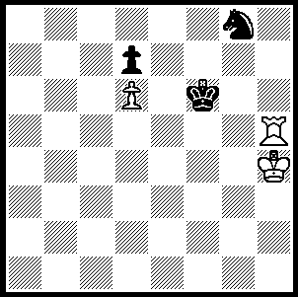
June 25, 2010

The endgame study below (E Pognsiants 1964)
tests your ability to win K & P and R v N endings
and its themes include sacrifice and zugzwang.
There are three basic variations and move 2 is the
hard one. White to play and win (up to 9 moves):

325

This week a couple of recent miniatures:

Short - Nepomniachtchi
Capablanca Memorial Elite, Havana, June 2010
Sicilian Dragon
1.e4 c5 2.Nc3 d6
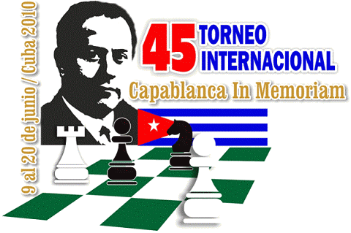
3.f4 Nc6 4.Nf3 g6
5.d4 cxd 6.Nxd4 Bg7
7.Be3 Nf6 8.Be2 Bd7
9.Nb3 Rc8 10.0-0 0-0
11.Qe1 a6 12.Kh1 b5
13.Rd1 Nb4 14.Rd2 Nxc2!
15.Rxc2 b4 16.Bxa6 Ra8
17.Bd3 bxc3 18.bxc3 Ra4
19.e5 Nd5 20.Bd4 Bc6
21.Rd2 Qa8 22.exd exd
23.Bxg7 Re8!! 24.Qa1 Ne3!
25.Rg1 Nxg2! 26.Rgxg2 Rxa2!
27.Rxa2 Qxa2! 28.Bf1 Bxg2+
White resigns
(29.Bxg2 Qxa1+ 30.Nxa1 Re1+ 31.Bf1 Rxf1+ 32.Kg2 Rxa1 & wins)
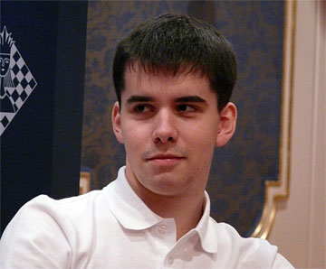

European Champion,19 year old Nepomniachtchi

Vitiugov - S Rublevsky
Karpov Tournament (Siberia) June 2010
Queens Gambit Accepted

1.d4 d5 2.Nf3 e6
3.c4 dxc4 4.e3 c5
5.Bxc4 a6 6.d5 b5
7.Bb3 exd5(a) 8.Bxd5! Ra7
9.e4 Nf6 10.Nc3! Nxd5
11.Nxd5 Nc6 12.0-0 Be6
13.a4! Be7 14.axb5 axb5
15.Ne5! Na5(b) 16.b4! Bxd5(c)
17.exd5 cxb4 18.Rxa5 Qxa5
19.Nc6 Qa4 20.Qd4! Bf6(d)
21.Qe3+ Kd7 22.Nxa7 b3
23.Qb6 resigns.

a) If 7...c4 8.dxe6! Bxe6 or 8…Qxd1= but not 8… cxb3?? 9.exf7+ Ke7 10.fxg8N+! Rxg8 11.Qxb3 wins.
b) If 15...Rxa1 16.Nxc6 wins.
c) If 16...cxb4 17.Qe2 0-0 18.Rxa5 Qxa5 19.Nc6 wins.
d) If 20...Rb7 21.Qxg7 Rf8 22.Nxe7 Rxe7 23.Bh6 wins.


I read an interesting recent article from the Sydney Morning Herald that part owner of Rugby League side the South Sydney Rabittohs, Russell Crowe, had arranged for members of the local chess community to teach the game to the rugby players. Chief executive Shane Richardson had called Crowe’s plan stupid but quickly changed his mind. “It was amazing, they love it,” he said. “They don't play poker any more, they play chess. The coaching staff all play chess.
They play before training, while they are in physio, they've put tournament draws on the notice boards. It's ludicrous. They've got magnetic chess boards to take with them on the plane.” (Readers of the West Australian may have seen a similar report in Wednesday’s Inside Cover which concluded with ‘Woosha, we’ve got a brilliant idea for you.’ Can you guess who provided this information?)
Russell Crowe with Rabbitoh players
SOLUTION: 1.Rh8 (the knight is trapped) 1…Kg7 2.Kg5!! Kxh8 3.Kg6 (Black is in zugzwzng and must lose the knight) 3…Nh6 4.Kxh6 Kg8 5.Kg6 Kf8 6.Kf6 Ke8 7.Kg7 Kd8 8.Kf7 Kc8 9.Ke7 winning the pawn & the game. If 2…Nf6 3.Rd8 Ne4+ 4.Kf4! Nxd6 5.Rxd7+ Nf7 6.Kf5 Kg8 7.Kf6 Nh6 (7…Nh8 8.Ra7 wins) 8.Kg wins. If after 2…Nf6 3.Kg5 Ne4+ 4.Kf4 Black now returns the knight with 4…Nf6 5.Kf5 Kf7 6.Rf8+! Kxf8 7.Kf6 winning as in Variation 1.

And, yes, I have to put my hand up to leaking the Crowe story to the West.

