Firstly a variation from the Magnus Carlsen – Wang Yue (2100 Kings Tournament, Romania, which Carlsen won with 7.5/10, two points ahead of runners up Teimour Radjabov and Boris Gelfand). White to play and win (4 moves). And secondly an actual position from the game in which White’s next move ensures a win.

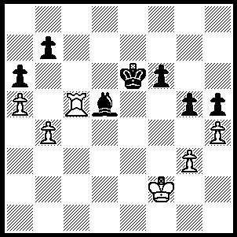
326 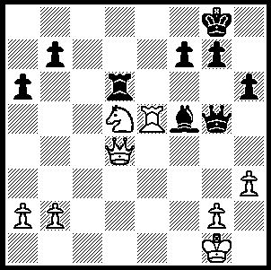 327

Held at the Perth Chess in Woodvale, the Perth Open, the fourth Grand Prix for the year, attracted 28 players. Joint winners were WA champion Tristan Boyd, Yita Chong and Tom Donaldson, all with 5/6. Other prizewinners: Under 1600 – 1st Girma Orssego (4), 2nd Denis McMahon (3.5): Under 1300 – =1st Mark Hagendoorn, Fraser Chibanda and junior George Carolin-Unkovich (2.5). Yita won the following game against Tristan in Round 5 but a draw with Tom in the final round enabled Tristan to join Yita and Tom in first place.

Yita Choong – Tristan Boyd
2010 Perth Open, Rd 5
Sicilian, Najdorf Variation
1.e4 c5 2.Nf3 d6
3.d4 cxd4 4.Nxd4 Nf6
5.Nc3 a6 6.Bc4 e6
7.Bb3 Nbd7 8.Bg5 Nc5
9.f4 Be7 10.Qf3 Qc7
11.0–0! Nxb3 12.axb3 0–0(a)
13.Kh1 Bd7 14.f5 Qd8(b)
15.Rad1 e5?(c) 16.Nde2 Bc6
17.Bxf6 Bxf6 18.Nd5 Rc8
19.Nec3 Bxd5 20.Rxd5(d) Rc6
21.Rfd1 Qb8 22.R5d3 Rfc8
23.Qg4 Qc7 24.Nd5 Qd8
25.c3 b5 26.Rh3 g6
27.fxg6 hxg6 28.Rf1 Bg7
29.Rhf3 Black resigns (e)

a) Not falling into the deep trap White has set with 12...Qc5 pinning the knight on d4. However, after 13.Rad1! e5? 14.b4! Qa7 15.fxe5 dxe5 16.Bxf6 Bxf6 17.Nd5, Black is in dire trouble: 17...exd4? fails to 18.e5! and 17...0–0? to 18.Nxf6+ gxf6 19.Qxf6 exd4 20.Rd3.
b) Black now has to worry about a discovered attack on the queen from a rook on d1. Better seems 14…b5 or the compact 14…Rae8.
c) This unnecessarily concedes the d5 square to White: better the switchback 15...Qc7.
d) With good knight v bad bishop White‘s immediate goal is to transfer the knight to d5 without dropping the c-pawn to ...Rxc2.
e) If 29...Qe8 30.Rxf7 Qxf7 31.Rxf7 Kxf7 32.Qd7+ Kf8 33.Qe7+ Kg8 34.Qe6+ Kf8/h8 35.Ne7 wins. (I am indebted to Yita for providing the bulk of the game notes.)

John Summerfield has recently established a junior club in Midland and would like to hear from senior players in the area with a view to getting a senior club up and running. Contact John on sommer@js.id.au or 0421 930 437.

SOLUTION: a) 1.Rxf5! Qxf5 2.Ne7+ Kf8 3.Nxf5 Rxd4 4.Nxd4.
b) 1.g4! obtaining a passed pawn. The game concluded 1…hxg 2.h5 Be4 3.Rc7 f5 4.h6 f4 5.h7 g3+ 6.Ke1 f3! 7.h8=Q f2+ 8.Ke2 Bd3+! 9.Ke3! resigns (9…f1=Q 10.Qh6+ mates)

