The July FIDE Ratings have confirmed Magnus Carlsen (Norway) as the top rated player with his rating going up 13 points to 2826. Veselin Topalov (Bulgaria) remains second on 2803, down 9 while World Champion Viswanathan Anand (India) has gained 11 points to be third with 2800, overtaking former World Champion Vladimir Kramnik (Russia), steady on 2790. Of the top 100 players virtually ¾ are in the 20 to 40 age group. Eight, headed by Anand, were born between 1966 and 1969 while eight, headed by Carlsen were born from 1990 onwards with the youngest 62nd placed Anish Giri (Netherlands) born in 1994 and 60th placed Wesley So (Philippines) born in 1993.
Let’s see an early win by Magnus Carlsen (v G. Gulbrandsen 2002). White to play and win (2 variations, 5 moves – look for a stunning first move).


328 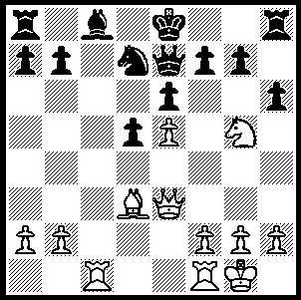 Magnus Carlsen

In the recent World Championship match both players struggled to hold their own with the Black pieces (with the exception being Anand’s fine win in the final game defending the Queens Gambit with Laskers Defence). It took some games before Topalov was able to counter Anand’s Catalan, losing his first two games with Black. Here is Anand’s second win:

Viswanathan Anand - Veselin Topalov
2010 World Championship, Sofia, Game 4
Catalan Opening
1.d4 Nf6 2.c4 e6
3.Nf3 d5 4.g3 dxc4
5.Bg2 Bb4+(a) 6.Bd2 a5
7.Qc2 Bxd2+ 8.Qxd2 c6
9.a4 b5 10.Na3!(b) Bd7
11.Ne5(c) Nd5 12.e4 Nb4
13.0-0 0-0 14.Rfd1 Be8
15.d5! Qd6 16.Ng4 Qc5
17.Ne3 N8a6 18.dxc6 bxa4(d)
19.Naxc4 Bxc6 20.Rac1 h6?(e)
21.Nd6 Qa7?(f) 22.Ng4! Rad8
23.Nxh6+! gxh6 24.Qxh6 f6
25.e5 Bxg2 26.exf6! Rxd6(g)
27.Rxd6 Be4(h) 28.Rxe6 Nd3
29.Rc2 Qh7 30.f7+ Qxf7
31.Rxe4 Qf5 32.Re7 resigns
a) 5...a6 was game 2 which Anand also won.
b) A novelty - 10.axb5 cxb5 11.Qg5 0-0 12.Qxb5 Ba6 13.Qa4 Qb6 14.0-0 Qxb2 15.Nbd2 Bb5 16.Nxc4 Bxa4 17.Nxb2 was Kramnik-Topalov Game 1 Elista 2006.
c) Not 11.axb5 cxb5 12.Qg5 h6! 13.Qxg7? Rh7! trapping the queen.
d) If18...Bxc6 19.axb5 Bxb5 20.Naxc4! Bxc4 21.Rac1 with advantage.
e) Weakening the kingside - better 20...Qe7.
f) A better move was 21…Qg5 which would be met by 22.h4 or f4.
g) If 26...Qh7 27.Qg5+ Kh8 28.Rc4 Rg8 29.Nf7+! Qxf7 30.Rh4+ Qh7 31.Rxh7+ Kxh7 32.Qh5#.
h) If 27...Bd5 28.Qg6+ Kh8 29.Rc4! Bxc4 30.Rd4! Qh7 31.Rh4 Rf7 32.Rxh7+ Rxh7 33.Qe8#.

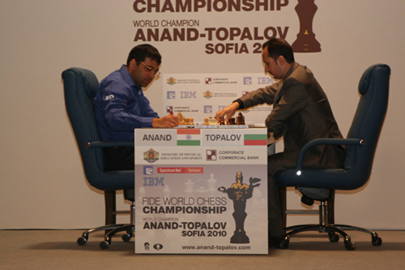

Anand – Topalov, Game 2

Entries for the WA Reserves Championship (starting Sunday 11 July and continuing on further Sundays) are invited. Venue is Moresby St. Centre, Kensington. Contact Haydn Barber at hadix@vianet.net.au or 9398 4242.

SOLUTION: 1.Qxa7!! (a brilliant deflection sacrifice) 1…Rxa7 2.Rxc8 Qd8 3.Rxd8+ Kxd8 4.Nxf7+ Ke7/8 5.Nxh8: if Black declines the sacrifice with 1…Rb8 then 2.Qxb8+! Nxb8 3.Rxc8+ Kd7 4.Rxh8 hxg5 5.Rxb8 and White has 2 rooks + bishop for the queen.

