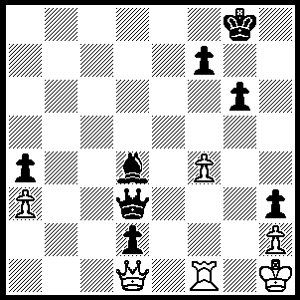

Radjabov - Topalov 2003:
Black to play and win
(3 moves – the second is delightful):

329

Back to the World Championship with Topalov, after two successive losses with the Black pieces, well prepared to face Anand’s Catalan System in Game 7 with an original line involving a piece for pawn sacrifice which extends to the bitter end:

Viswanathan Anand - Veselin Topalov
2010 World Championship, Sofia, Game 7
Catalan Opening
1.d4 Nf6 2.c4 e6
3.Nf3 d5 4.g3 Bb4+
5.Bd2 Be7 6.Bg2 0-0
7.0-0 c6 8.Bf4 dxc4
9.Ne5 b5 10.Nxc6 Nxc6
11.Bxc6 Bd7
This is Topalov’s new idea.
12.Bxa8 Qxa8 13.f3 Nd5
14.Bd2 e5! 15.e4 Bh3
Anand has used about 40 minutes, Topalov only a couple.
16.exd5 Bxf1 17.Qxf1 exd4
18.a4 Qxd5 19.axb5 Qxb5
20.Rxa7 Re8 21.Kh1
Black threatened 21…Qb6 / 22…c3.
21...Bf8
The first real thinking by Topalov (15 mins) If 21…Qxb2 22.Qe1! h6 (not 22…Kf8? 23.Rxe7! Rxe7 24.Bb4) 23.Rxe7 Rxe7 24.Qxe7 Qxb1+ 25.Kg2 Qb2 26.Qe8+ Kh7 27.Qe4+ g6 28.Qe8! Qxd2+ 29.Kh3 Kg7 30.Qe5+ Kh7 31.Qe8 drawing.
22.Rc7 d3
Not 22… Bc5? 23.b4! Bxb4 24.Qxc4 but now White gets a blockade and some stability.
23.Bc3 Bd6 24.Ra7 h6
25.Nd2 Bb4! 26.Ra1 Bxc3
27.bxc3 Re2 28.Rd1 Qa4
29.Ne4 Qc2 30.Rc1 Rxh2+
31.Kg1 Rg2+ 32.Qxg2
32.Kh1 invites a draw by repitition.
32...Qxc1+ 33.Qf1 Qe3+
34.Qf2 Qc1+ 35.Qf1 Qe3+
If 35…d2 36.Nxd2 Qxd2 37.Qxc4=
36.Kg2
Declining a draw.
36...f5 37.Nf2 Kh7
38.Qb1 Qe6 39.Qb5 g5
40.g4! fxg4 41.fxg4 Kg6
42.Qb7
Now 42.Qa4! might have given winning chances: Black cannot play 42…d2 (43.Qc2+) and White can gradually improve his position.
42...d2 43.Qb1+ Kg7
and drawn after 44.Kf1 Qe7
45.Kg2 Qe6 46.Qd1 Qe3 47.Qf3 Qe6 48.Qb7+ Kg6 49.Qb1+ Kg7 50.Qd1 Qe3 51.Qc2 Qe2 52.Qa4 Kg8 53.Qd7 Kf8 54.Qd5 Kg7 55.Kg3 Qe3+ 56.Qf3 Qe5+ 57.Kg2 Qe6 58.Nd1

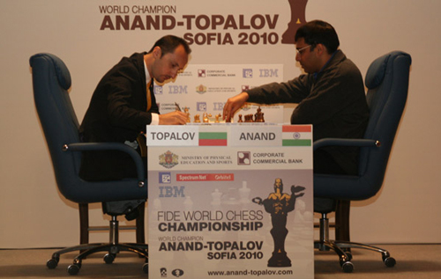

The start of the Anand – Topalov match.

SOLUTION: 1…Qe4+ 2.Rf3 Bf2! (cutting off the rook’s return to f1, with 3…Qe1+ to come).
Note the similarity to the game with the passed pawn on d2.

