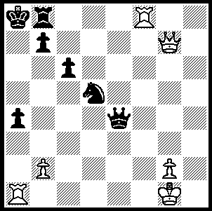
Giri - Cuipers (Neth. Ch. 2009):
a startling White move results
in an immediate resignation:

330

Earlier this month mention was made of the July FIDE ratings. You may remember the name Anish Giri, at 16 the youngest in the top 100 rated players at 62nd. Anish was born in June 1994 in St Petersburg to a Nepalese father, a research scientist, and a Russian mother. In 2002 his family moved to Japan and in 2008 to Netherlands. He became a GM at 14 and his most notable tournament successes have been winner of the 2009 Netherlands Championship and winner of the Corus B this year. He was one of a number of players to provide assistance to Vishy Anand in his preparation for his world championship match against Veselin Topalov, evidence of his high standing in chess circles. He speaks Russian, English, Dutch, Japanese and a little Nepalese and is studying German. Other interests include football and table tennis. Here is one of his games from this year’s Netherlands Championship in which he was runner-up:

W Spoelman - A Giri
Dutch Championships 2010 (9)
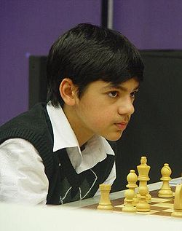
Reti Opening
1.c4 Nf6 2.Nf3 g6
3.g3 c6 4.Bg2 Bg7
5.0-0 d5 6.b3 e5!?(a)
7.Nxe5 Ng4 8.f4 dxc4
9.Bb2(b) Nxe5 10.fxe5 Be6
11.Na3 Nd7 12.Qc1(c) cxb3
13.Nc4 0-0 14.d4?!(d) bxa2
15.Ba3 Nxe5!! 16.dxe5 Qd4+
17.Ne3 Qxe5 18.Bxf8 Rxf8
19.Nc2 Qc5+ 20.e3 Bxa1
21.Nxa1 Qxc1 22.Rxc1 Rd8(e)
23.Bf3 Rd2 24.Rc2(f) Rxc2
25.Nxc2 Bd5 26.e4 Be6
27.Kf2 b5 28.Na1 b4
29.Bd1 c5 30.Ke3 c4
31.Kd4 b3 32.Kc3 f6
White resigns

a) A remarkable novelty leading to an original and unbalanced position.
b) Not 9.bxc4? Qd4+ 10.Kh1 Qxa1.
c) Interesting is 12.Nxc4!? Bxc4 13.bxc4 Qb6+ 14.d4 Qxb2 15.Rb1 Qxa2 16.Rxb7 0-0-0 17.Qb1 Qxb1 18.Rfxb1 with excellent compensation.
d) After 14.axb3 Bxc4 15.bxc4 Nxe5 White has some compensation for the pawn.
e) White is now unable to cope with Black’s passed pawns despite the extra piece.
f) White must prevent 24…Rb2/ 25…Rb1.

And here’s a bonus game played when Anish was eleven:

R.Kiutti – A. Giri
Under 12 European Championship 2005
Sicilian, Taimanov Variation
1.e4 c5 2.Nf3 e6
3.d4 cxd 4.Nxd4 Nc6
5.Nc3 Qc7 6.Be2 a6
7.0-0 Nf6 8.a3 b5
9.Be3 Bb7 10.f4(a) Bc5
11.e5? Qb6! 12.exf6 Nxd4
13.fxg7 Nxe2+ 14.Kh1 Rg8
15.Bxc5 Rxg7!! 16.Qxe2 Rxg2!
White resigns(b)

a) 10.Nxc6 is advisable.
b) 17.Bxb6 Rxe7+ 18.Kg1 (18.Rf3 staves off mate but leaves White without hope) 18…Rg2+ 19.Kh1 Rg8+ mates.

SOLUTION: 1.Qe5!! resigns.

