In 1957, when 14, Bobby Fischer won both the US Junior Championship and the US Championship.
However he missed a 3 move win in the following position (White v Otteson):

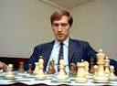
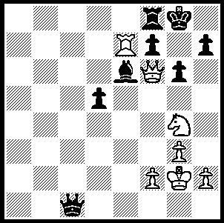 332

Mysteries surrounding Bobby Fischer’s latter years included the claims that he had played a considerable number of blitz games (3 min) on the Internet. Nigel Short, a former challenger to the world title, was convinced that an anonymous Internet opponent in 2001 was none other than the reclusive American former world champion. Short was beaten 0-8 in their first meeting and although subsequently gaining better results was never able to get close to 50% despite having a 6-6 record against Kasparov. ‘I am 99% sure that I have been playing against the chess legend. It’s tremendously exciting,’ said Short. What must have been galling for him was that his opponent would open with such ridiculous moves as 1.f3, 2.Kf2, 3.Ke3. Fischer would have been 58 at the time, an age Short considered virtually geriatric for a chess player. Unfortunately no records survive of these games but the mystery player had a series of blitz games on the Internet with French IM Robert Fontaine (rating 2452) who played under the name Beber, with the overall score being +20, =2, -3 in favour of the mystery player. So was this mystery man the great Fischer or someone using, after the early moves, a computer especially well programmed for blitz games? We may never know. Here is one of the recorded games:


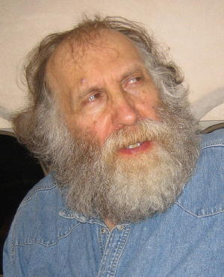

An aging Bobby Fischer Nigel Short

Guest 31 (Bobby Fischer?) - Beber (Robert Fontaine)
Internet Chess 2001, Game 3
Sicilian Irregular
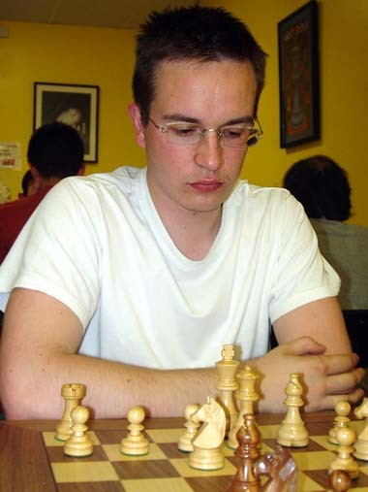
1.e4 c5 2.Ke2 Nc6
3.Ke3 g6 4.Nc3 Nd4
5.d3 Nf6 6.Kd2 d5
7.Ke1 Bg7 8.h3 0-0
9.a3 e5 10.Bg5 Be6
11.exd5 Bxd5 12.Nxd5 Qxd5
13.c3 Ne6 14.Be3 Rad8
15.Qa4 e4 16.dxe Nxe4
17.Rc1 a6 18.Be2 b5(a)
19.Qxa6 c4 20.Rd1 Qf5
21.Nf3 Nxc3 22.bxc3 Bxc3+
23.Nd2 Nc5 24.Bxc5 Bxd2+
25.Rxd2 Rxd2 26.Kxd2 Rd8+
27.Kc1 Qe5 28.Bxc4(b) Qc3+
29.Kb1 bxc4 30.Rc1 Qb3+
31.Ka1 Rd2(c) 32.Qc8+ Kg7
33.Bf8+ Kf6 34.Qc6+ Kf5
35.Qc5+ Kf6 36.Qe7+ Kf5 Robert Fontaine (Beber)
37.Qxf7+ Kg5 38.Be7+ Kh6
39.Qf8+ Kh4 40.g4#

a) This pawn sacrifice leads to further sacrifices and a strong attack.
b) 28.Qxb5 Qa1+ 29.Kc2 (29.Qb1 Qc3+ 30.Qc2 Qa1+ draw) 29…Qa2+ 30.Kc3 (30.Qb2? Rd2+! wins) 30…Kc3 31.Qd2+ Kb4 32.Qb2+ Kxc4 33.Qb2+ draws.
c) Allowing a crushing counter attack.

NEXT WEEK: claims of a love child and the exhumation of Fischer’s body.

SOLUTION: 1.Rc7! Qd2 (1…Qxc7 2.Nh6#) 2.Rc2! Qxc2 3.Nh6#.

