A blunder from Bobby Fischer in 1957, when 14,
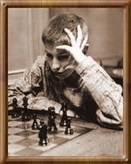
the year he won both the US Junior Championship
and the US Championship. Black v Santasiere, he
played 1…Qd5? forking the rooks but resigned
next move. Can you see why and decide on a
better move?

334 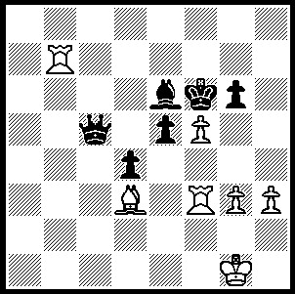

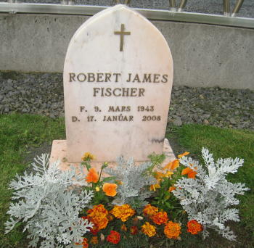
BOBBY FISCHER’S BODY TO BE EXHUMED
Chess legend Bobby Fischer left no will when he died in
Reykjavik, Iceland, in 2008, aged 64 and his US$2million
estate is now at the centre of a legal dispute amid claims
he fathered a secret love child in the Philippines. The
Iceland Supreme Court has given permission for his body
to be exhumed to prove whether he was the paternal father
of Jinky Young, 9, daughter of 31 year old Marilyn Young,
ruling that DNA can be taken from Fischer's remains and
compared to genetic matter from the girl. Evidence has
emerged that the chess champion sent money to Jinky’s
mother on a number of occasions and she has produced
pictures of her, Fischer and Jinky together and at least
two postcards to her daughter signed 'Daddy' that she said
were from Fischer.
Also with a claim to his estate is a Japanese Chess Federation official Miyoko Watai who has presented a wedding certificate and claimed she lived with Fischer while he was in Japan during the time the US was attempting to obtain his extradition back to the States. Under Icelandic law, a woman who is a lawful wife is eligible for a third of the estate of a deceased person while a lawful child inherits the remaining two thirds. Other claimants are the two sons of his deceased sister Joan and the US tax authority with claims for unpaid taxes.
Last week we saw an internet game won by a mysterious ‘Guest 31’ who is thought to have been Fischer who defeated French IM (now GM) Robert Fontaine +20, =2, -3. Here is another game from those encounters. One would think Black goes too far in his outrageously provocative
opening play as he repeats the first 12 moves of the previous
game which he lost quickly.
Beber (Robert Fontaine) - Guest 31 (Bobby Fischer?)
Internet Chess Club, Blitz (3 min) Game 13
Irregular Defence
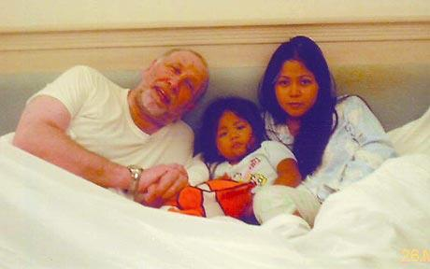
1.e4 f6 2.d4 Kf7
3.Nc3 Kg6 4.f4 h5
5.Nf3 Kh6 6.Bd3 e6
7.f5+ g5 8.fxg6+ Kxg6
9.0-0 d6 10.Nh4+ Kg7
11.Qf3 Kf7 12.e5 dxe5(a)
13.dxe Qd4+ 14.Qf2 Bc5
15.Qxd4 Bxd4+ 16.Kh1 f5(b)
17.Nf3 Bxc3 18.bxc3 b6
19.a4(c) Nd7 20.a5 Nc5
21.Bc4 Ne7 22.Ng5+ Kg6
23.Bf4 Nc6 24.axb cxb
25.Rad1 Na5 26.Ba2 Ba6
27.Rfe1 Bc4 28.Bxc4 Nxc4
29.Nf3 a5(d)

a) Improving on the previous game when Black lost quickly with 12…f5 13.Nxf5! exf5 14.Bxf5 Bxf5 15.Qxf5+ Nf6 16.Bg5 Nbd7 17.e6+ Kg7 18.exd7 Be7 19.Rae1 Rf8 20.Re6 Kh8 21.Rxe7! Qxe7 22.Bxf6+ Rxf6 23.Qxf6+ Qxf6 24.Rxf6 & wins.
b)16…Bxe5 loses to 17.Ng6.
c) The advance of the a pawn to a5 merely gives Black a passed a pawn which decides the game.
d) White is now clearly lost: the game concluded 30.Rd4 b5 31.Nh4+ Kg7 32.Bg5 Rhb8 33.Bf6+ Kh6 34.Rf1 a4 35.Rf3 Rg8 36.Rd1 a3 37.Ra1 a2 38.Be7 Ne4 39.Rd3? Nf2+ White resigns.

.
OLYMPIAD APPEAL: The biannual Chess Olympiad, one of the world’s biggest sporting events will be held in Siberia, starting next month. Australia will field an Open and a Women’s team but unlike most nations will receive no government assistance so donations are urgently needed. Please check on acfapppeal.aunz.org for information. It is intended that donations of $50 or more will receive regular email bulletins

SOLUTION: After 1…Qd5 White played 2.fxe6+! and Fischer resigned, realising 2…Qxf3 would be met by 3.Rf7+ winning the queen. The most obvious alternative 1…Bd5 is met by 2.fxg+! Bxf3 3.Rf7+ Kg5 4.Rxf3 leaving the outcome uncertain unless Black takes a perpetual. Best is the simple 1…gxf and White will be unable to cope with Black’s pawn mass.

