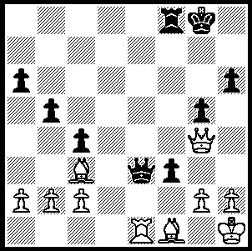
Vodopianov – Kapstin 1974:
Black is already 2 bishops down
but can invest further material
to win brilliantly (4 moves):

286

For the last two weeks we have seen outlandish opening play in internet Blitz chess, a strategy we might think unlikely to succeed in normal tournament chess. However this might not always be the case. I can remember when playing at Hastings many years ago (I went mainly to watch the great Botvinnik) I played 1.Nf3 which was countered by 1…g5. That was the one game I lost in the event. A similar galling fate was experienced by Dutch IM C van Oosterom when confronted by a beginner’s defence:

C Van Oosterom - M Sadler (x)
Weekender, Haarlem, Netherlands, 2010
Irregular Defence
1.e4 a6 2.d4 h6
3.Bd3 c5 4.dxc5 e6
5.Be3 Qc7 6.b4 Nc6
7.c3 d6 8.cxd6 Bxd6
9.Nf3 Nf6 10.h3 g5
11.a3 g4 12.Nd4 Ne5(a)
13.Be2(b) Nxe4 14.hxg4 Bd7
15.g5 0-0-0 16.gxh6 Bc6(c)
17.Nxc6 Qxc6 18.Qb3 Bc7
19.a4 Ng3! 20.fxg3(d) Qxg2
21.Rf1 Nd3+ 22.Bxd3 Rxd3
White resigns

a) Black has positional compensation for the pawn.
b) Black can meet 13.Bb5+ (14.axb5? Nxb5 winning the d6 bishop) with 13…Ke7.
c) At the cost of 2 pawns Black has fully mobilised.
d) If 20.Rg1 Qe4 21.Nd2 Rxd2! 22.Kxd2 Rd8+ 23.Ke1 Nd3+ 24.Bxd3 Rxd3 25.Qb2 Rxe3+! wins

x) Matthew Sadler is a former British champion
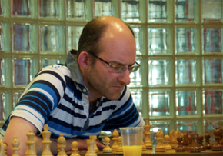
and England international who retired from
tournament play in 1999. He continued to play
in the German Bundesliga until 2004 but had
begun a career in computing, settled in the
Netherlands and gave up competition entirely.
Sadler's performances for England included an
individual gold medal for his score of 10.5/13
on Board 4 at the Olympiad in 1996. The
following year he was top scorer, also on Board
4, for the gold medal winning England team at
the European Team Championship. His return
to the board came in May, when he won a Rapid
event with 7/7 and followed this up with a win
in the Haalem weekender with 5/6.

2010 OLYMPIAD APPEAL: The biannual Chess Olympiad, one of the world’s biggest sporting events, takes place in Khanty-Mansiysk, 1900km from Moscow in Siberia, starting next month, Australia will be sending a team consisting of 5 players, reserves and non-playing captain to both the Open and Women’s event. The Open team consists of Zong-Yuan Zhao, David Smerdon, George Xie, Darryl Johansen and Stephen Solomon with Manuel Weeks as captain. The ACF receives no financial assistance from the Government and followers of the game are asked to consider donating to the Olympiad Appeal to assist players meet the considerable expense. Check www.acfappeal.aunz.org for details and donation form. It is intended that donors of $50 or more will receive regular email bulletins of the event.

SOLUTION: 1…Qg1+!! 2.Kxg1 f2+ 3.Kh1 fxe1=Q 4.Bxe1 Rxf1#

