Coming to the letter X in our alphabet series presents something of a challenge. There is no entry in my Chess Encyclopedia and I can think of no prominent player whose name begins with X. However the alternative name for a Skewer is an X-ray Attack so that’s what will be today’s subject.
Definition: ‘A double attack along the same rank, file or diagonal, one enemy unit being attacked ‘through’ the other as though they were speared on a skewer’ (Golombek’s Encyclopedia of Chess).
Usually this means a more valuable piece will have to escape the attack leaving the less valuable piece to be taken. The most effective skewer is when a king must move out of check exposing the queen to capture. The first is a relatively simple example (Mohr-Conquest 1989): Black to play and win (4/5 moves). The second is a rather more complicated example with a number of variations, an endgame study by L van Vliet: White to play and win (4 to 7 moves, the first being a quiet move).

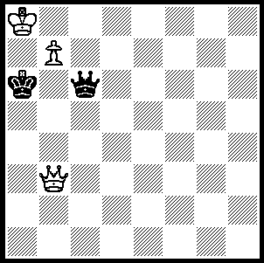
296 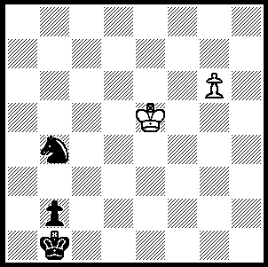 297

And now a game finishing with a skewer:

Richard Reti – Julius Brach
Kosice 1918
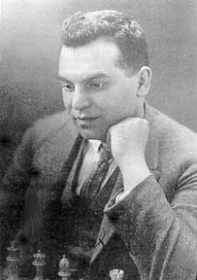
Caro-Kann, Classical Variation
1.e4 c6 2.d4 d5
3.Nc3 dxe 4.Nxe4 Bf5
5.Ng3 Bg6 6.Nf3 e6
7.Bd3 Bd6 8.0-0 Nd7
9.Bxg6 hxg6 10.Ng5 Ngf6
11.Qd3 Qe7 12.h3 0-0-0
13.f4 Bc7 14.c4 Bb6
15.b4 Ne5 16.fxe5 Bxd4+
17.Be3 Bxa1 18.exf6 Bxf6
19.Qa3 Bxg5 20.Bc5 Qc7`
21.Ne4 Be7 22.Qxa7 Bxc5+
23.bxc5 f6 24.Rb1 Qb8
25.Qa3 Rh4 26.Nd6+ Rxd6
27.cxd6 Kd7 28.c5 Rd4
29.Rb6 Rd5 30.Qb4 Kc8
31.Qg4 Kd7 32.Qxg6 Rxc5
33.Rxb7! Qxb7 34.Qxg7+ wins(a) Richard Reti

a) If 34…Kxd6 35.Qxb7: if 34…Kc8 35.Qf8+ Kd7+ 36.Qe7+ Kc8 37.Qe8#.

SOLUTION: 296 - 1...Nd5! 2.Kxd5 (2.g7 Nd7 3 Kc6 Nb8+ 4.Kc7 Kc2! 5.Kxg8 b1=Q when Q v g pawn on 7th wins) 2…Kc2 3.g7 b1=Q 4.g8=Q Qa2+ (or …Qb3+) creates a skewer & wins the White queen.
297 -1.Qb4 (restricting the king and forcing the queen to move) 1…Qd5 or …Qf3 2.Qh4+ Kg6 3.Qg3+!! Qxg3 4.b8=Q+ K moves 5.Qxg3: 1…Qg2 2.Qa3+ Kg6 3.Qb2+!! etc: 1…Qh8 2.Qa3+ Kg6 3.Qg2+ Kf7 (3…Ka6 4.Qa2+ Kg6 5.Qg1+!! etc) 4.Qh2+!! Qxh2 5.g8=Q+ etc).

