Fischer – Fine 1963: one move wins immediately:

335 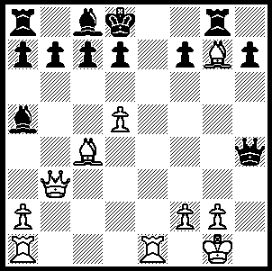

EXHUMATION OF FISHER’S BODY
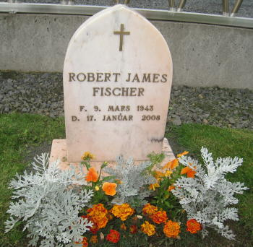
After a three week holiday I have been trying to catch up with
chess news, both local and international. A month ago I
reported on the planned exhumation of the body of Bobby
Fischer in Reykajvik to prove if he was the father of 9 year old
Jinky Young, daughter of Philippine woman Marilyn Young.
Tissues were taken from the body and the samples subjected
to DNA testing. The forensic authorities concluded that the
testing ruled out the possibility of Jinky being the biological
daughter of Fischer. This leaves Miyoko Watai, who claims to
have married Fischer in Japan, and Fischer’s two nephews by
his sister Joan with claims on Fischer’s estate. However
Marilyn Young through her lawyer has refused to accept the
Bobby Fischer’s tombstone results claiming the method of extracting the tissues was
unreliable.

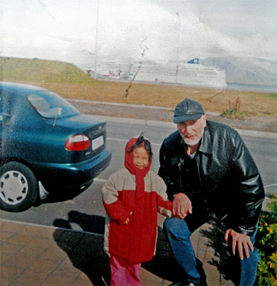

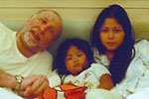

Bobby, Jinky & Marylin in the Philippines

Four year old Jinky on holiday with Bobby in Reykajvik

FISCHER - CELLE
1964 Simultaneous on 10 boards with clock
Evans Gambit Accepted

1.e4 e5 2.Nf3 Nc6
3.Bc4 Bc5 4.b4 Bxb4
5.c3 Be7 6.d4 d6
7.dxe Nxe5 8.Nxe5 dxe5
9.Qh5 g6 10.Qxe5 Nf6
11.Ba3 Rf8 12.0-0 Ng4
13.Qg3 Bxa3 14.Nxa3 Qe7(a)
15.Bb5+! c6 16.Nc4! Qe6(b)
17.Rad1! cxb5 18.Qc7 Bd7
19.Nd6+ Ke7 20.Nf5+! gxf5(c)
21.exf5 Rac8 22.Rxd7+! Qxd7
23.f6+ Nxf6 24.Re1+ Ne4
25.Rxe4 Kf6 26.Qxd7 Rfd8
27.Qg4(d) resigns

a) Threatening to simplify after 15.Nc2 with 15…Qe5 (16.f4? Qc5+).
b) 16…cxb5 17.Nd6+ Kd8 18.Rfd1 Bd7 19.Nxb7+ Kc8 20.Nd6+ was most uninviting.
c) If 20…Kf6 21.Rd6 gxf5 22.Qxd7! wins.
d) 27.Qe7+ mated in four but it hardly matters.

TIM HARE NEW WA CHAMPION.
Tim Hare became WA champion after the final round of the state championship last Sunday. With a half point lead a win would secure Tim the title. However after his main challenger Yita Choong was unable to overcome Tom Donaldson Tim agreed a draw with Dave Dempster to gain the title. Tim was unbeaten with 7/9 while runner-up Yita was also unbeaten with 6.5/9. Fifteen times champion Haydn Barber can join Yita on 6.5 if he wins a postponed game.
John Fedec won the Reserves title with 6.5/7 just ahead of Stephen Phillip (6) whom John beat in their vital clash.

WA LIGHTNING CHAMPIONSHIP (5 min. 11 rd. Swiss) will be held on Sunday 12 Sept.at Moresby St. Centre, Kensington starting 11 am. Entry cawa.org.au or Haydn Barber 9398 4242 or at venue by 10.45.

SOLUTION: 1.Qg3! resigns (1…Qxg3 2.Bf6#). This skittles game played against former great Fine was also an Evans Gambit Accepted: 5…Ba5 6.d4 exd 7.0-0 dxc 8.Qb3 Qe7 9.Nxc3 Nf6? 10.Nd5! Nxd5 11.exd5 Ne5 12.Nxe5 Qxe5 13.Bb2 Qg5 14.h4! Qxh4 15.Bxg7 Rg8 16.Rfe1+ Kd8 17.Qg3! resigns.

