DEATH OF BENT LARSEN AGED 75.

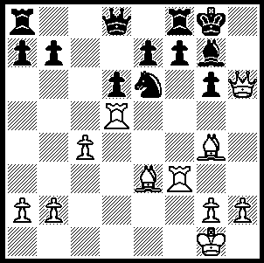

I have postponed an article on the 2010 WA
Championship after reading of the recent death
of Danish GM Bent Larsen. Firstly a position
from Larsen – Petrosian 1966 where the then
world champion loses spectacularly to ‘The
Great Dane’ in only 30 moves (6 moves):

337

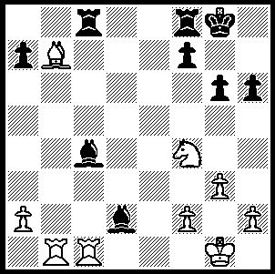

Larsen – Stein (Rest of World v USSR,
Bd 1, 1970) White wins a pawn (4 moves).
This enabled Larsen to use his consummate
skill to win the ensuing endgame.

336

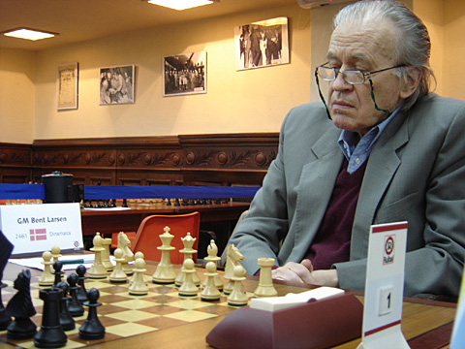
Born in Tilsted, Denmark, in 1935, Larsen learnt chess
at the age of six. He became a Grandmaster at the age
of 20 after scoring a remarkable 13/18 on Board 1 at
the Moscow Olympiad. This result persuaded him to
give up his engineering studies and take up chess
professionally. He was an aggressive player, reluctant
to tamely agree draws. This style made him a dangerous
and highly successful tournament player with a host of
first places against the leading players of the world. He
defeated seven players who were world champion,
Botvinnik, Smyslov, Tal, Petrosian, Spassky and Fischer.
He was seen with Bobby Fischer as a hope of wresting Larsen in play in 2009
the world title from the Soviets. He reached the semi-finals
of three World Championship Candidates tournaments, eliminated by Tal, Spassky and finally Fischer. His loss to Fischer 0-6 led to his decline as a player and he was handicapped in later life by diabetes. He died in Argentina where he had livedsince the 1970s. He has an opening named after him, Larsens Opening, 1.b3, and he was prepared to play a number of unfashionable openings including Birds Opening and Philidors Defence. Here is one of his fine games, a victory against one of the leading Soviet players:

Bent Larsen - Yefim Geller
Copenhagen 1960
Benko’s Opening
1.g3 e5 2.Bg2 d5
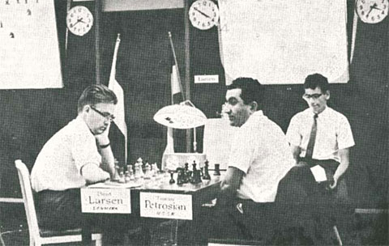
3.Nf3 Nc6(a) 4.0-0 Nf6
5. c4 d4(b) 6.d3 Bd6
7.Na3 0-0 8.Rb1 Re8
9.Nc2 a5 10.b3(c) h6
11.a3 Bf5 12.b4 axb
13.axb Qd7 14.b5 Nd8
15.e3! dxe 16.Nxe3 Bh7
17.Bb2 c6 18.Ra1 Rxa1
19.Qxa1(d) cxb 20.Nxe5 Qc7
21.Nf3 Be7 22.Rc1 bxc
23.dxc Qb6 24.Nd5 Nxd5
25.cxd5 Bf8 26.Bd4 Qb3
27.Ne5 b5 28.Nd7 Ba3 Larsen v Petrosian 1966 (see Diagram 337)
29.Bxg7!(e) Bxc1 30.Nf6+ Kxg7
31.Nxe8+ Kf8 32.Qh8+ Ke7
33.d6+ Kd7 34.Nf6+ Kc8
35.Bh3+ Kb7 36.Qxd8 Bd3
37.Bc8+ Ka8 38.Qa5+ resigns

a) Confronted by the unusual Benko’s Opening Black is reluctant to play 3…e4, instead steering the game into a Benoni Reversed.
b) Quieter and safer was 5…dxc.
c) White’s queenside play is less effective after 10.a3 a4.
d) Pure Reti! If now 19…Bxd3 20.Rd1 e4 21.Ne1 regaining the pawn or 20…Be2 21.Rd2 Bxf3 22.Bxf3 with more than sufficient compensation for the pawn.
e) Black was hoping for 29.Rc3 Bb2! 30. Rxb3 Bxa1 31.Bxa1 Re1+. Instead White brings his kingside attack to a brilliant conclusion.

SOLUTION 337: 1.Qxg6!! Black played 1…Nf4 which blocks the c1-h6 diagonal and the game concluded 2.Rxf4 fxg6 3.Be6+ Rf7 (3…Kh8 4.Rh3+ Bh6 5.Bxh6 wins) 4.Rxf7 Kh8 5.Rg5 (5…Bh6 6.Bd4+) 5…b5 6.Rg3 resigns.

SOLUTION 336: 1.Nxg6! fxg6 (1…Bxc1 2.Rxc1 Rc7 3.Nxf8 Rxb7 4.Rxc4 winning) 2.Rxc4! Rxc4 3.Bd5+ / 4.Bxc4.

