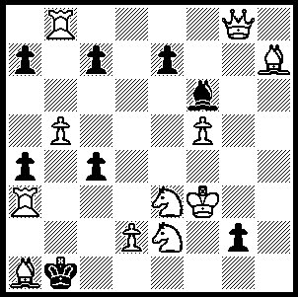
It’s quite a while since we had
a problem. This problem by
A C White 1906 (White to play
and mate in 2) has the en passant
capture featuring four times in
the many variations:

338

Tim Hare, the new WA Champion is clearly a strong believer in the kingside fianchetto, using it in all his games of the championship. With White he played the Reti (1.Nf3) or the English (1.c4) while with Black he consistently employed the Modern Defence (1…g6). Here is one of his wins:

Tim Hare - Tom Donaldson
2010 WA Closed Championship, Rd 4
Reti Opening
1.c4 c6 2.g3 d5
3.b3 Bg4 4.Bg2 e6
5.Bb2 Nf6 6.d3 Bc5
7.Nf3 dxc4 8.d4(a) Bb4+
9.Kf1 cxb3 10.Qxb3 Qb6
11.Ne5 Bd6(b) 12.Nc4 Qxb3
13.Nxd6+ Kd7 14.axb3 Kxd6
15.f3 Bh5 16.e4(c) Kc7
17.Nd2 Nbd7 18.Kf2 Rhe8
19.Rhc1 Bg6 20.Nc4 Nb6
21.Ne3 Red8 22.g4 h6
23.Ra5 Rd7 24.h4 a6(d)
25.h5 Bh7 26.d5 Rad8
27.Be5+ Kc8 28.dxc6 bxc6
29.Rxa6 Kb7 30.Rca1 Ra8(e)
31.Rxb6+! Kxb6 32.Rxa8 and wins

a) Either recapture loses the f pawn (8.bxc Qb6).
b) 11…Be7 seems better.
c) White has the two bishops, the centre and play against Black’s floating king, more than enough for the pawn.
d) It would be prudent to get out of the pin with 24…Kd8 although Black remains in a parlous position.
e) Loses a piece but there is no saving move.

The name Dave Dempster is usually associated with the courts of justice in WA where he works as state prosecutor, a position which hitherto left no room for chess. Fortunately with a less heavy workload he is now again able to devote time to a game he loves. Here he very efficiently exposes his opponent’s lack of development after pawn grabbing:

Dave Dempster - Akef Saleh
2010 WA Closed Championship, Rd 4
Caro-Kann Advance Variation
1.e4 c6 2.d4 d5
3.e5 Bf5 4.Nf3 e6
5.Be2 c5 6.Be3 cxd4
7.Nxd4 Bg6 8.O-O Nc6
9.c4! Nxe5 10.cxd5 exd5
11.f4 Bxb1 12.fxe5 Be4
13.Qa4+ Ke7 14.Qb4+ Kd7
15.Qxb7+ resigns

WA Lightning Championship (5 min. 11 rd. Swiss), held on Sept. 12, was won for the 7th time by Bozidar Mandic with 10/11. Second was Yita Choong (9.5) and 3rd Tom Donaldson (8.5).

The Willetton Open (Australian & WA Grand Prix event) will be held on Sat 2nd & Sun 3rd of October. Details on cawa.org.au or contact Haydn Barber 9398 4242.

SOLUTION: Black has only one defensive resource, 1…Bxa1 when 2.c6+ can be met by 2…Kb2. To take away this defence White plays 1.d4! and if Black reopens the diagonal with 1…fxe en passant 2.Qa2#. White en passant mates occur after 1…a5, 1…c5 & e5 (2.bxa#, bxc# & fxe#). Other pawn moves suffer similar fates while bishop moves are met by 2.c6# and 1…g1=N+ by 2.Qxg1#.

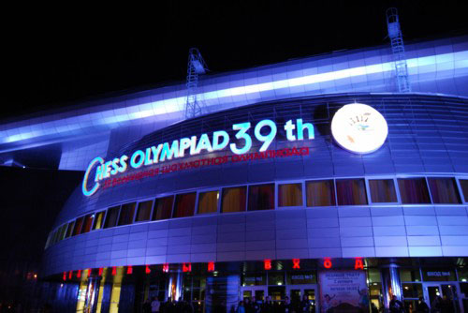
The 39th Chess Olympiad opened with
a spectacular ceremony at the Ice Palace Arena
in Khanty-Mansiysk, Siberia. |FIDE President
Kirsan Ilyumzhinov declared the games open
and there was a video speech from Russian
President Dmitry Medvedev. A living game
was played, the moves being “The Immortal
Game" (Anderssen – Kieseritsky) and these
pieces later featured in the draw. Round 1
commenced on Tuesday.

Venue for the Opening Ceremony

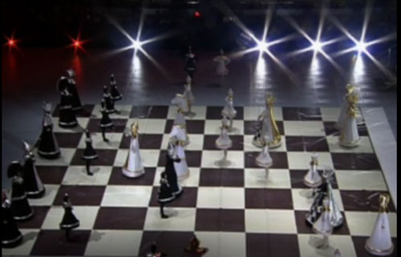
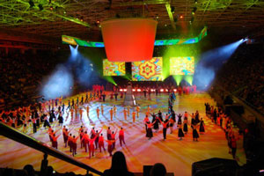

Opening Ceremony Display of Living Chess at ceremony

