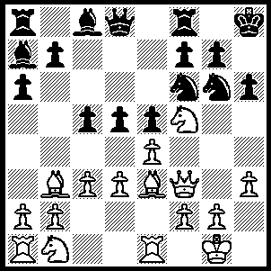
The 39th Chess Olympiad is well under way in Khanty-Mansiyak,
Siberia. Despite some early concerns, there have been none of the
problems that have accompanied the Commonwealth games in Delhi.
There are 156 teams in the Open event and 118 in the Women’s with
4 boards played each match with 11 rounds. Time limits are 90 mins
for 40 moves + 30 mins to complete the game with 30 sec increments
from move 1 with match results rather than game points determining
scores. Here is a position from Erdogdu (Turkey) – Howell (England).
White now played 1.exd but was forced to resign after two moves.
Can you see how? 339

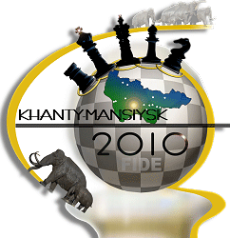
Russia won the Olympiad six times in succession from 1992 – 2002
(previously USSR had won six in succession 1982 – 90) with the most
recent winners being Ukraine 2004 and Armenia 2006 & 2008. Russia
has 5 teams in the competition with its top two teams strong contenders
for the title. However both lost in Round 5, Russia 1 to Hungary and
Russia 2 to Armenia. In Round 6 the two 100% teams Armenia and
Georgia drew while Ukraine, Russia 1 and Russia 2 all won. Scores
after 6 rounds: Ukraine, Armenia, Georgia 11, Russia 1 & Russia 2 10
(Australia is =39th with 7). The biggest surprise so far was the loss by
world number 1 Magnus Carlsen:
2010 Olympiad symbol
Baadur Jobava (Georgia) - Magnus Carlsen (Norway)
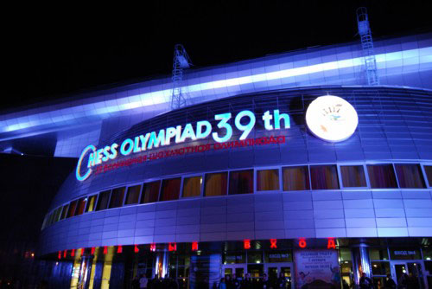
39th Olympiad Khanty-Mansiysk 2010 Rd 4
Nimzo-Indian Defence, Saemisch Variation
1.d4 Nf6 2.c4 e6
3.Nc3 Bb4 4.a3 Bxc3+
5.bxc3 Nc6 6.e4!?(a) Nxe4
7.Qg4 f5 8.Qxg7 Qf6
9.Qxf6 Nxf6 10.Nf3 b6
11.d5 Na5 12.Nd4 Kf7
13.dxe6+ dxe6 14.Bf4 Ba6
15.Nf3 Ne4 16.Ne5+ Kf6
17.f3 Nd6 18.0-0-0 Rhd8 Olympiad Venue
19.h4!(b) Nf7 20.Nd7+ Kg7
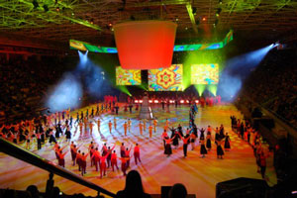
21.Rh3 Kh8 22.Bg5! Nxg5
23.hxg5 Kg7 24.Rh6 Bxc4
25.Bxc4 Nxc4 26.Rdh1 Rh8
27.f4?(c) c5 28.Rxe6 Rae8
29.Rxh7+! Rxh7(d) 30.Rxe8 Kf7
31.Ra8 Rh1+ 32.Kc2 a5
33.Ra7 Nxa3+ 34.Kd2 Rh2
35.Nxb6+ Kg6 36.Rxa5 Rxg2+
37.Kd1 Nb1 38.Rxc5 Nd2
39.Nd5 Ne4 40.Rc6+ Kf7
41.Ne3 Rg3 42.Ke2(e) Opening Ceremony

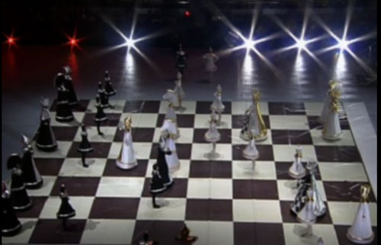
a) A very rarely played move.
b) Threatens 20.Bg5+! eg 19...Rg8 20.Bg5+! 20...Kxe5? 21.f4+ Ke4
22.Re1# or 20...Rxg5 21.hxg5+ Kxe5 22.g3! with advantage.
c) Better 27.Rxe6 Rae8 28.Rc6: Black should now play 27...Rad8!
(28.Nf6 c5 29.Rxh7+ Rxh7 30.Rxh7+ Kg6 31.Rh6+ Kf7 32.Rh7+ Kg6
33.Rxa7 e5! 34.g3 e4! with equality).
d) 29...Kxh7 30.Nf6+ Kg7 31.Nxe8+ Kf7 32.Nc7
e) Black is now lost: continued - 42…Ke8 43.Re6+ Kf7 44.Re5 Nxc3+
45.Kf2 Rh3 46.Rxf5+ Kg6 47.Rf6+ Kg7 48.Nf5+ Kg8 49.Kg2 Rd3
50.Rd6 Ne2! 51.Rg6+ Kh8 52.Rh6+ Kg8 53.Ne7+ Kf7 54.Ng6 Kg7
55.Kf2 Nc3 56.Ne7 Ne4+ 57.Ke2 Ra3 58.Nf5+ Kg8 59.Re6 Nc3+ Display of Living Chess
60.Kf3 Nd5+ 61.Kg4 Ra1 62.Re5 Rg1+ 63.Kf3 Rf1+? & resigns. ‘ The Immortal Game’ (Anderssen – Kieseritsky 1851)

WILLETTON OPEN (WA & Australian GP) tomorrow (12.30 start) & Sunday (10.30) at Moresby St. Centre, Kensington. Get details cawa.org.au and phone entry to Haydn Barber 93984242 / 0401473031 or enter on day.

SOLUTION: 1.exd Bxf5 2.Qxf5 Nh4! resigns (3.Qxe5 Bb8 wins the queen).

