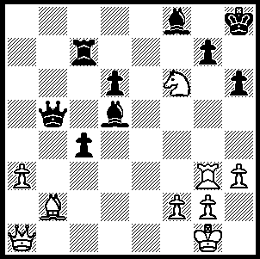

Ivanchuk – Kruppa 1988,

White to play & win

(3 moves):


The recently completed 39th Chess Olympiad in Khanty-Mansiyak, Siberia, has to be considered
a great success with a record number of participating nations and comments on the
organization and hospitality very positive. Winners were Ukraine repeating their success
of 2004. Ukraine led by a single point going into the last round and Russia 1, with a win over Spain, would ensure Ukraine would have to beat
Israel to finish on top. Kramnik defeated
The winning Ukraine Team receiving their medals Shirov on Bd 1 but in a big upset Spain’s
Bd 2 Ivan Salgado Lopez defeated Peter
Svidler despite having a 136 point lower rating. When it became apparent Russia 1 would only draw 2-2, Ukraine agreed 2 draws on their uncompleted games to also draw. Leading scores: 1st Ukraine +8, =3, -0, 19pts, 2nd Russia 1 +8, =2, -1 (to Hungary), 18 pts, 3rd Israel 17 pts, 4th Hungary 17pts, 5th-8th China, Russia 2, Armenia (champions 2006 & 2008), Spain 16pts. Ukraine’s Vassily Ivanchuk gained the Bd 1 prize with 8/10 and was superbly supported by the other 4 Ukrainian team members. Australia scored +5, =2, -4 to finish 55th /149. Other interesting facts: Ukranian born Sergey Karjakin was the top scorer for Russia 1, world number 1 Magnus Carlsen lost 3 games, Yemen forfeited against Israel on political grounds and Zambia gained the best performance taking into account ratings by coming 47th when ranked 121st. The Women’s event was won convincingly by Russia 1 in which sisters Tatiana and Alexandra Kosintseva scored 7/10 & 8.5/10 on boards 1 & 2. Australia scored +6, -5 to finish 46th /113.

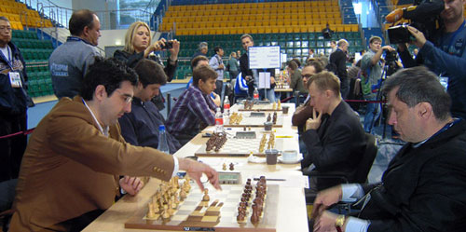

Kramnik (Russia 1) opens 1.d4 against Shirov (Spain)
Peter Svidler (Russia 1) - Ivan Salgado Lopez (Spain)
39th Olympiad, Rd 11, Bd 2
Philidors Defence
1.e4 d6 2.d4 Nf6
3.Nc3 e5 4.Nge2 Nbd7
5.g3 Be7 6.Bg2 c6
7.a4 b6 8.0-0 a6
9.h3 h5 10.Be3 Bb7
11.Nc1 0-0 12.Nd3 Qc7
13.f4 b5 14.Nf2 Rfe8
15.g4(a) hxg4 16.hxg4 b4
17.Ne2 exd4 18.Qxd4 c5
19.Qd3 d5! 20.e5 Ne4!
21.Nxe4 dxe4 22.Qd1(b) Rad8
23.Qc1 f6!!(c) 24.e6 Nb6
25.f5 Nd5 26.Nf4 c4
27.Nxd5 Rxd5! 28.Bf4(d) Qb6+
29.Kh2 g5! 30.fxg6 Qxe6
31.Kg3 Rg5! 32.Bxg5 fxg5
33.Rf5 Bd6+ 34.Kf2 e3+
35.Kg1 Bxg2 36.Kxg2 Qe4+
White resigns(e)

a) A dubious flank attack with the pawns as the centre is not stable and White’s pieces are not well positioned to start a kingside attack.
b) Not 22.Bxe4? c4 23.Qd4 Bc5 wins.
c) A most surprising move giving White a protected passed pawn on the 6th. However Black’s pieces now spring into action for a decisive counter attack.
d) If 28.Bxe4 Qg3+ 29.Bg2 Rd1+! wins.
e) After 37.Kh3 Kg7 mates.

SOLUTION: 1.Qb1! gxf6 2.Bxf6+ winning the queen.

